## The Interpreter Pattern

### Understand the Interpreter Pattern

Imagine a scenario where two people are trying to communicate, but they don't speak the same language. A translator or an interpreter can join them and translates everything they say to each other. The interpreter pattern is a way of translating one language into another.

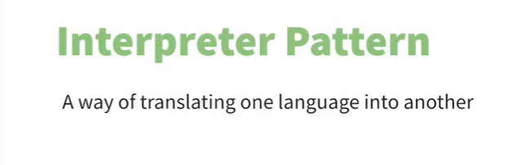

#### Use Cases

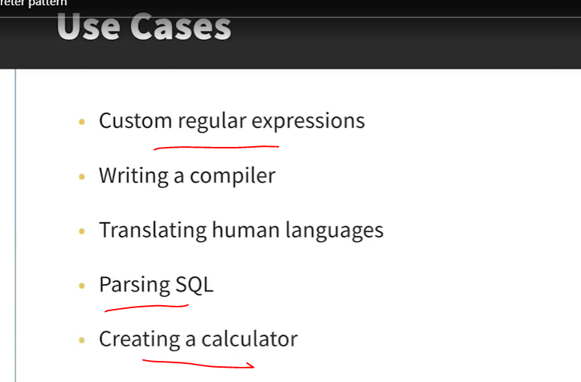

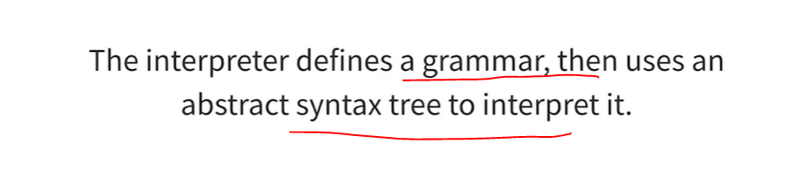

The idea of the interpreter pattern in Java is that if the same problem keeps coming up, then you can express that problem as a sentence and interpret it. The interpreter defines a grammar for the language and then uses an abstract syntax tree to interpret it. This is quite a complicated concept, so let's see what it actually looks like.

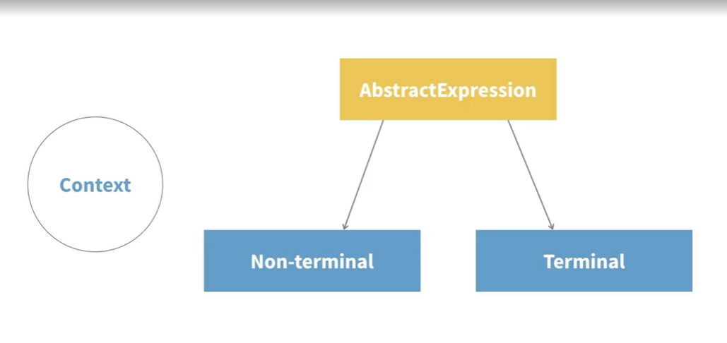

The first component in the interpreter pattern is the context. If you are translating a sentence into another language, the context would be the sentence. So the context is often just a string. The next part is an AbstractExpression class. This is an interface or an abstract class that defines a method used for interpreting the context. Each time the interpret method is called, the context is changed in some way. There are two different possible implementations of the AbstractExpression; terminal and non-terminal. A non-terminal expression calls the interpret method, which alters the context, and then it passes the context on to another expression until it reaches the terminal expression. A terminal expression is the last time the interpret method gets called. So, for example, if you were translating a language, the context could be "Hello world." The non-terminal operations translate each word into the correct word in the new language. And when it gets to some punctuation, like a period or exclamation mark, it returns that and stops.

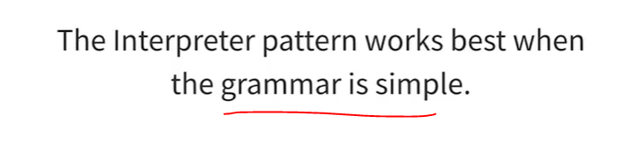

This structure makes it easy to extend and implement the grammar. However, the interpreter pattern works best when the grammar being interpreted is simple. Complex grammars can be difficult to maintain because you would need a new expression class for every new rule you introduce.

### Creating an Interpreter for a Language

See code below:

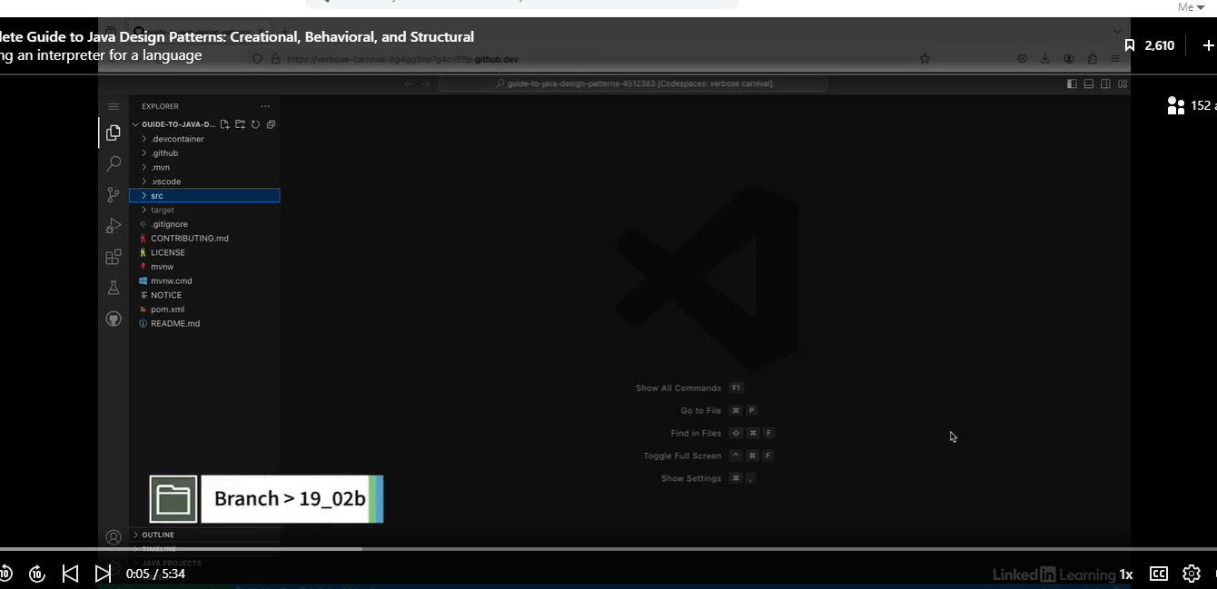

One of the possible uses of the interpreter pattern is interpreting code itself. You might have come across features in your IDE that show you hints when there are things in your code that it thinks could be improved. So one example is the organized input feature, where your IDE will rearrange your import statements in alphabetical order, and it will remove any unused ones. In this example, I'm going to implement a new feature similar to those used by your IDE to alter variable names so that they meet Java naming conventions. And I'm going to use the interpreter pattern.

See interface below:

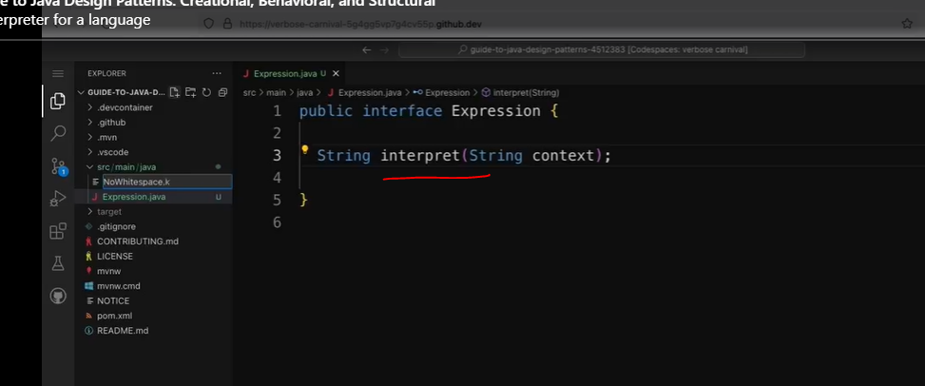

This will be a terminal operation.

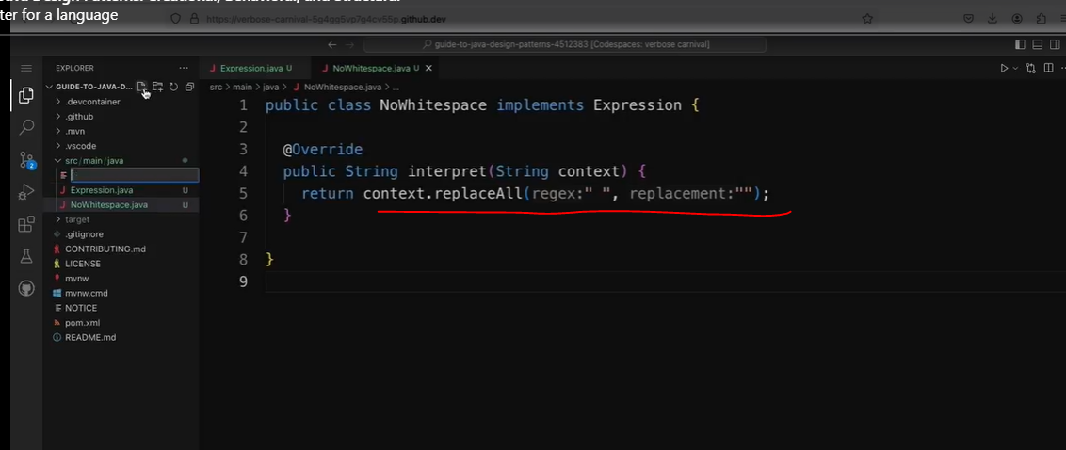

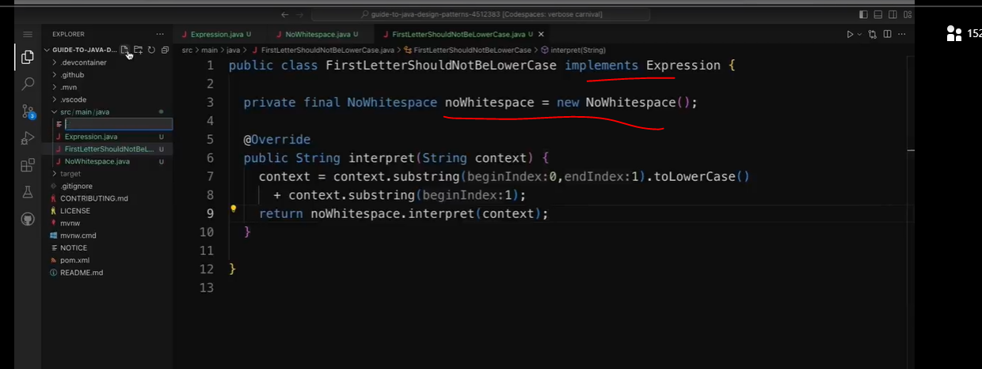

So I'm going to say return context.replaceAll. And for the first argument, I'm going to put a string with a whitespace. And the second argument is the replacement, so I'm just going to put an empty string. Next, I'm going to make sure that the variable name doesn't begin with a capital letter. So I'm going to create another new class, and I'm going to call this one FirstLetterShouldNotBeLowerCase. And again, this is going to implement the Expression interface. So I'm going to add implements Expression. Then I'm going to override the interpret method again. So I'm going to say @Override and public String interpret. And I'm going to pass in a string called context. So this time I'm going to make sure that the first letter of the variable is lowercase. So I'm going to say context equals context.substring and pass in zero for the first character and one for the second character, then I'm going to say .toLowerCase. Then I need to add to the rest of the string. So I'm going to say + context.substring and pass in one. So this basically says take the first letter of the string, make sure it's lowercase, and then append the rest of the string to that. However, this time I'm not just going to return the context directly. After checking the first letter, I wanted to check for whitespace. So in this class, I'm going to add a new field for NoWhitespace. So I'm going to say private final NoWhitespace noWhitespace equals new NoWhitespace. Then in the interpret method, I'm going to say return noWhitespace.interpret and pass in the new context.

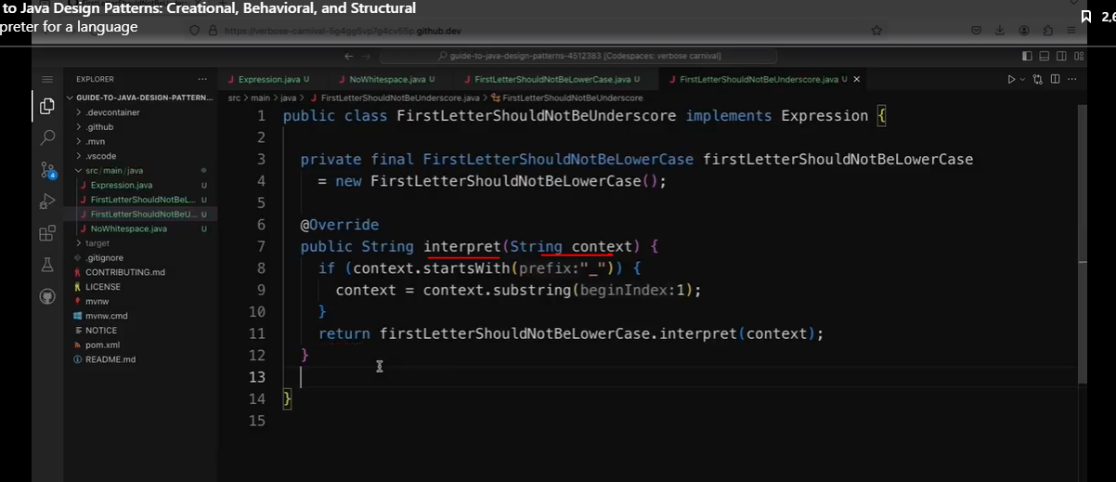

Now, I'm going to add one more rule to the chain, which is that the variable name should not start with an underscore character. So I'm going to create another new class and I'm going to call it FirstLetterShouldNotBeUnderscore. So again, this is going to implement the Expression interface. And this time this class is going to have a field of type FirstLetterShouldNotBeLowercase. So I'm going to say private final FirstLetterShouldNotBeLowercase firstLetterShouldNotBeLowercase equals new FirstLetterShouldNotBeLowercase. And then I need to override the interpret method again. So I'm going to say @Override, and then public String interpret. And I'm going to pass in a string called context. Then first, I'm going to make sure that the context doesn't start with an underscore. So I'm going to say if context.startsWith and pass in underscore. Then I'm going to say context equals context.substring, one. So that's essentially removing the first character if it's an underscore. Then I'm going to say return firstLetterShouldNotBeLowercase.interpret and pass in the new context. So now I've created an interpreter for the language. As you can see, it would be quite easy to add new rules to the chain, but if there were hundreds of different rules, this would get quite complex. And so I just need to make sure I've spoke return rights in that last line. So now I have an interpreter for the language. And now the next step is to actually interpret some variables. So I'll be doing that in the next video.

### Interpreting a Variable

Now I've got an interpreter that will apply some rules to variable names to make sure they follow Java naming conventions. So I just need a client to try it out now.

See code below:

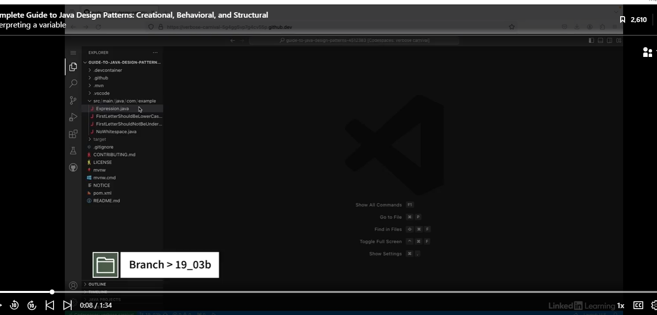

The code below is the client code.

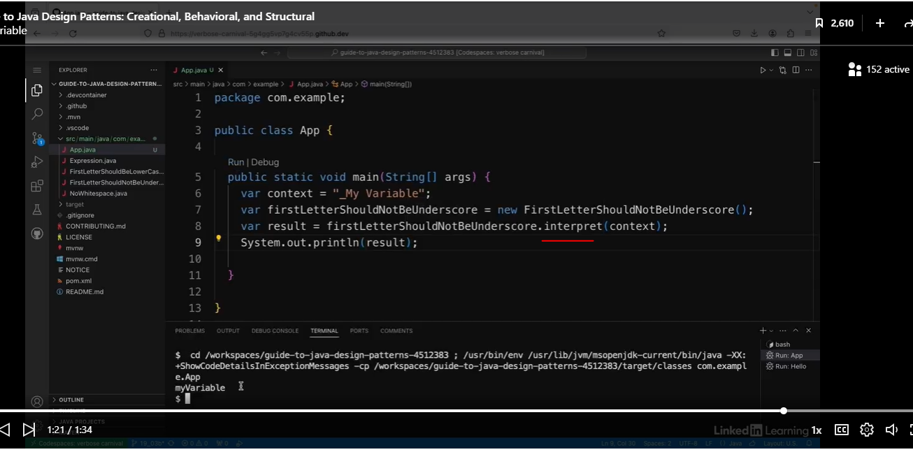

So I just need a client to try it out now. So I'm going to create a new Java class. And I'm going to call it up. And I'm going to create a main method in here. So to test out my interpreter, I'm going to create a variable name that deliberately breaks all of the rules I've implemented. So I'm going to say var context =, and my variable name is going to start with an underscore and then a capital M and then have a white space and then the variable. Now I'm going to create a variable of type. First letter should not be underscore as this is the first check in the chain. So I'm going to say var firstLetterShouldNotBeUnderscore = new FirstLetterShouldNotBeUnderscore. Then I'm going to use that to interpret my variable name. So I'm going to say var result = firstLetterShouldNotBeUnderscore .interpret and pass in my context, which is my variable name. And then I'm going to print it out. So I'm going to say System.out.println and pass in the result. So if I run this, I can see that it's applied all three of my rules, so it doesn't begin with an underscore, and then it doesn't begin with the capital M, it's a lowercase m and there's no whitespace in it. So that's a full implementation of the interpreter pattern.

## The Iterator Pattern

### Understand the Iterator Pattern

Very commonly used, especially with collections.

You've probably used the iterator pattern in Java quite a lot. In fact, maybe even more than you realize. If you've ever used collections, which you probably have is likely you've used the iterator pattern extensively. This for-each loop is commonly used in Java to iterate over a collection of objects, and under the hood is actually using the iterator pattern. The Collection interface implements another interface called Iterable, which is what the for each loop is using. One of the benefits of the iterator pattern that's shown in this example is that it doesn't matter what type of collection the sentence object is, it could be an ArrayList or a HashSet or a LinkedBlockingQueue or whatever, as long as it's something that implements the collection interface, the for-each loop works the same on all of them, and it's irrelevant what the underlying structure looks like.

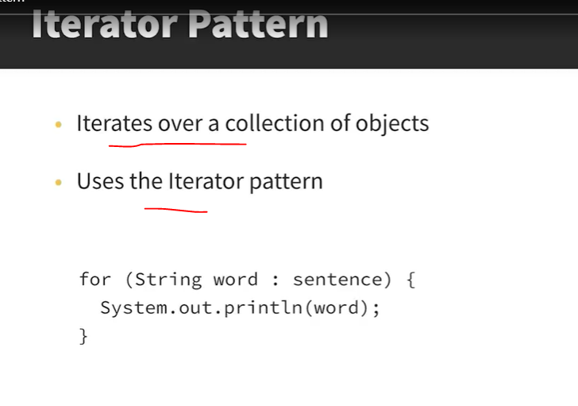

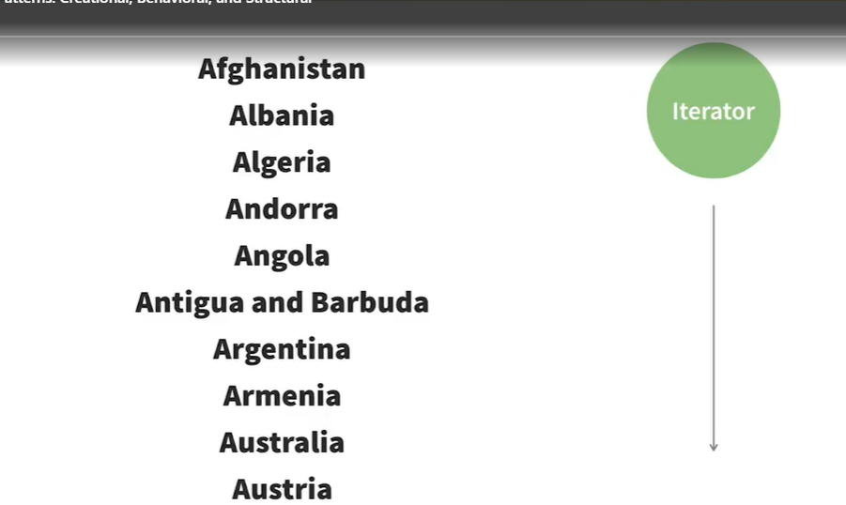

So say I have a list or collection like this list of countries here, for example. I might want to traverse this list and access the items in it for some app that I'm making, and there might be different ways I want to traverse it. For example, I might want to skip all of the countries in Europe or all of the countries with a certain population size and so on. I could add a load of methods to the List class to sort through the list in different ways, but I don't want to just add them all in there because it will turn into one big class with loads of stuffing. I also don't know yet which kinds of iteration I need, so I might end up including loads of unused code. So this is where the iterator comes in. The iterator is a separate object that takes all of the responsibility for moving along the list and accessing the objects inside it. It's responsible for keeping track of which elements have already been traversed.

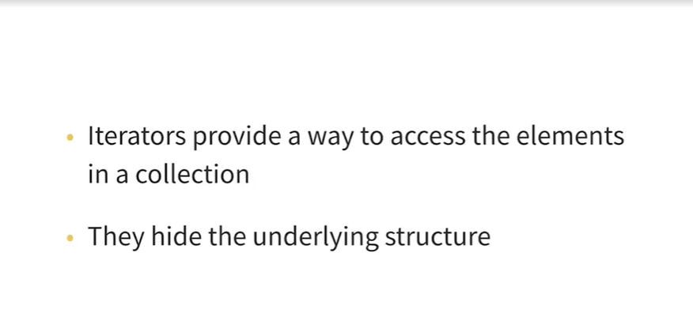

So to summarize, the iterator pattern provides a way to access the items in a list or collection of some type without exposing the underlying structure. In Java, there are interfaces called **Iterable** and **Iterator** which do a lot of the heavy lifting for you. But it's also important to know how it works because you might want to write your own custom iterators, and it will help you to understand how the iterators you use day-to-day work under the hood.

### Create an Iterable

See code below:

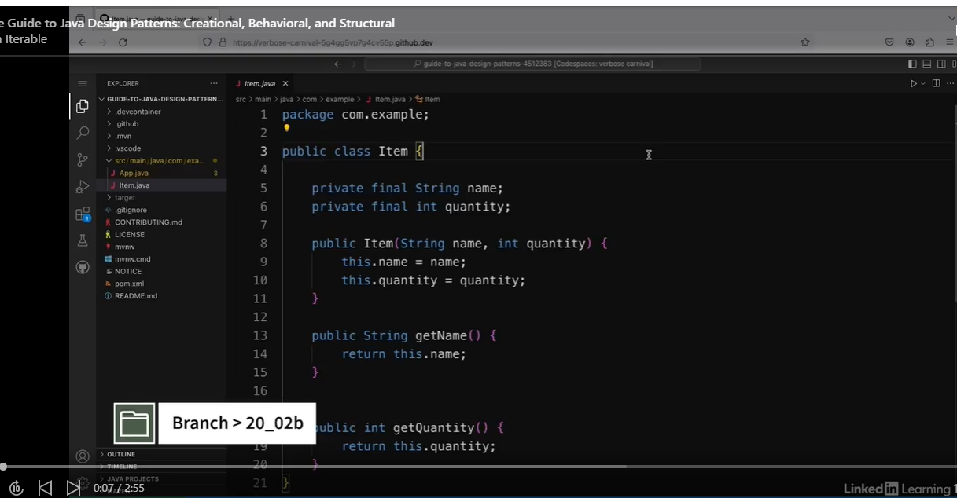

Client Code

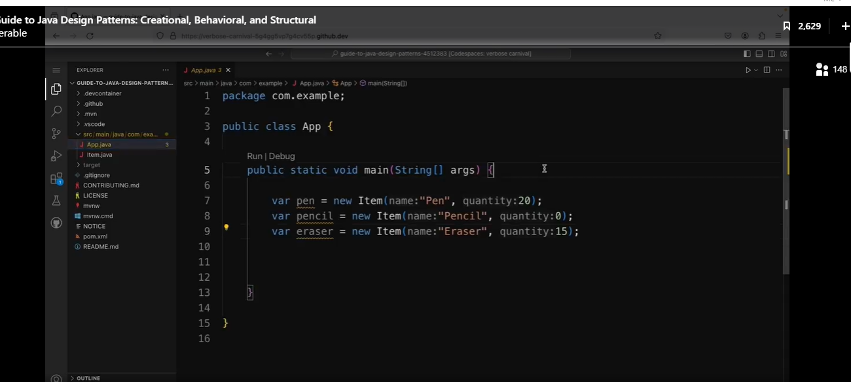

I want to be able to iterate over the items and only return the ones that are in stock.

So the first step is to create an iterable, which is a collection that can be iterated over. So I'm going to create a new Java class and I'm going to call it inventory. Normally, in iterator pattern, you would create your own interface for iterables and iterators. But as Java already has its own for each of these already included in the JDK, I'm going to make use of these pre-made ones. So I'm going to add implements iterable, which is a class from the JDK.

#### Custom Iterable

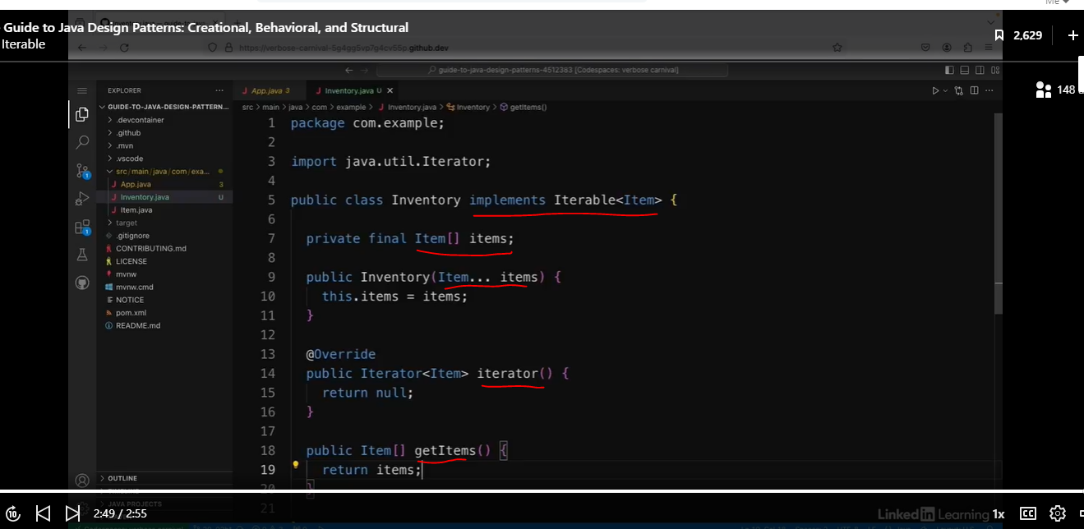

So now I have a class that represents the collection I want to iterate over, and the next step is going to be to create the iterator itself.

### Create an Iterator

See code below:

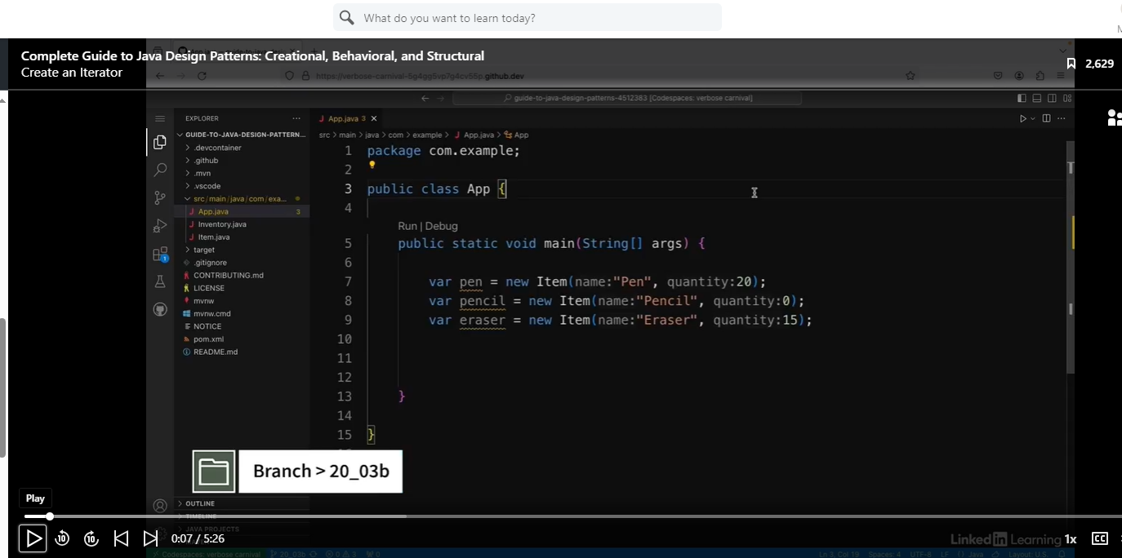

I want to be able to iterate over my collection of items using the iterator pattern. I've already created an iterable, and now I'm going to create a class to do the iteration. So I'm going to create a new Java class and I'm going to call it StockIterator. And this class is going to implement an interface from the JDK. So I'm going to say implements iterator. And in angle brackets I'm going to put item. Then I need to make sure that I've imported the iterator class.

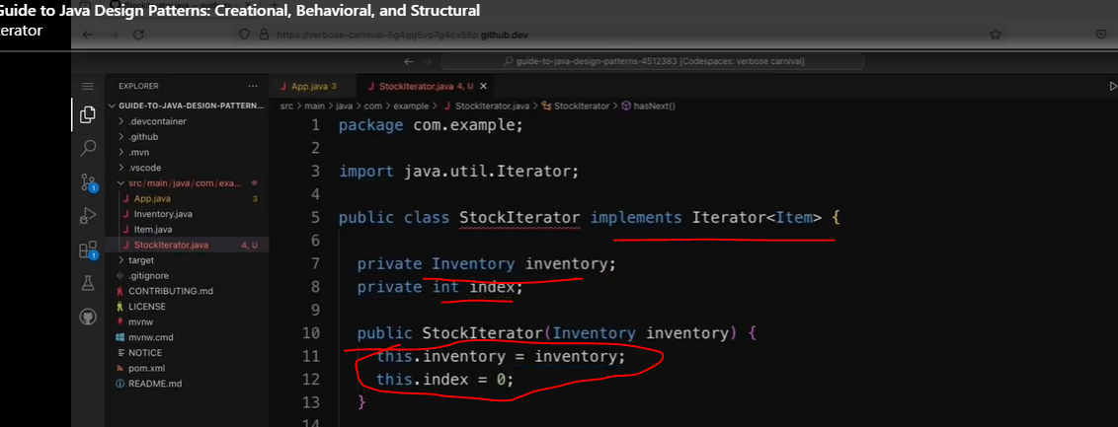

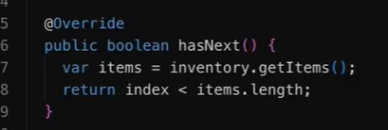

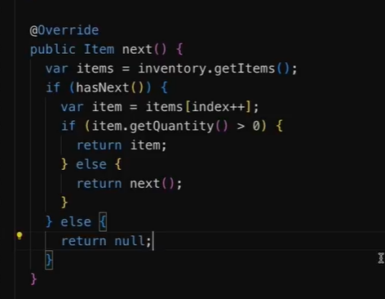

In our custom Iterable, refactor the null value below:

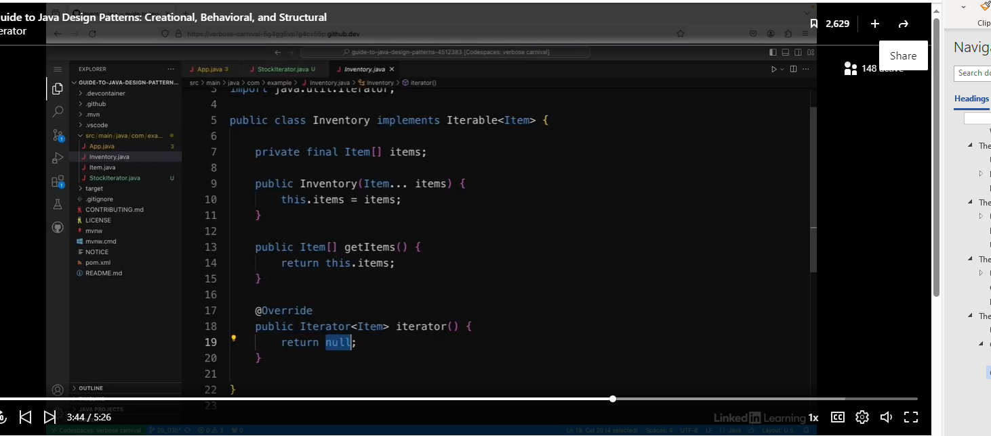

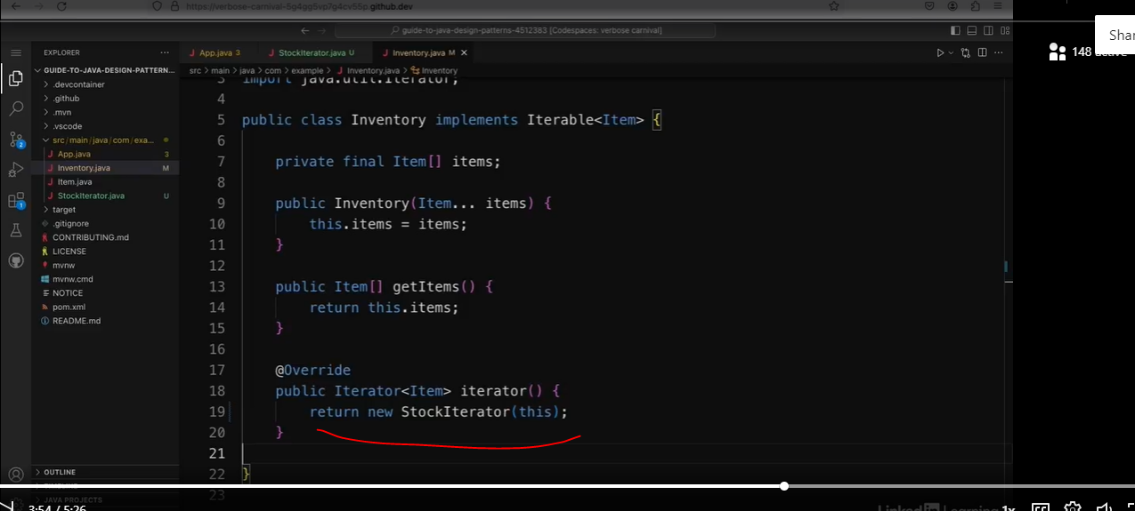

Let’s put this in our client code.

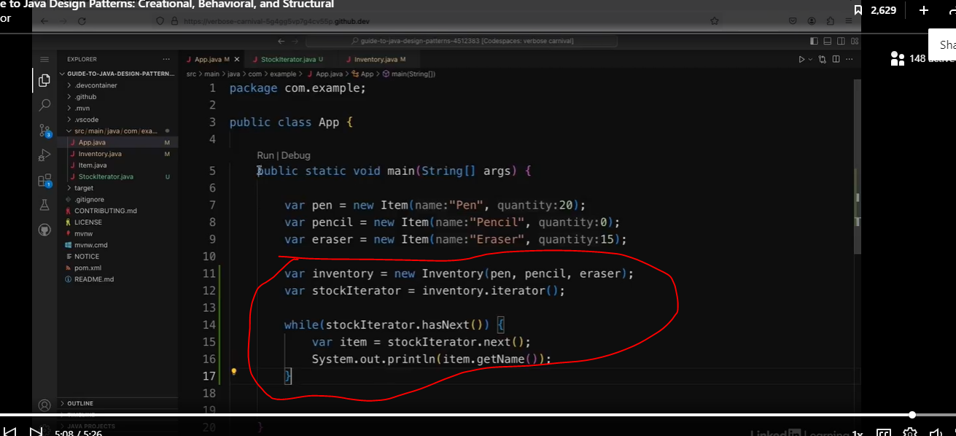

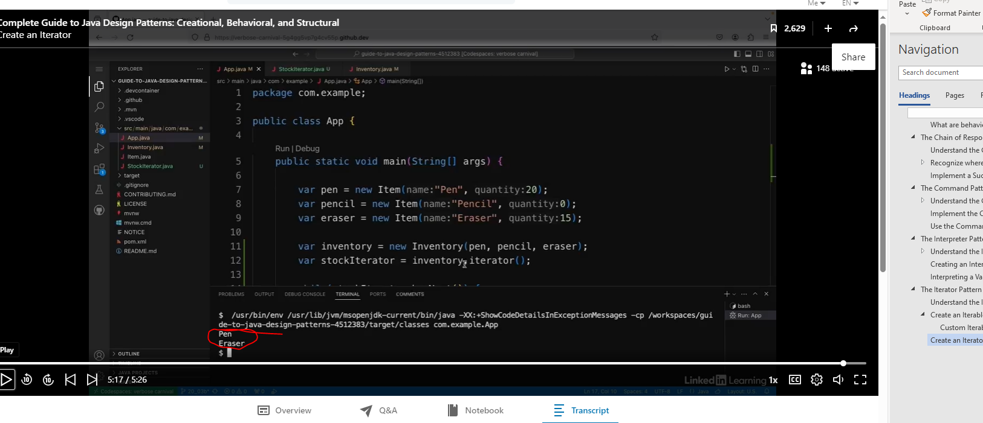

So if I run the app, I can see it prints out the items in the collection, but only the ones where the quantity isn't zero. So it prints out pen and eraser, but not pencil because the quantity of pencils is zero. So this is how you can use the iterator pattern to traverse the items in a collection.

#### Note:

With functional programming and lambdas/streams, I would never really do this.

## The Mediator Pattern

### Understand the Mediator Pattern

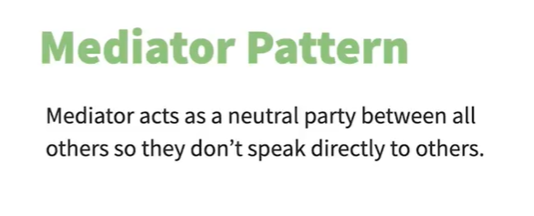

Analogy

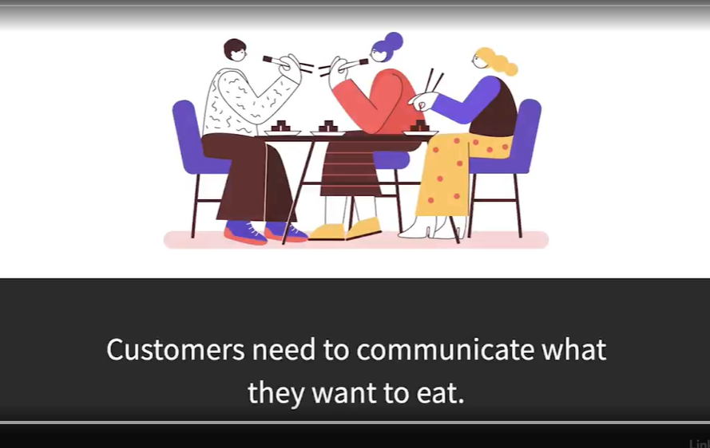

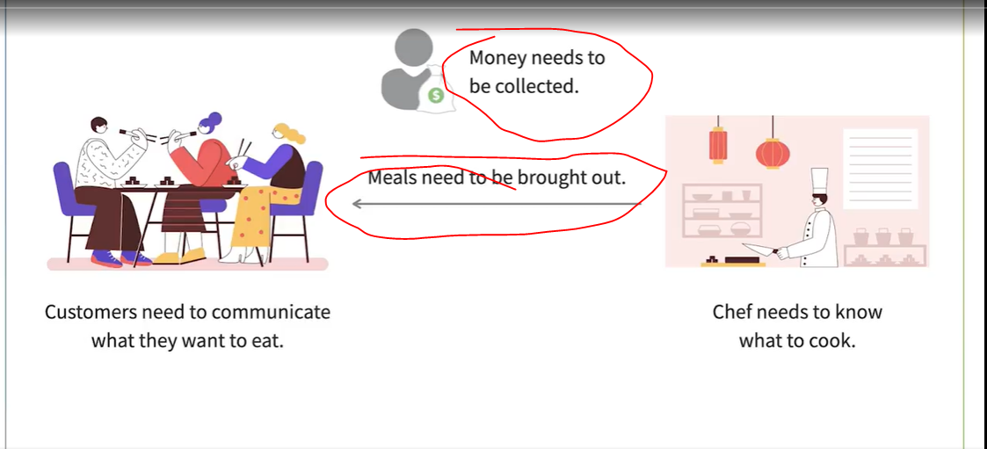

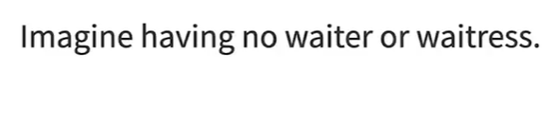

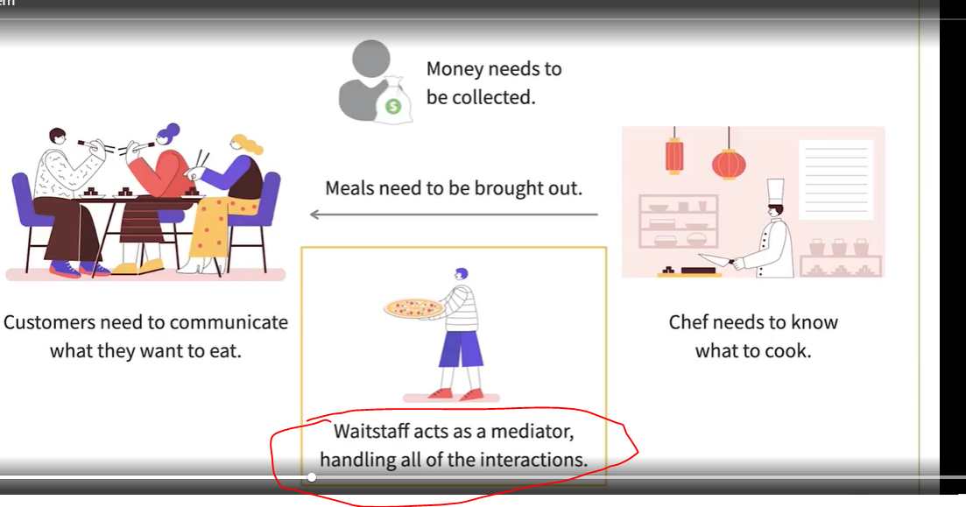

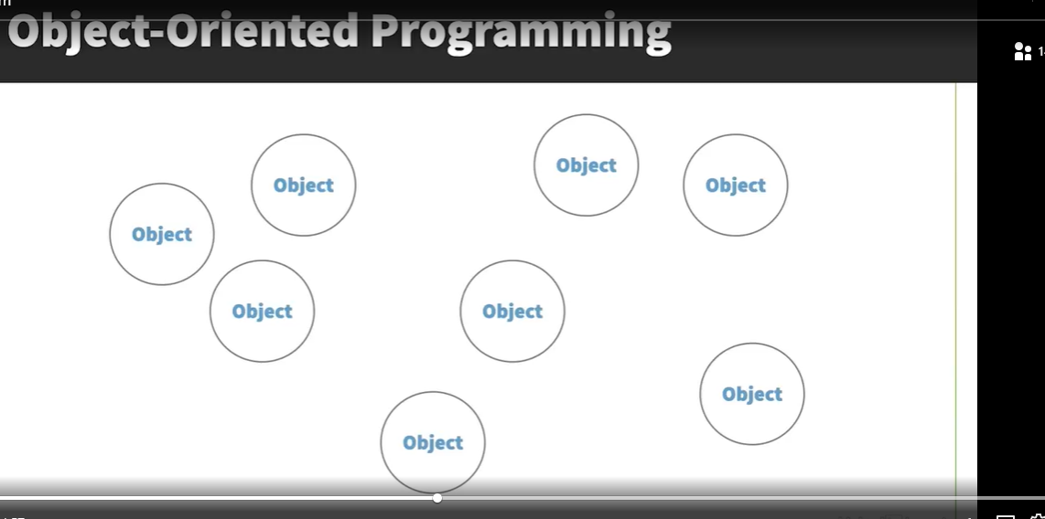

So if we go back to coding and object-oriented design, you often end up with large applications that have lots of different objects. We're told that classes should be small and self-contained, so you often have lots of different ones, which leads to lots of different objects. This is a good thing, as it means that each class is focused on its one thing, and the behavior of the application as a whole is split into small chunks. But one of the downsides that can occur is that you end up with a system with lots of different objects that all know about each other and are all interconnected. You might even end up with a situation where every object knows about every other objects.

Apart from the fact that it might become a nightmare to understand what's actually going on, this leads to tight coupling between objects, and changes to one might result in the need for changes to another.

It might also make it difficult to reuse objects because they might have to communicate with so many others.

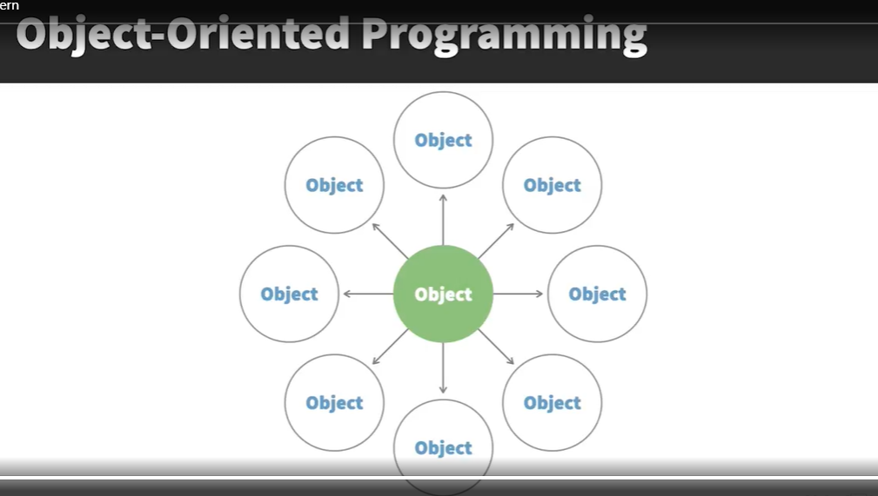

The idea of the mediator pattern is to have an object that sole purpose is to handle these interactions between all of the different objects. It sits in the middle of them all and handles the communications between them. This provides a loose coupling between the objects, and this makes the program simpler to understand and to maintain.

### Avoid Tight Coupling between objects

See Class below.

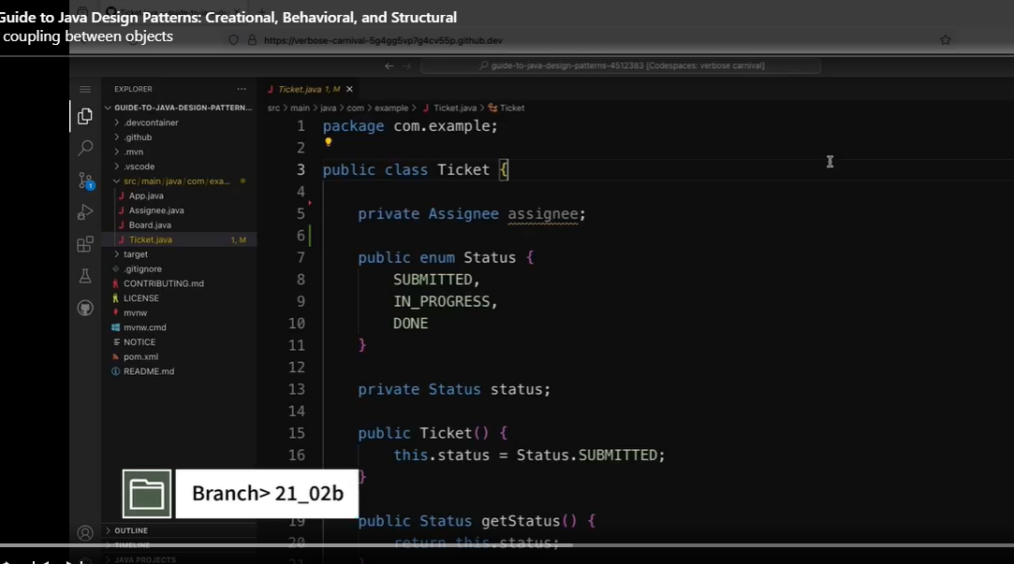

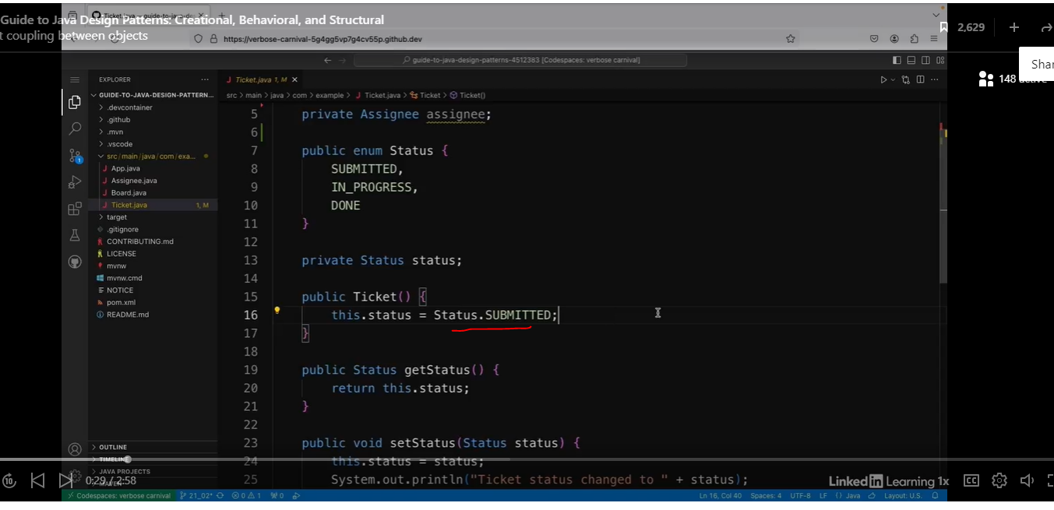

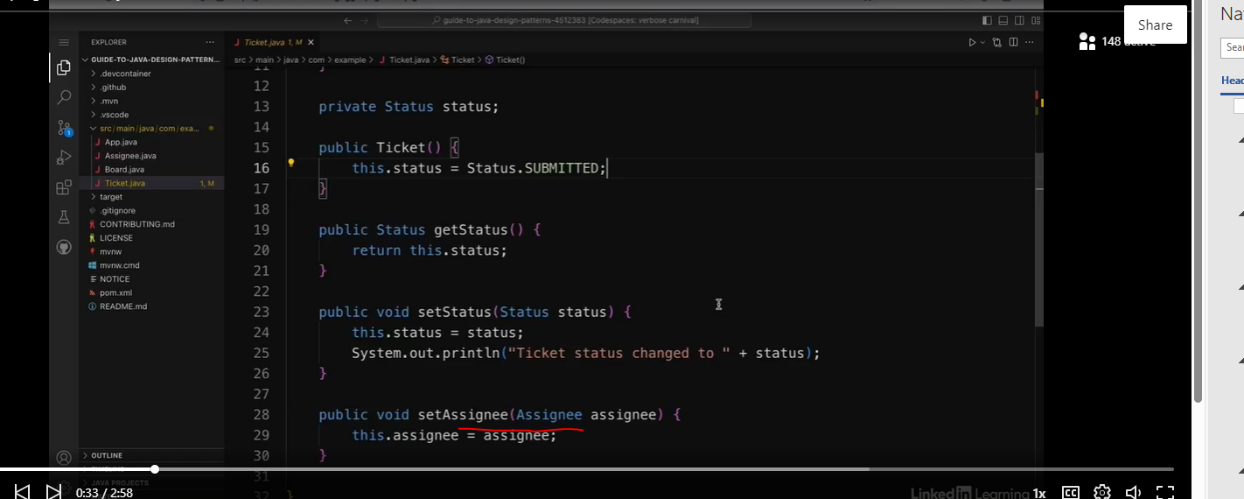

See the Board Class.

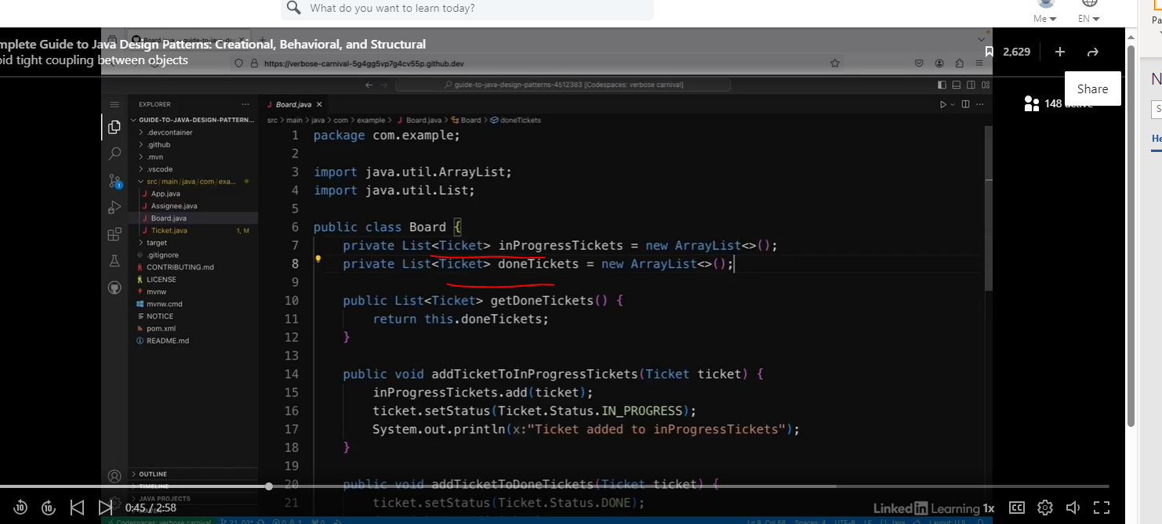

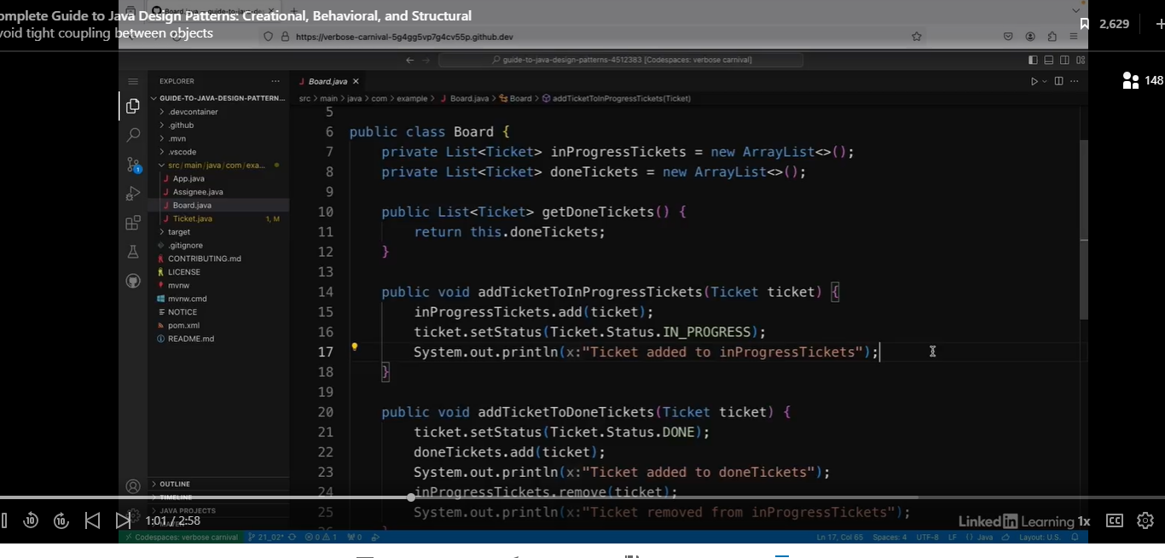

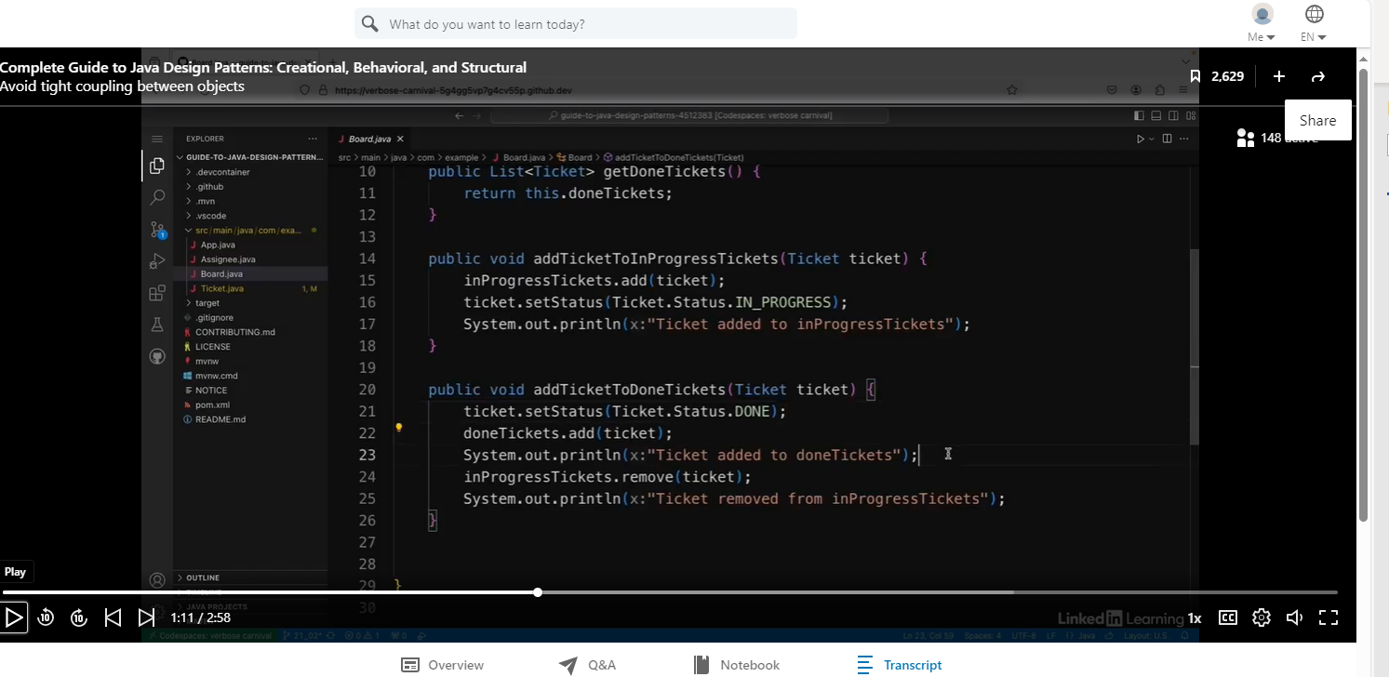

Assignee Class

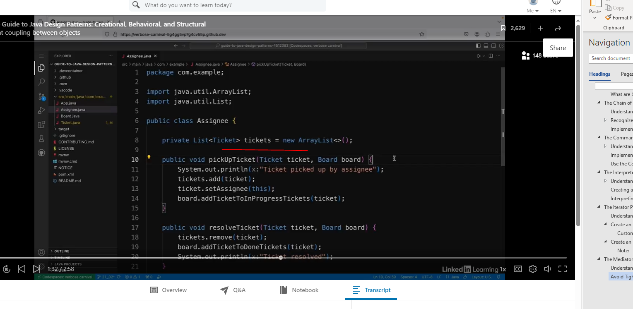

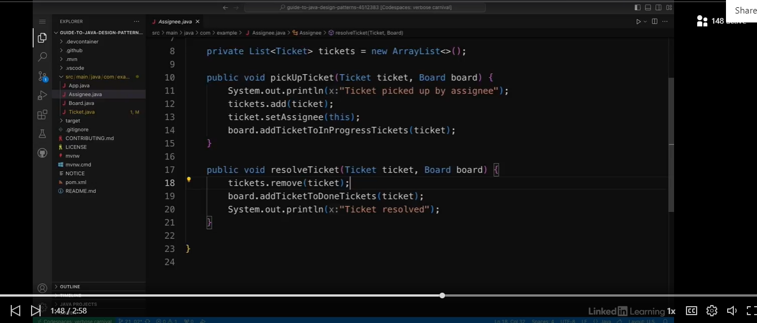

Client Code

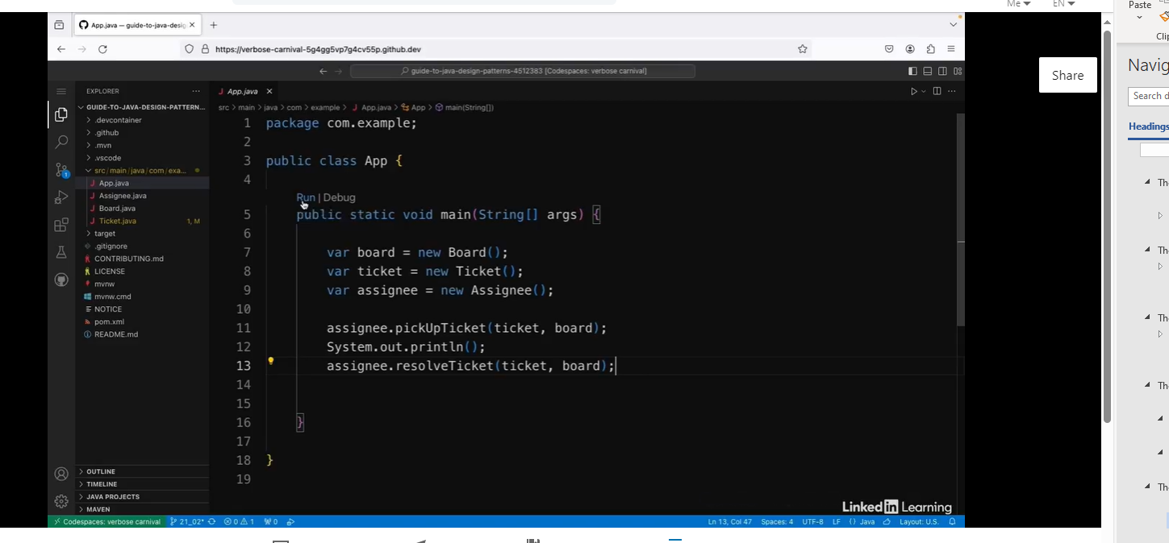

See the output.

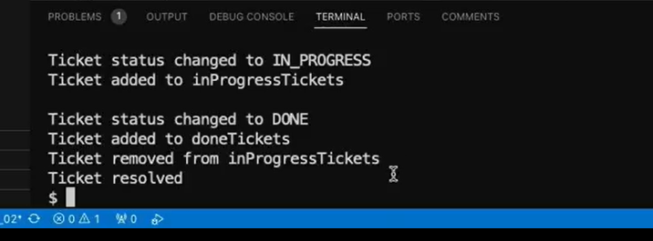

So the assignee class in particular is having to do lots of updating of the states of ticket and board classes, which means that they're tightly coupled. And in the board class is also updating the states of the tickets. This means that if something changes in the ticket class, there are several different places that I need to check to make sure everything still compiles and works properly. It's also generally a really confusing structure, and I wouldn't be surprised if you found that **explanation quite confusing to follow**. The states of the different objects is being updated in quite a few different places, so this app is a good candidate for implementing the mediator pattern.

### Create a Mediator Object

See the original client code.

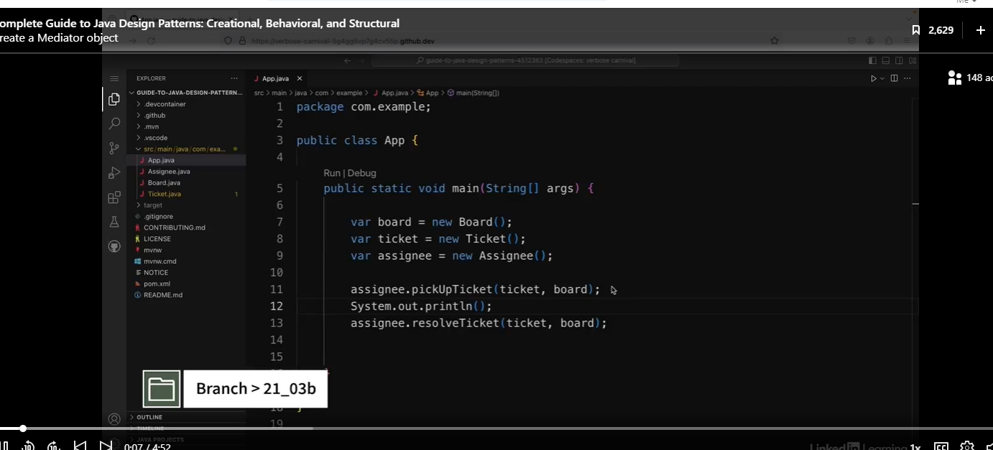

Let’s create the Mediator, and list fields that need to be updated.

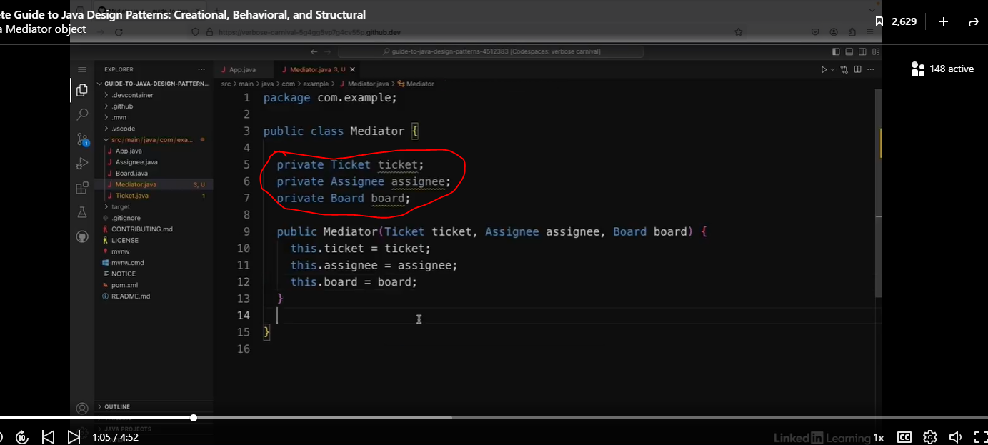

Code below is problematic, because they involve an assignee, a ticket, and a board. In other words, we have tight coupling.

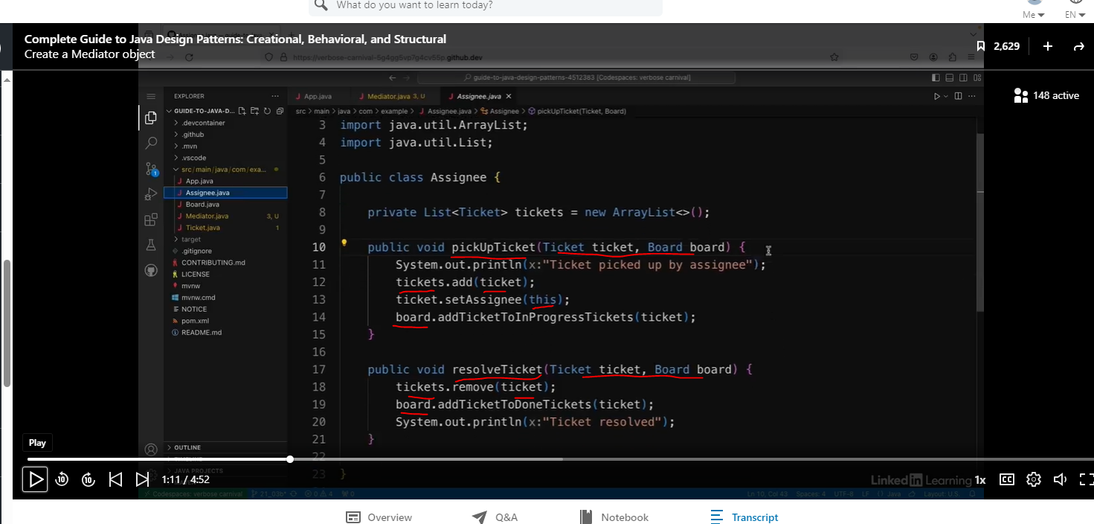

Let’s continue with our Mediator.

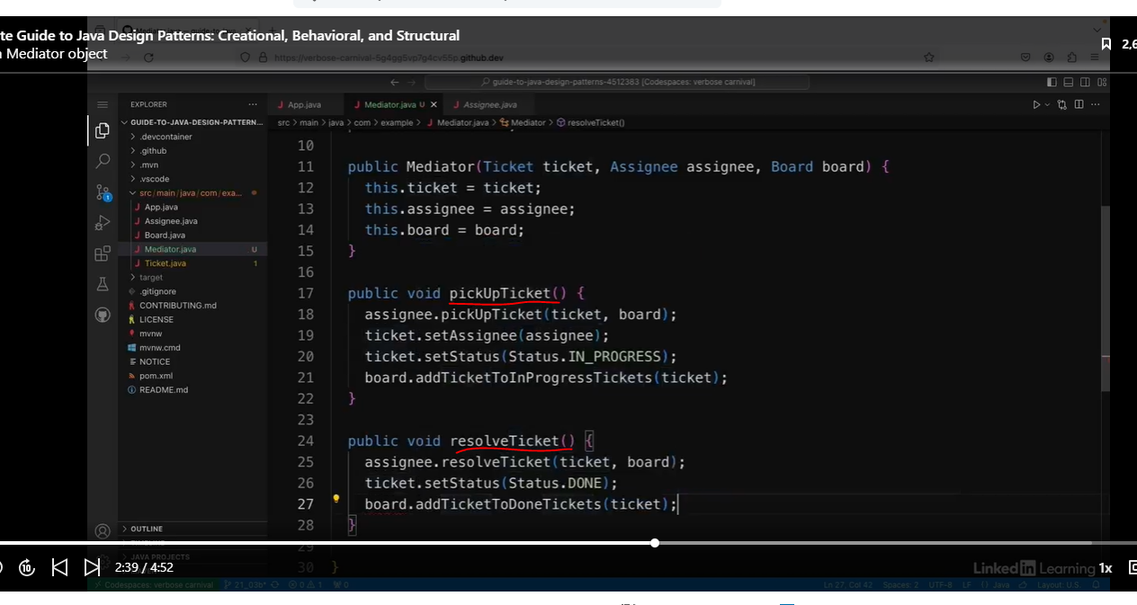

Let’s refactor the Board class.

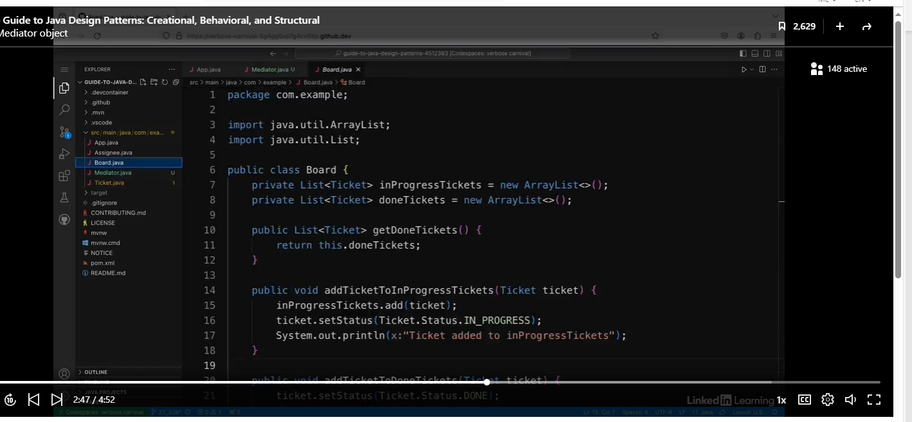

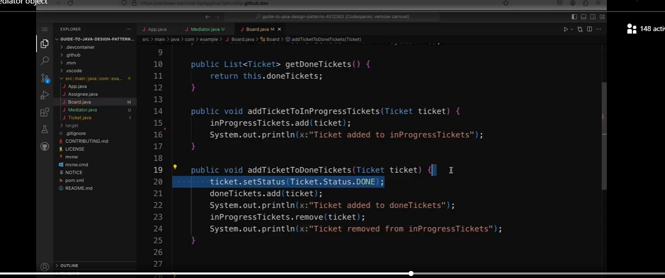

We removed lines 16 and 20. We basically removed the ticket.setStatus methods, because they are handled in the mediator.

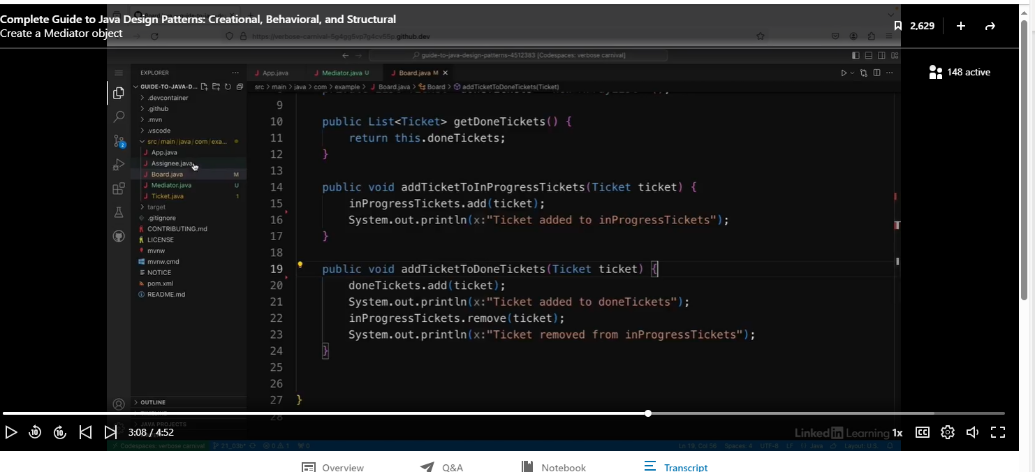

In the Assignee class, we are going to remove lines 13 and 14.

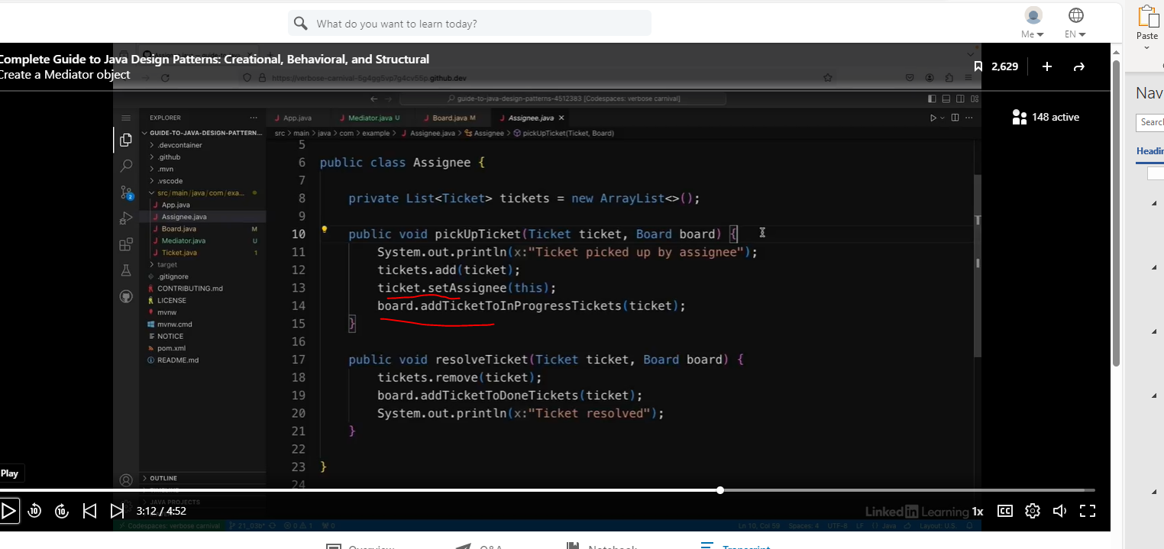

We also removed line 19, and removed the Board paremeter.

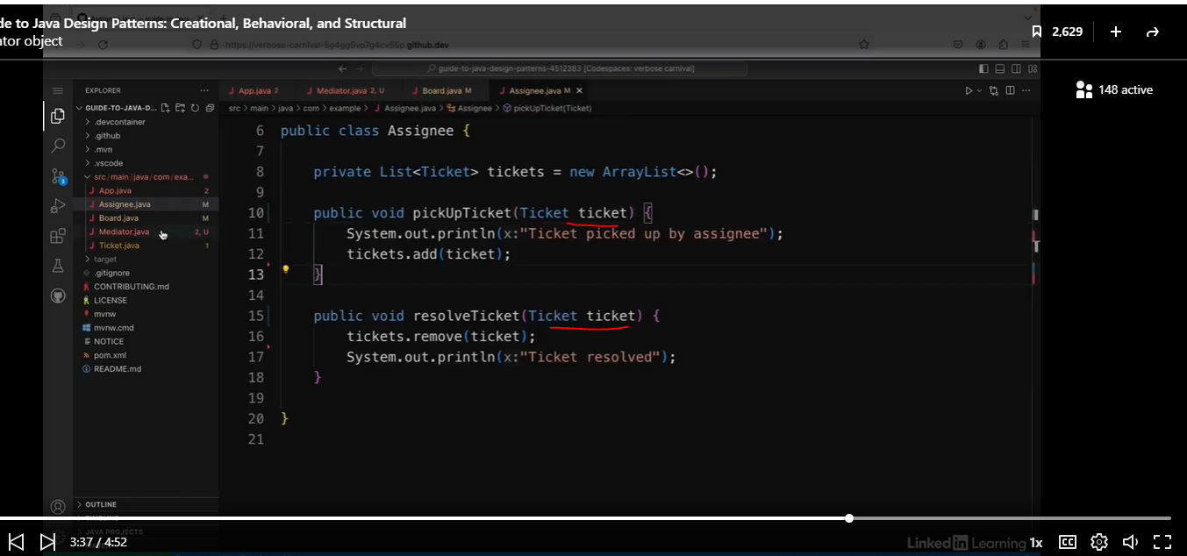

Let’s go back to our Mediator.

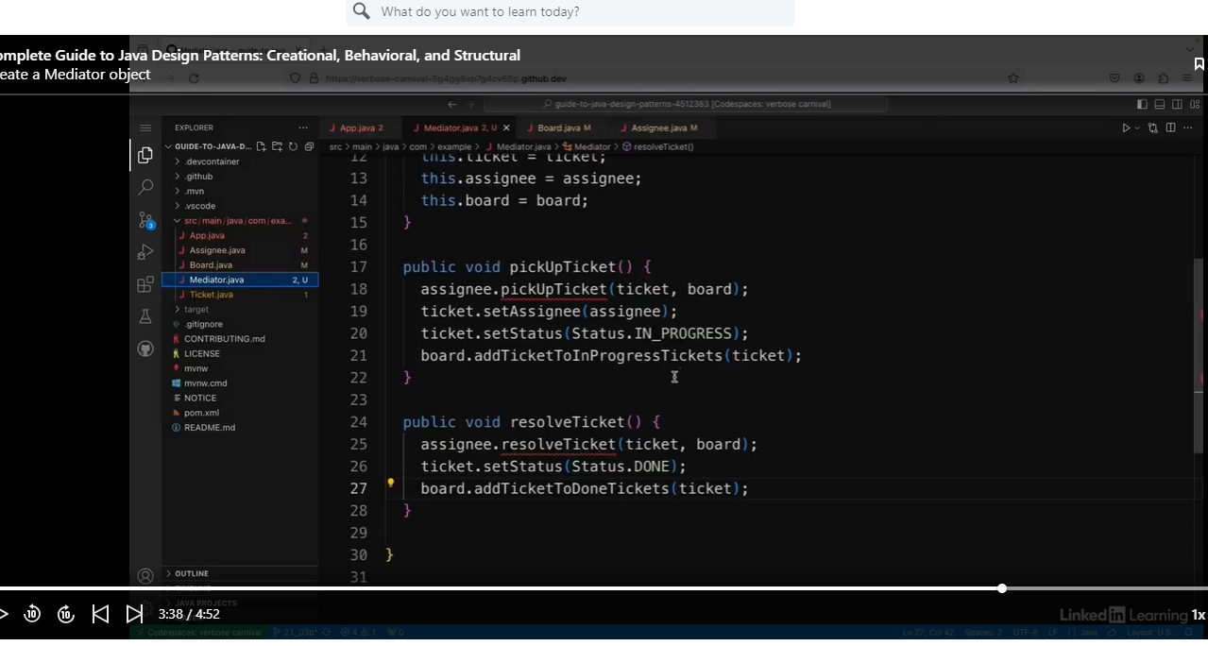

We simplified lines 18 and 25.

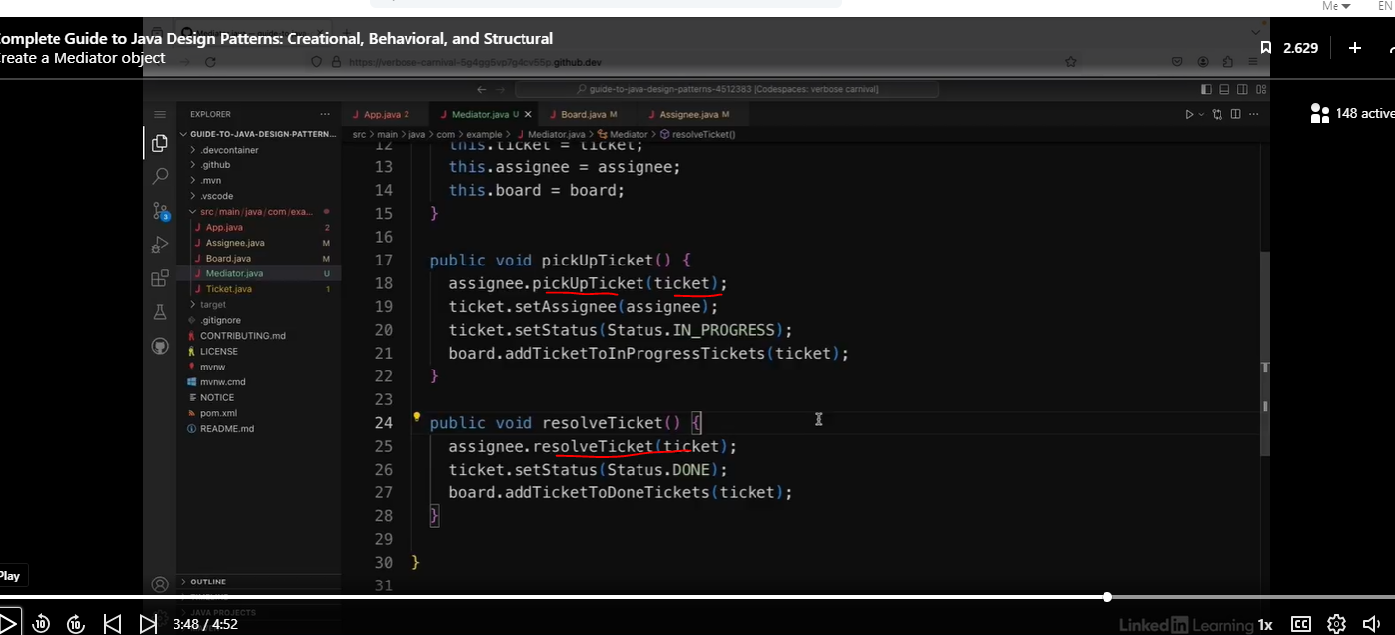

Let’s go to our client code.

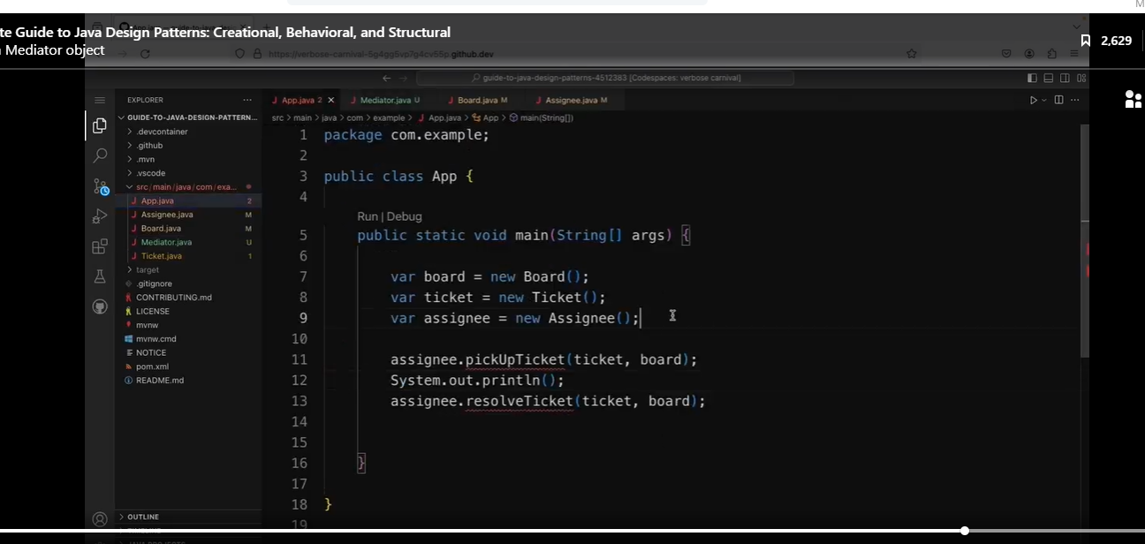

We will add the mediator variable.

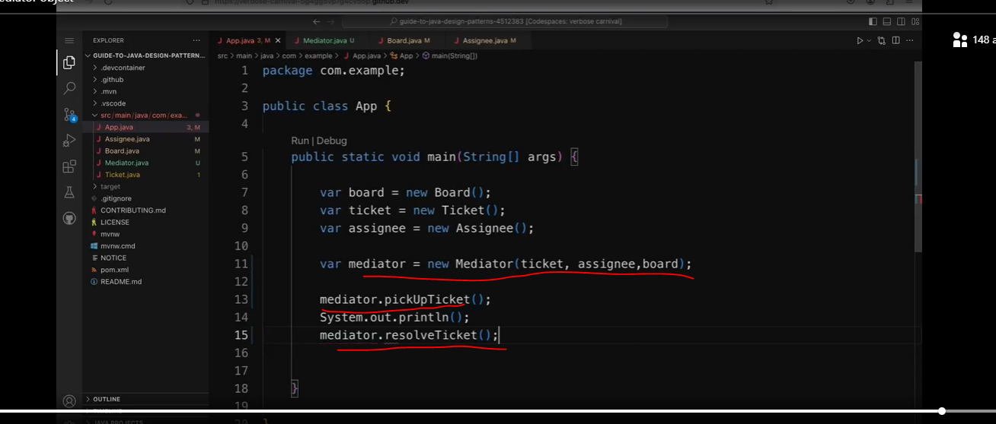

So I get the same output, but my classes are no longer tightly coupled together. All these interactions are handled by the mediator class instead.

We remove coupling by allowing the mediator to accept the three objects: board, ticket, assignee.

## The Memento Pattern

### Understanding the Memento Pattern

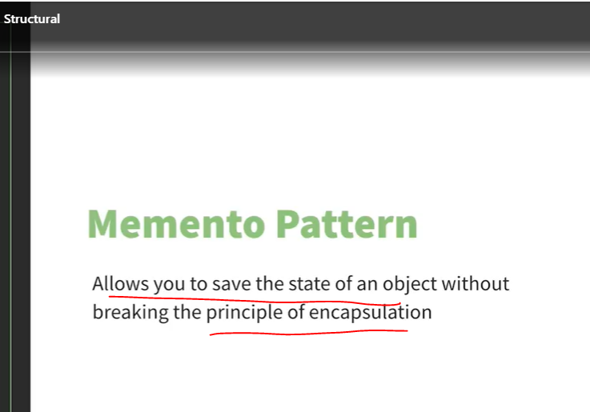

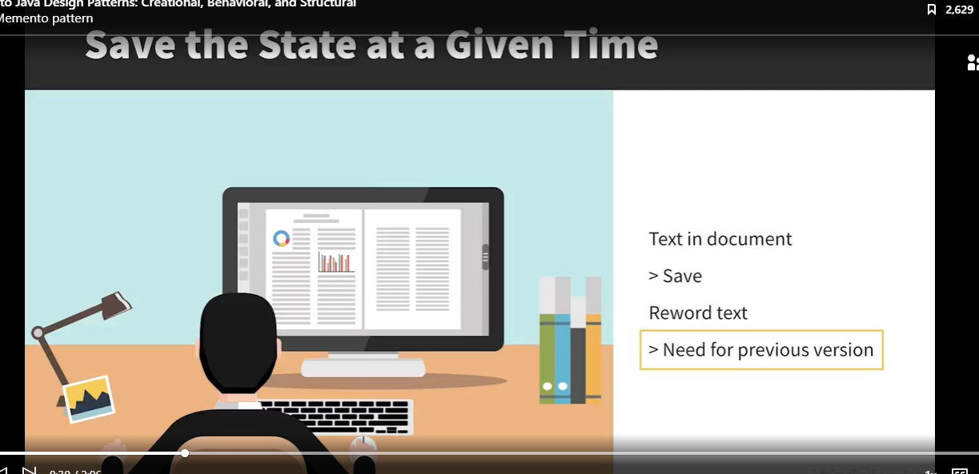

Imagine you want to create an undo operation, and to do that you need to save the state of an object. But you also don't want to break the principle of encapsulation. The Memento pattern allows you to do exactly this. There are some cases where you need to keep a record of the states of an object. For example, say you're writing in a text document and at some point you click on save and then you reword what you've written. But later you decide you want to go back to that previous version. You'd need to have a record of the state that document was in before you saved it. This is what the Memento pattern does.

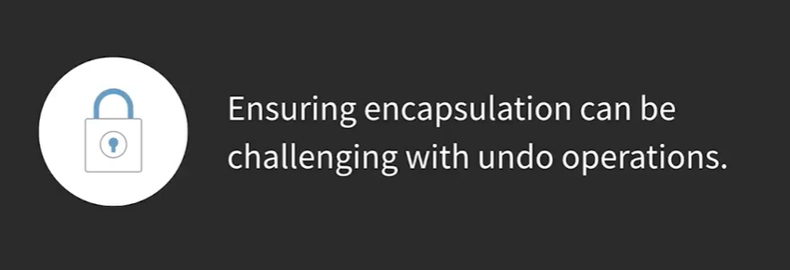

But the main challenge is how you do this without breaking encapsulation. One of the benefits of encapsulation is that it ensures objects hide their states from other objects. Classes often contain several fields that should be kept in a consistent state. So, for example, in Java, you often have private fields with public getter methods, and this is so that other objects can't interfere with the states of those private fields. If they're encapsulated, it prevents anyone else using the objects from messing with the states. Encapsulation also means you can change the underlying structure of the objects without causing breaking changes for anything else using it.

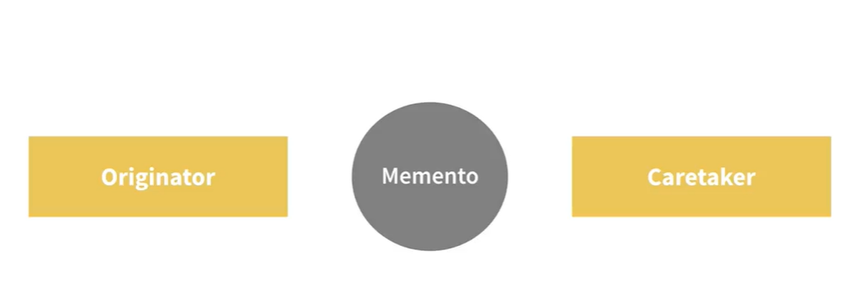

So in the Memento pattern, you create a copy of that state in a separate object. First of all, you have an object whose states are going to be changing, and this is called the originator. Then you have the object which is going to be changing it, which is called the caretaker. For example, in the document example, the document would be the originator and the person editing it would be the caretaker. The Memento object sits between these two. So the objects doing the changing has access to the memento, which provides the saved states. The implementation of the originator state is a black box. The Memento object just knows what the state was at a given time.

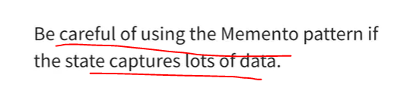

It's worth bearing in mind that if the object whose states you want to capture contains a lot of data, using the Memento pattern can result in an increase in memory usage, and this might outweigh the benefits of using it. But if the object state is fairly simple and you want to be able to save it and restore it later, the Memento pattern is a good way to do this without exposing the structure of the objects.

### Restoring and Object’s State

This is an app for displaying documents and a document viewer. I want to amend it so that I can save and undo text in the documents.

See code below:

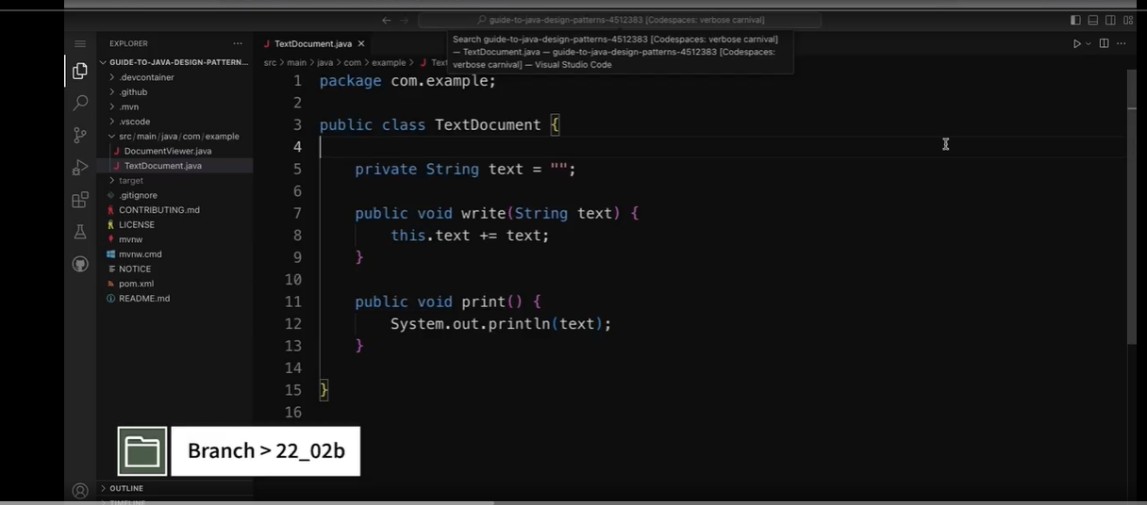

See client code below:

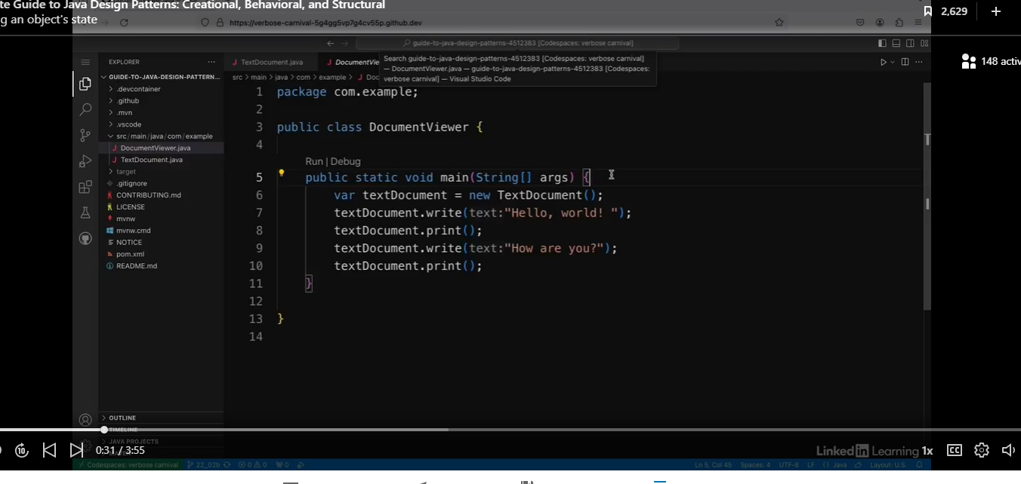

See the results.

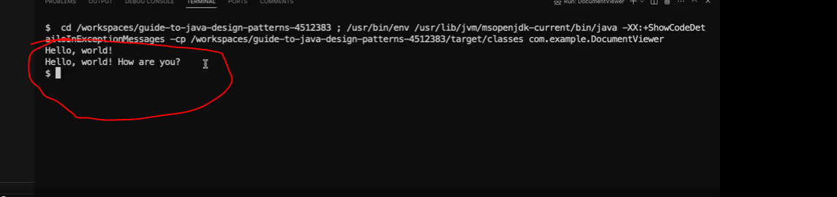

So if I run this, I can see I get "Hello, world!" and then I get "Hello, world! How are you?" Now, I want to be able to save the text document and then undo to go back to that state later. And I'm going to use the Memento pattern to do that.

See our new class below:

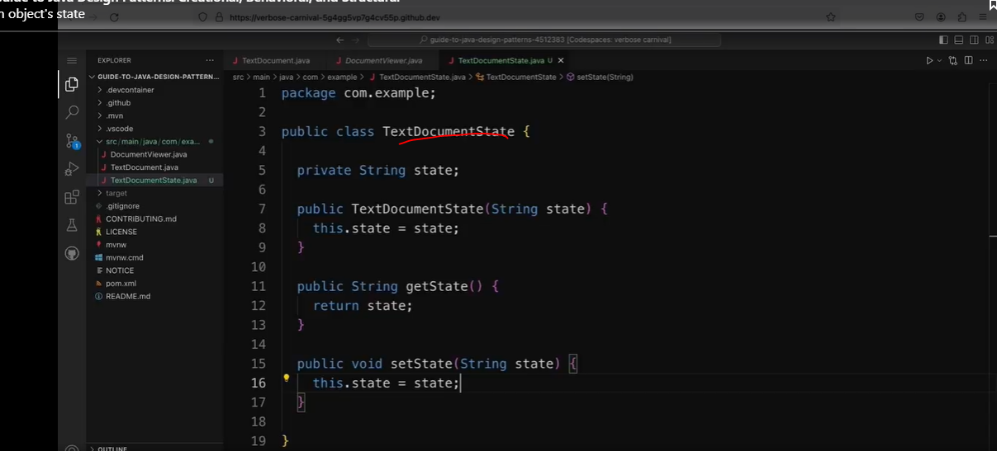

Now, I can use this Memento to implement save and undo methods in my TextDocument class.

Let’s refactor the TextDocument class.

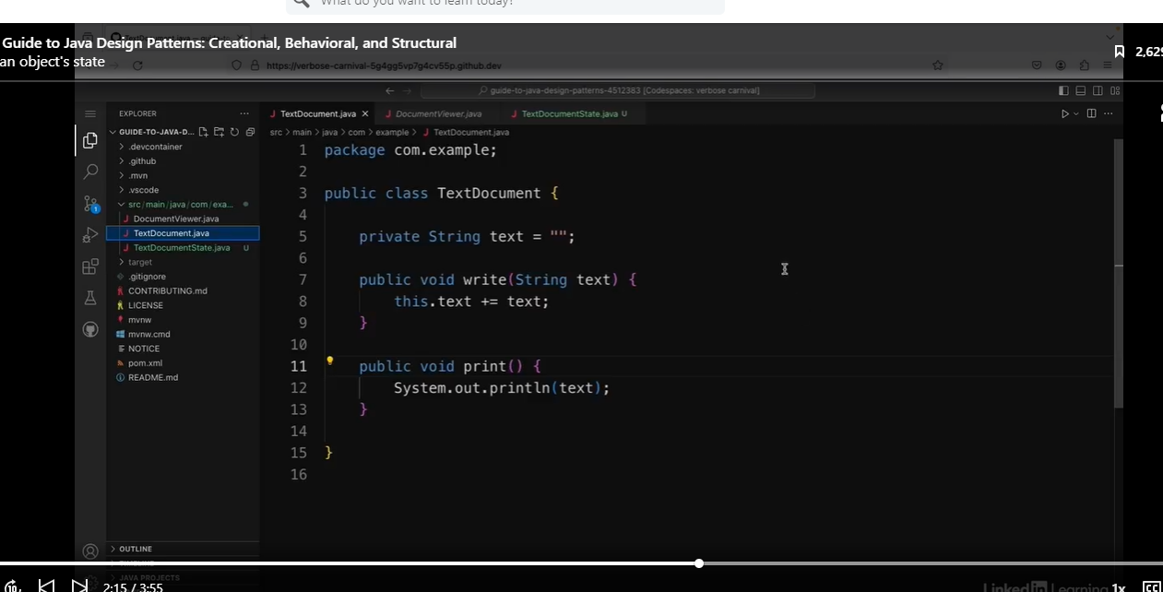

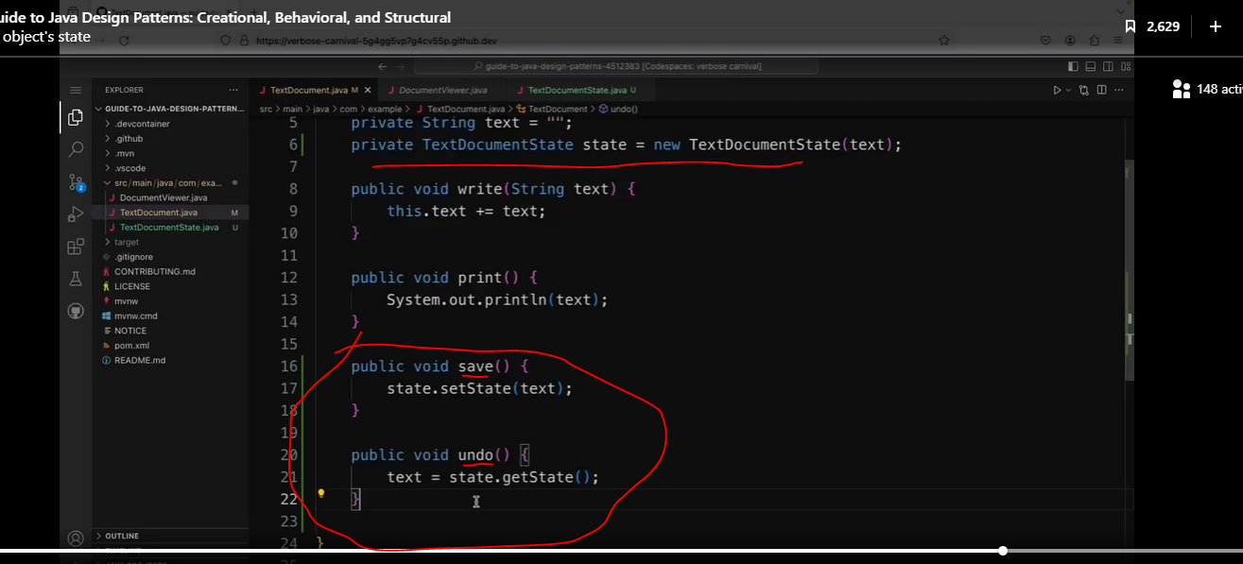

So that's going to revert the text to whatever was saved in the state object.

Let’s test this out in the client code.

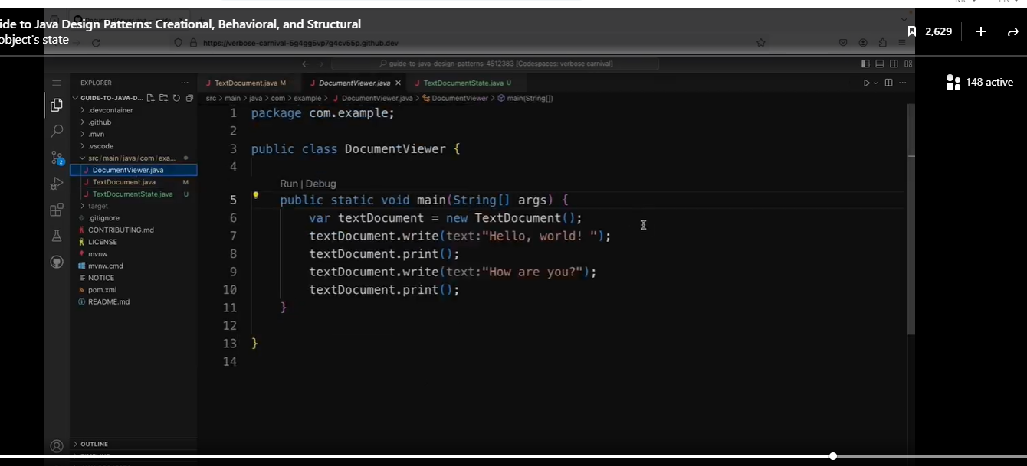

First, we will need to refactor the code.



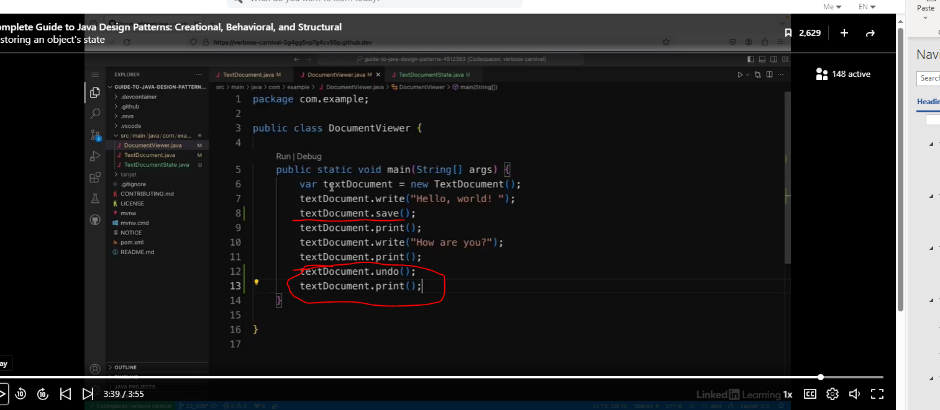

So it should remove the "How are you?" sentence because I haven't saved it and go back to just the "Hello, world!" sentence. So if I run this, I can see I get "Hello, world!" and then "Hello, world! How are you?" And then back to the previous state, which is "Hello, world!" So this is how the Memento pattern can be used to implement save and undo operations.

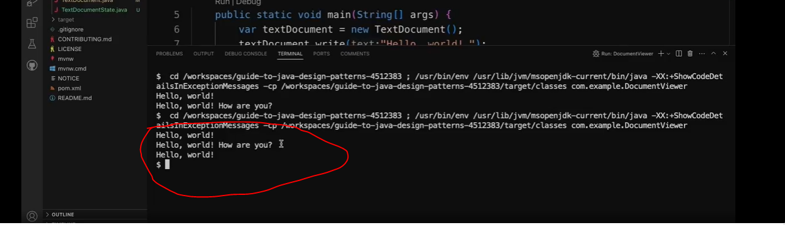

## The Observer Pattern

### Understand the Observer Pattern

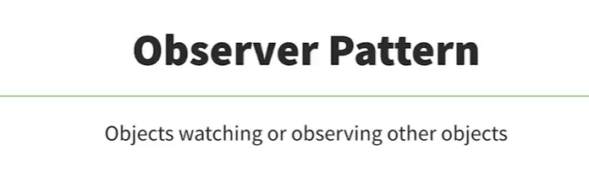

As the name of this pattern suggests, the observer pattern is all about objects watching or observing other objects. In object-oriented design, you often end up with a system broken up into lots of classes that work together. One of the challenges is making those classes interact and cooperate while avoiding tight coupling between them. The observer pattern provides a way to do this.

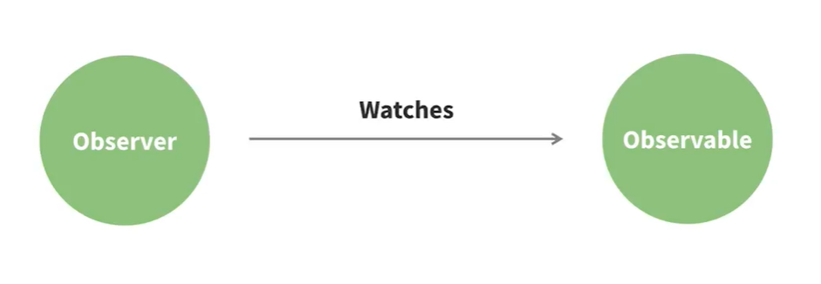

The observer pattern provides a way to do this. You have an object that's being watched called the subject or the observable, and then you have the observers which watch the objects.

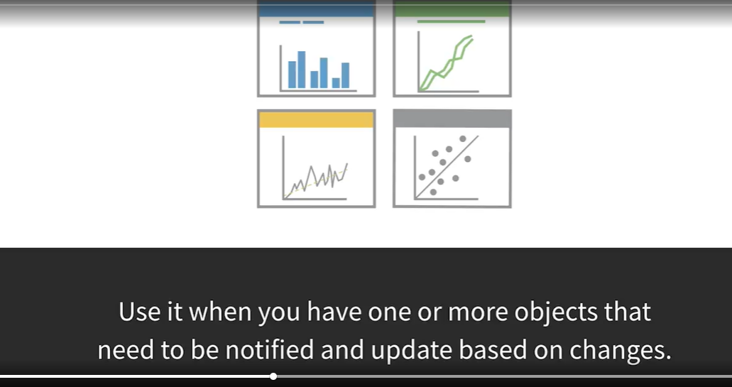

As a real-life example, think about social media sites where you're connected to people or follow people. If you post something, rather than sitting and watching to see if anyone comments, you'll receive a notification if someone does. In this example, the post is the observable and you are the observer.

#### Interesting Fact: Deprication

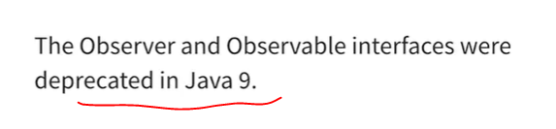

They longer recommended for use. One of the problems was that they could be used to tell you that something had changed, but they didn't give you any details about what had changed. Another option is to implement these interfaces yourself, or you can use the property change listener and property change support classes, which is what I'll be using in my example.

### Implementing an Observer

See the code below:

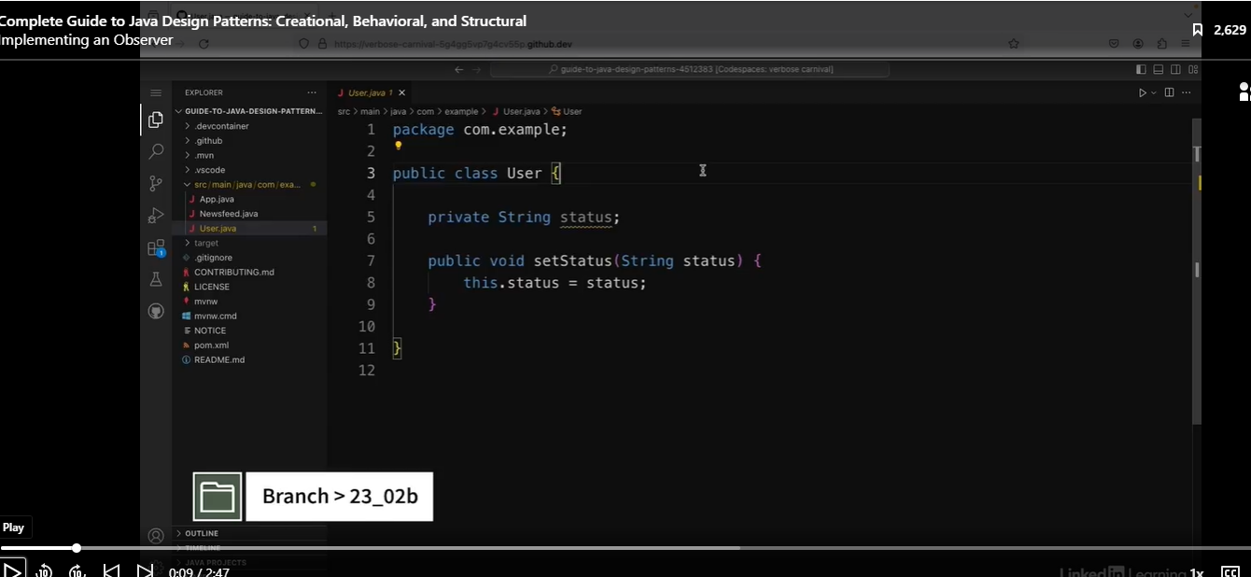

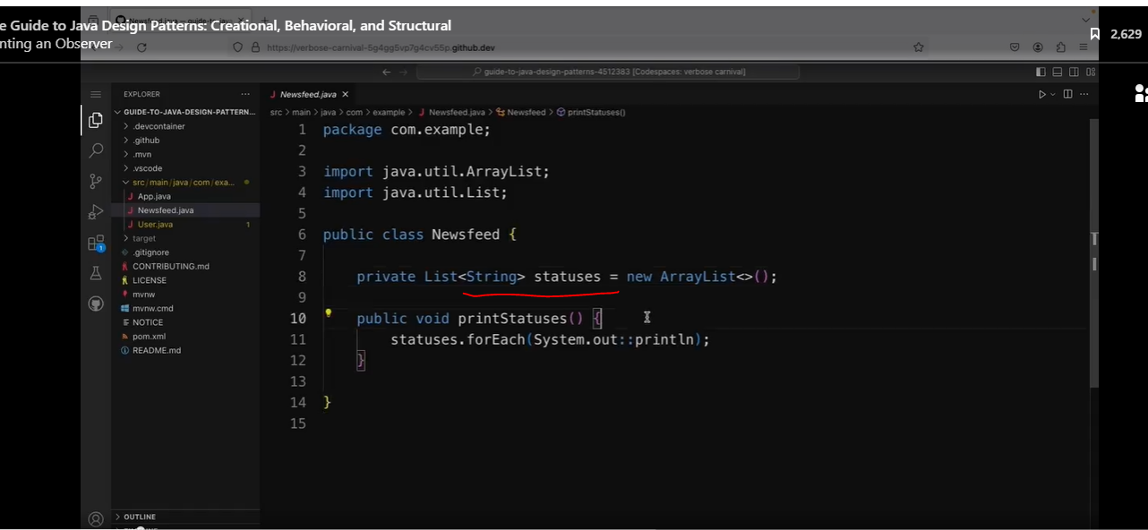

See client below:

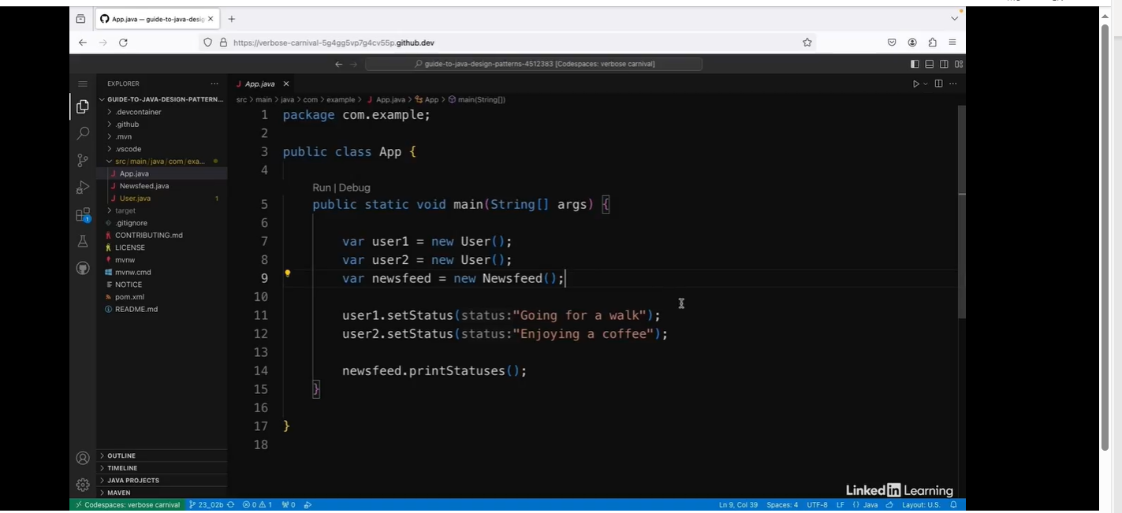

At the moment, this won't actually do anything because the User and Newsfeed classes are just separate classes with no link to each other. So if I run this, I don't get any output in the console. But I want the feed to update when a user updates their status. I could maintain a list of users inside the Newsfeed class, but that would make the classes tightly coupled. If I change the implementation of the User class, I might have to go back and change something in the Newsfeed class as well. So I'm going to use the observer pattern.

And to do this, I'm going to make use of the PropertyChangeListener and PropertyChangeSupport classes which come as part of the JDK.

In this example, the user is the observable and the newsfeed is the observer. So let's start with the observer, which is the Newfeed class.

Let’s refactor the code below:

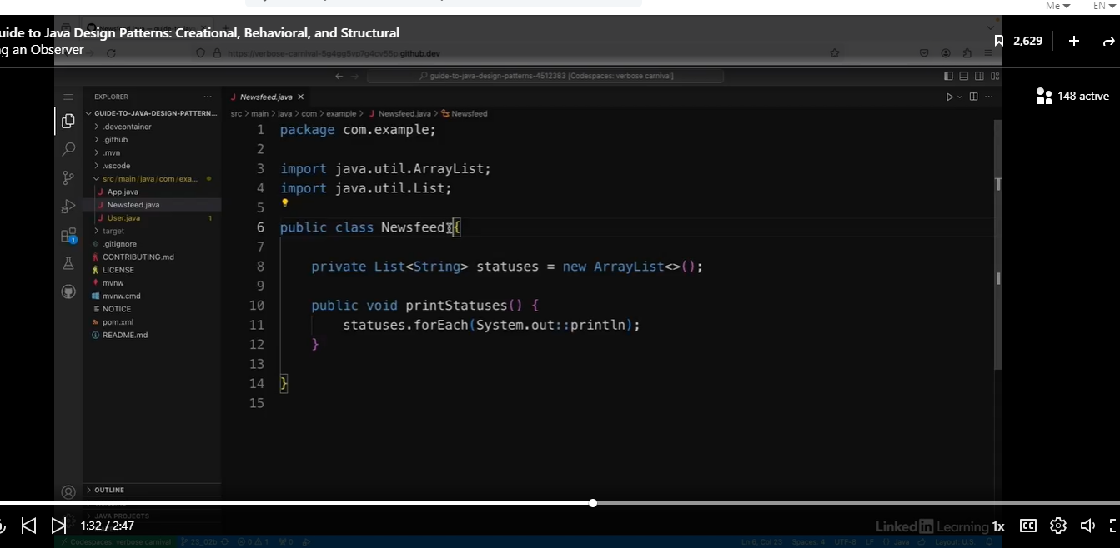

Yuck! Casting.

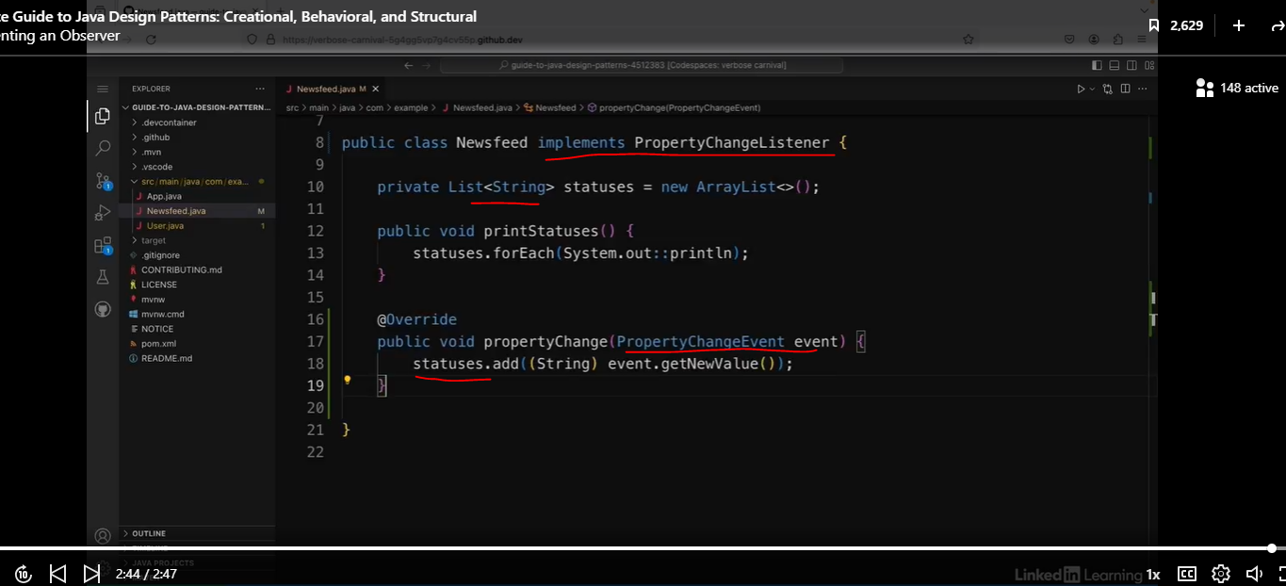

### Implementing the Observable

See code below:

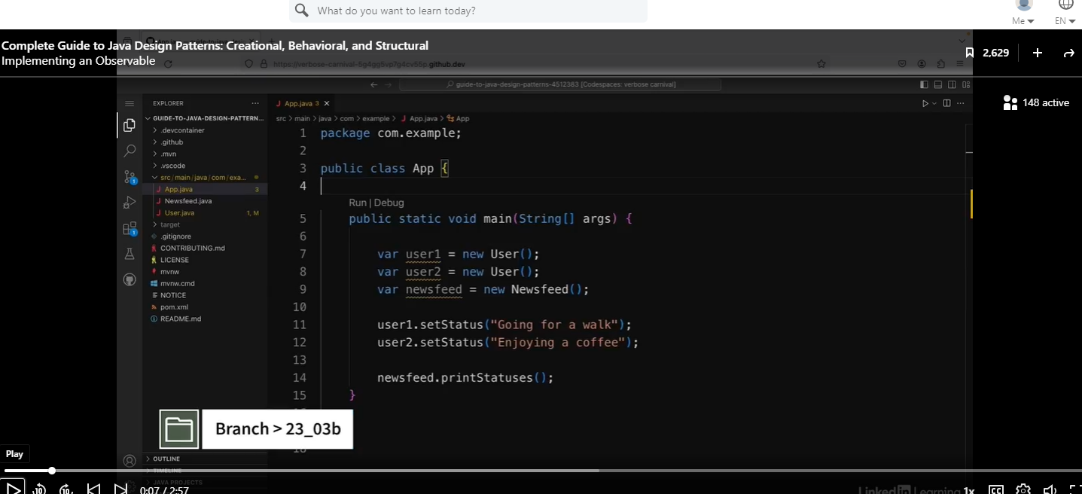

Now, I've made the newsfeed in my social media app into an observer. So the next step is to implement an observable for it to watch. In this example, the observable is the User class. So I'm going to open up that class.

Let’s refactor the code below:

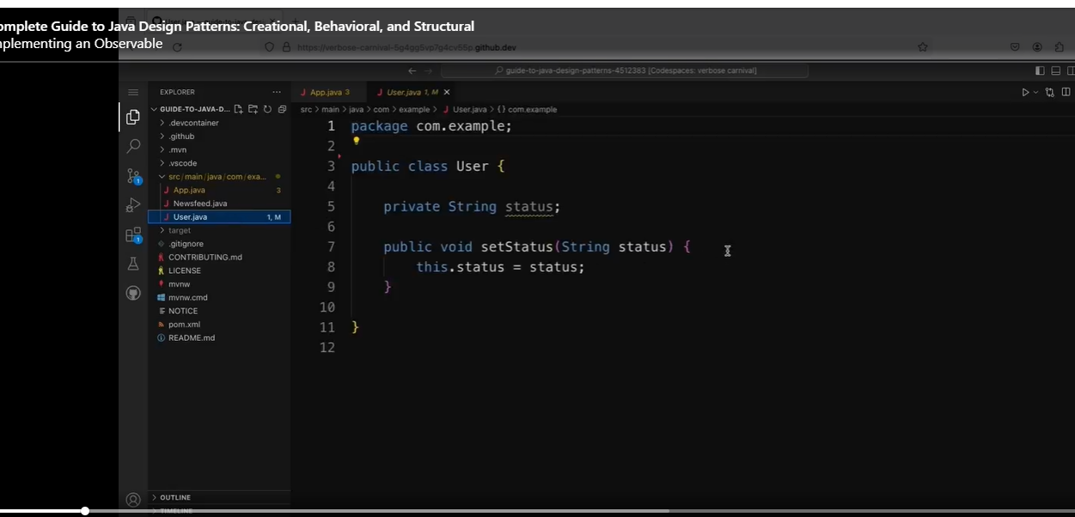

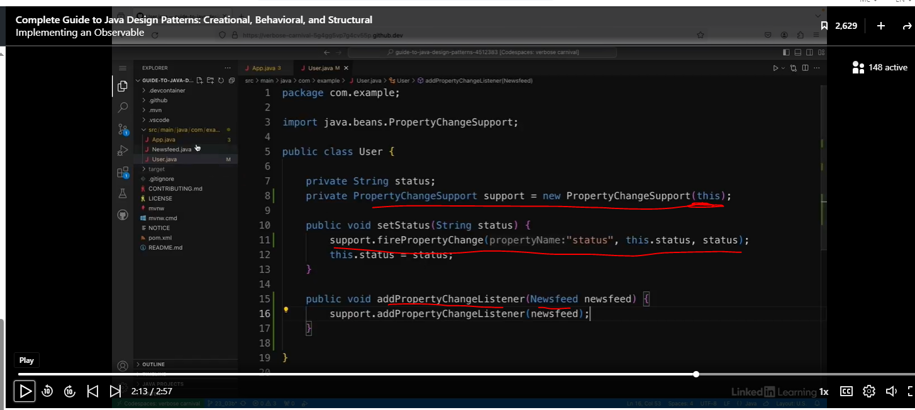

And the first thing I'm going to do is I'm going to add a new fields of type PropertyChangeSupport. So underneath the status field, I'm going to say private PropertyChangeSupport, and I'll call it support. Then I'm going to say equals new PropertyChangeSupport, and I'm going to pass in this. This PropertyChangeSupport is going to notify the observer when a property in this class changes. Now, I need to edit this setStatus method. In this method, I'm passing in a string and setting the status field to that value. I also want to let the observer know that the field has changed, so I need to add a line at the start of the method. And I'm going to say support.firePropertyChange. I need to pass in three arguments to this method. The first one is a string, which is the name of the property that has changed. So I'm going to pass in the string status. In my example, I'm going to be listening for all properties, but sometimes you might want to listen only for specific ones, which is why I need to pass in the name of the property here. The second argument is the old value. So I'm going to pass in this.status because I haven't updated it yet. And the third argument is the new value that it's changing to. So I'm going to pass in the status object. If the old and new values are the same, this method will do nothing. But if they're different, it will notify the observer that the status has changed. The last thing I need to do in this class is I need to create a method to add a listener so that observers can listen for changes. So at the bottom, I'm going to say public void addPropertyChangeListener. My Newsfeed class already implements the PropertyChangeListener class. So that's what I'm going to be parsing into this method. So in the brackets, I'm going to say Newsfeed newsfeed. And inside this method, I'm going to say support.addPropertyChangeListener and I'm going to pass in the newsfeed object.

Refactor the Client Code

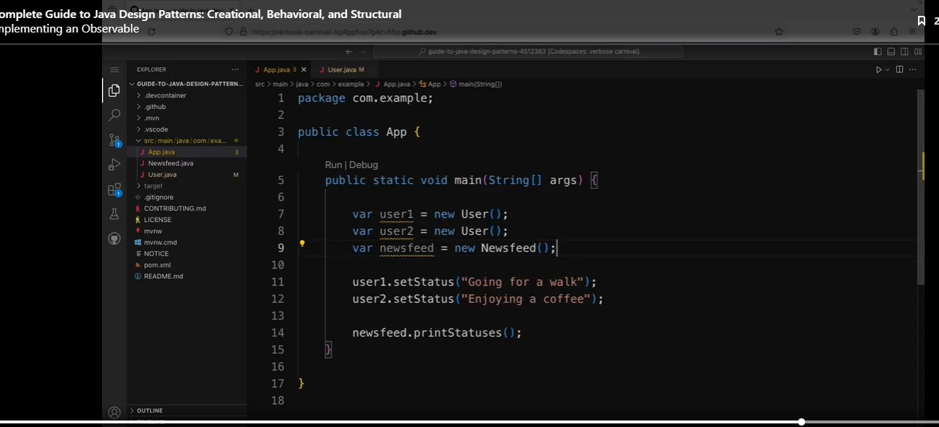

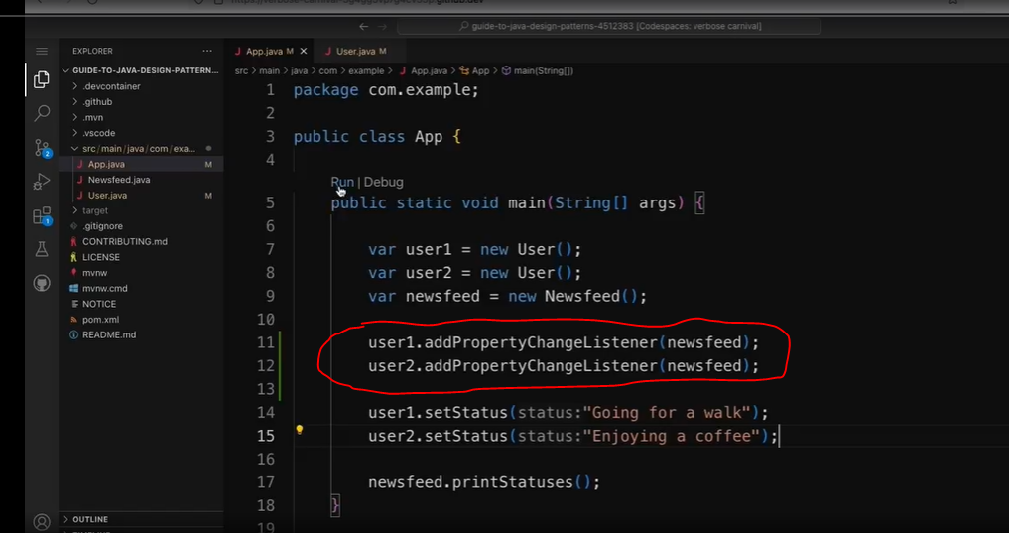

See results below:

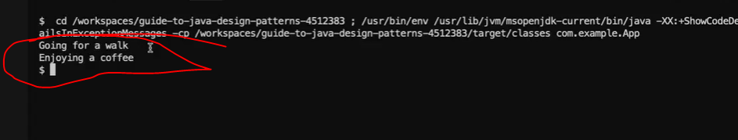

So if I run that up, I can see it says "Going for a walk" and "Enjoying a coffee" which is user1 status and then user2 status. So this is how you can use the observer pattern to watch for changes in other objects without coupling them together.

## The State Pattern

### Understanding the State Pattern

Sometimes you'll have an object that needs to behave differently depending on its internal state. The state pattern allows the object to alter its behavior when its state changes.

The media player.



Imagine a play or pause button on a media player. If someone clicks the play button, what happens will depend on the state of the media player. For example, it could be already playing or paused or rewinding, and so on.



For example, it could be already playing or paused or rewinding, and so on. If you write a media player in Java, you might end up with loads of if statements about the state of the player. For example, you check if it was playing and then have the code to handle that scenario, and then you check if it was paused and then have some code to handle that scenario, and so on. This can get quite lengthy and complex.

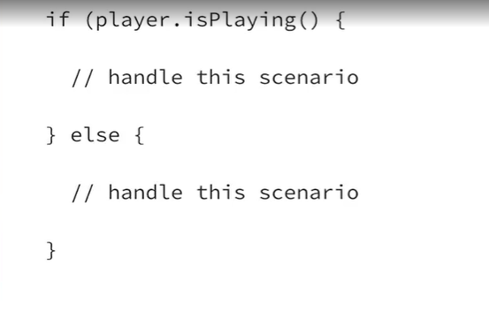

You'd also need these long if statements at every method you created. So in the pause method and the rewind method and so on, as well as the play method.

#### State Pattern Solution

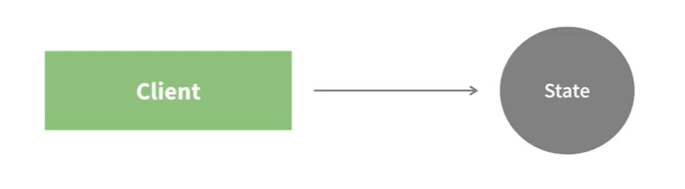

The state pattern provides a better solution to this problem. The state is separated out as a separate objects from the clients. Usually there's an interface for the state and then concrete implementations for each different states.

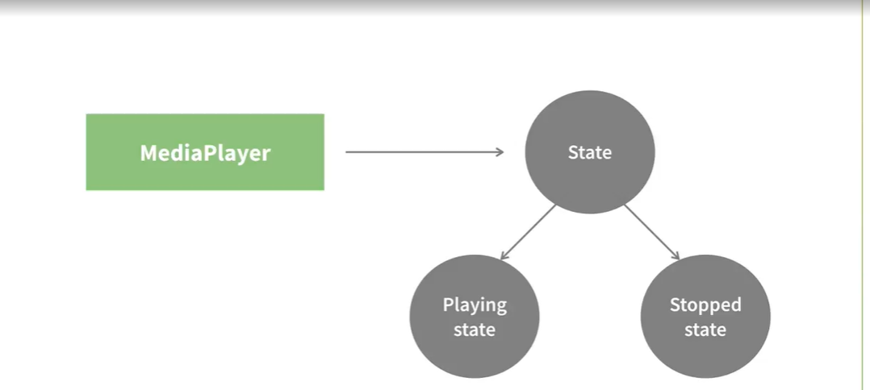

So for example, in the media player example, the media player itself would be the client. And then there would be a concrete implementation of states for playing and stopped and so on. Any of the operations performed by the clients that depend on the state of its are handled by these concrete implementations of the state interface.

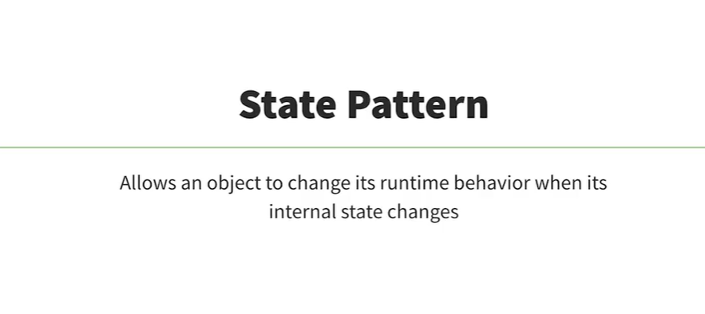

So the state pattern is a way of avoiding huge if else blocks or switch statements. And in this way, it can help simplify the code. The state pattern allows an object to change its runtime behavior when its internal state changes.

### Avoiding multiple if-else statements

See the code below:

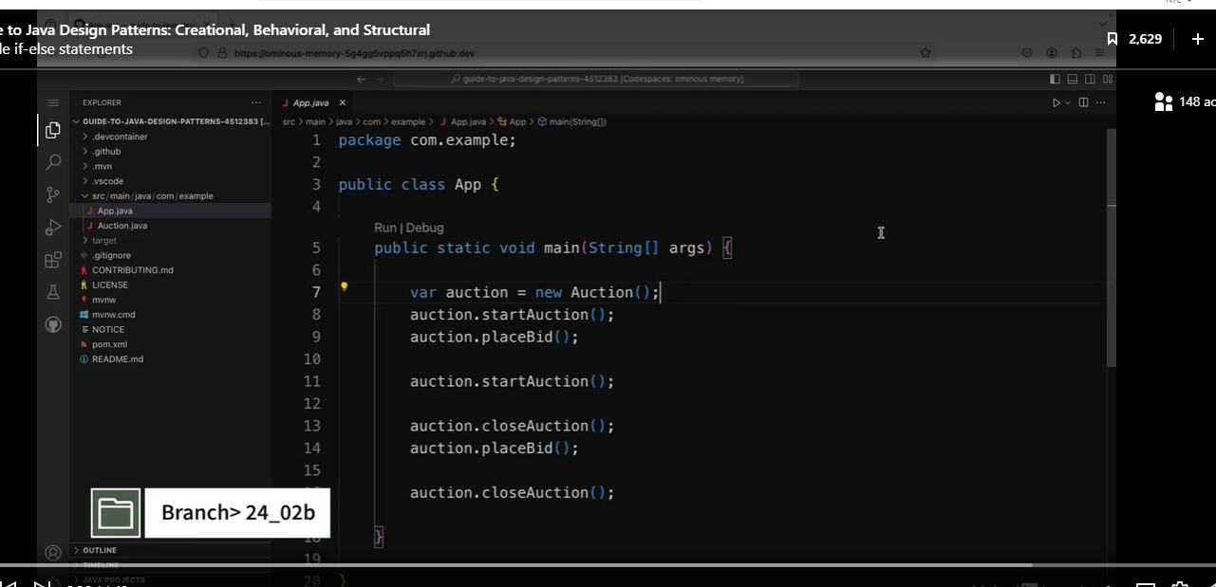

See the results below:

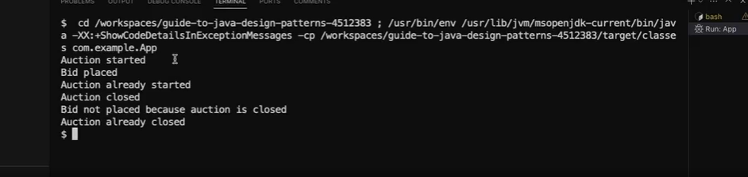

Let’s look at the Auction class.

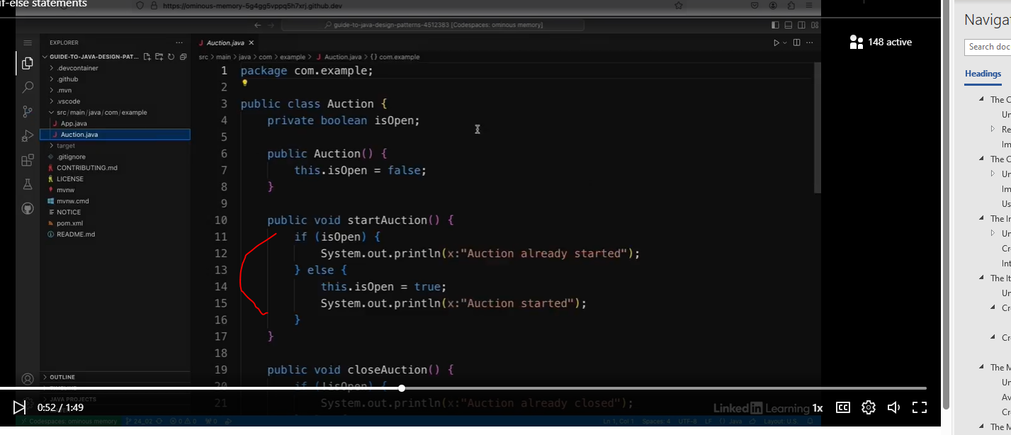

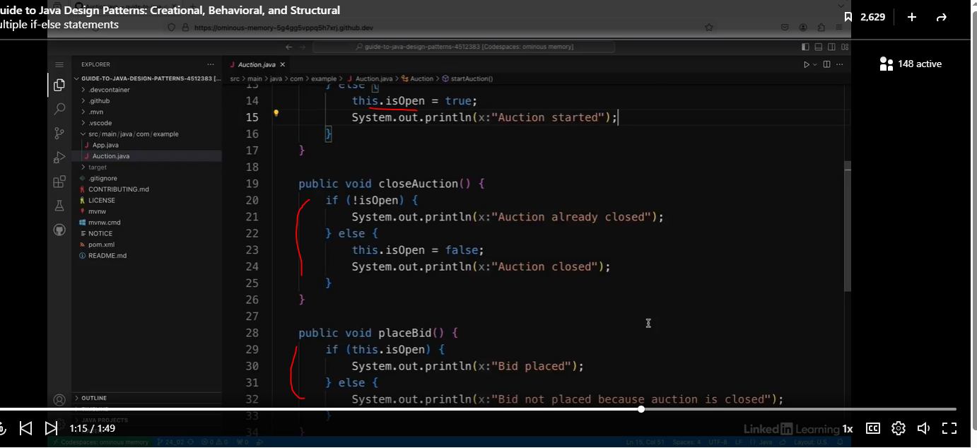

A common theme in all of these methods is that I have to check if the auction is open and implement different logic depending on that boolean. It's a bit repetitive having to have lots of if else statements everywhere, and if I want to add more states later on, then this is going to get a bit more complex.

So this is a good candidate for using the state pattern, where the state is separated out into a separate object.

### Allowing an object to change its behavior

Let’s refactor the code below:

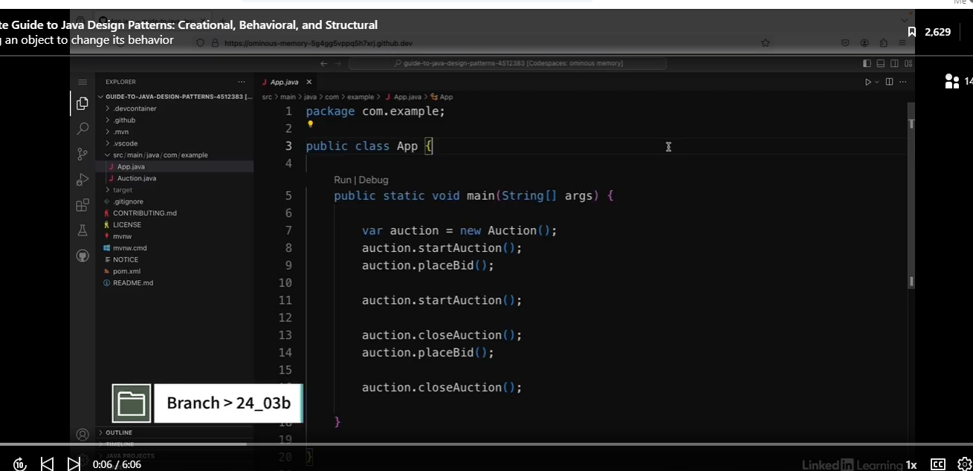

First, create a new interface called AuctionState.

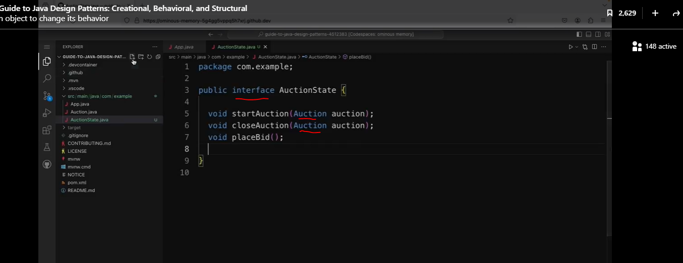

Let’s create an implementation of that interface.

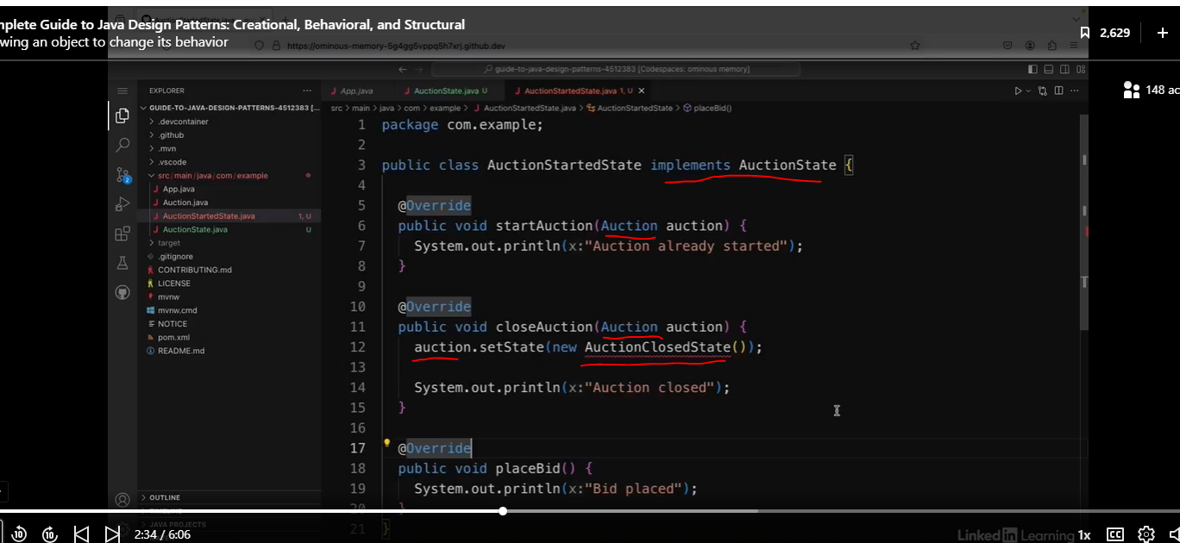

To resolve the compiler error above, we will need to create the AuctionClosedState class.

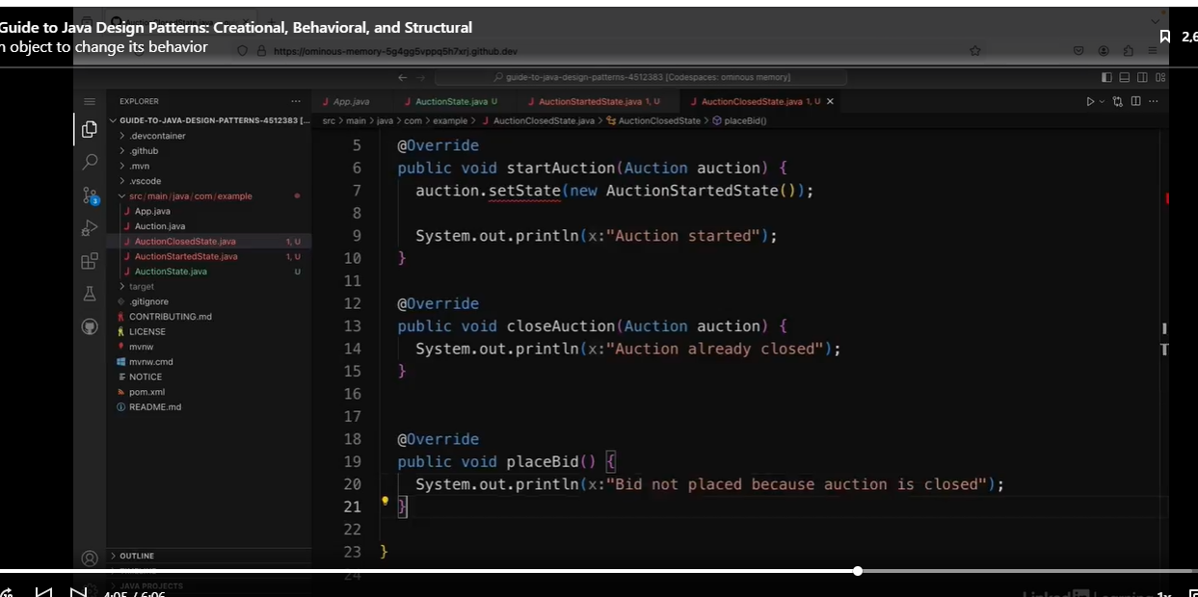

Now the fun part, let’s refactor the Auction class.

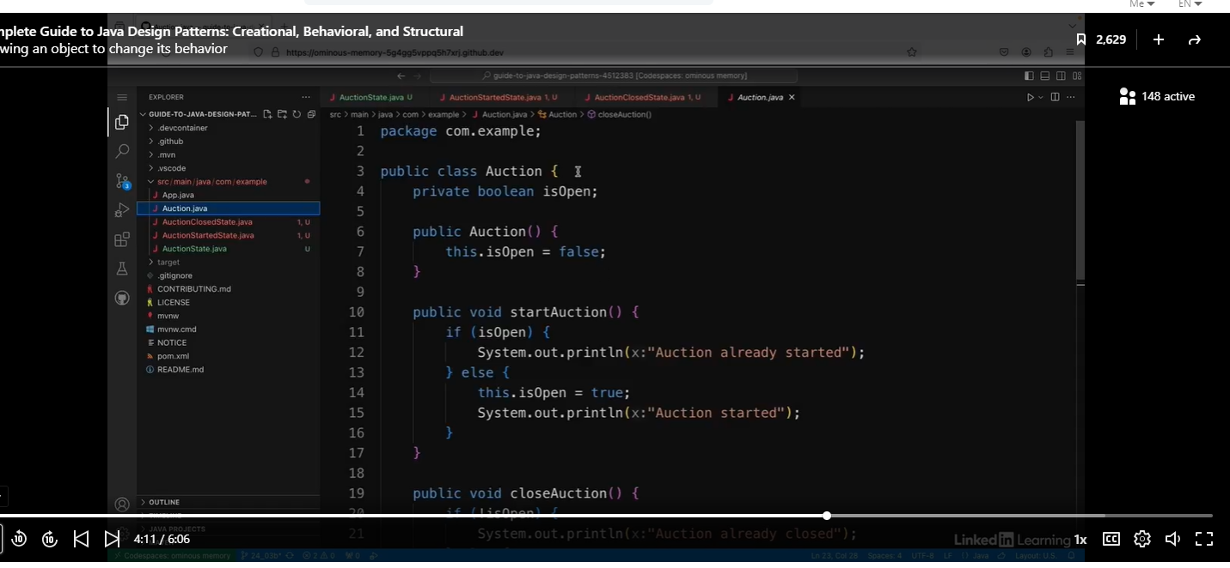

First, we make some changes at the top.

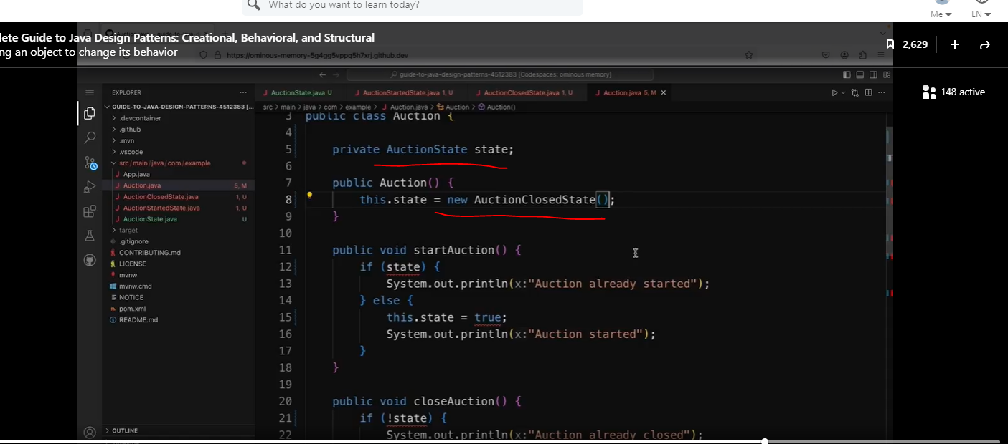

Notice the methods below are much cleaner and easier to read.

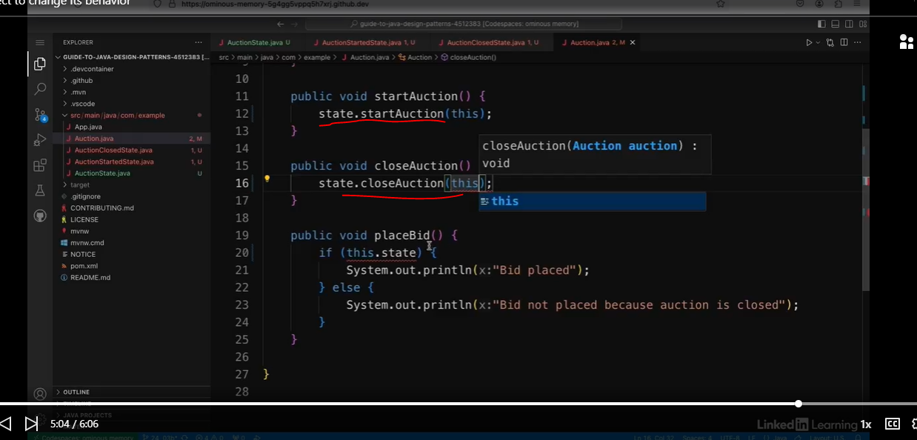

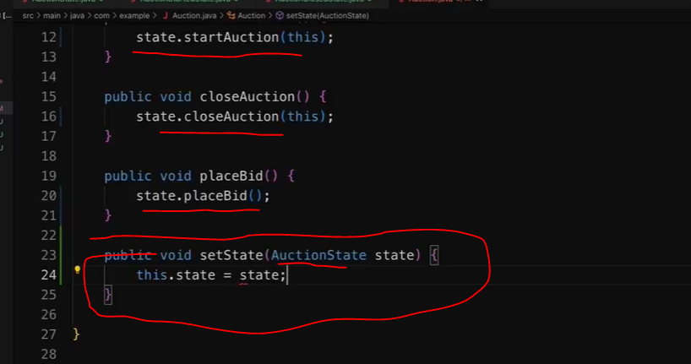

The nice thing is we did not need to make changes to the client code.

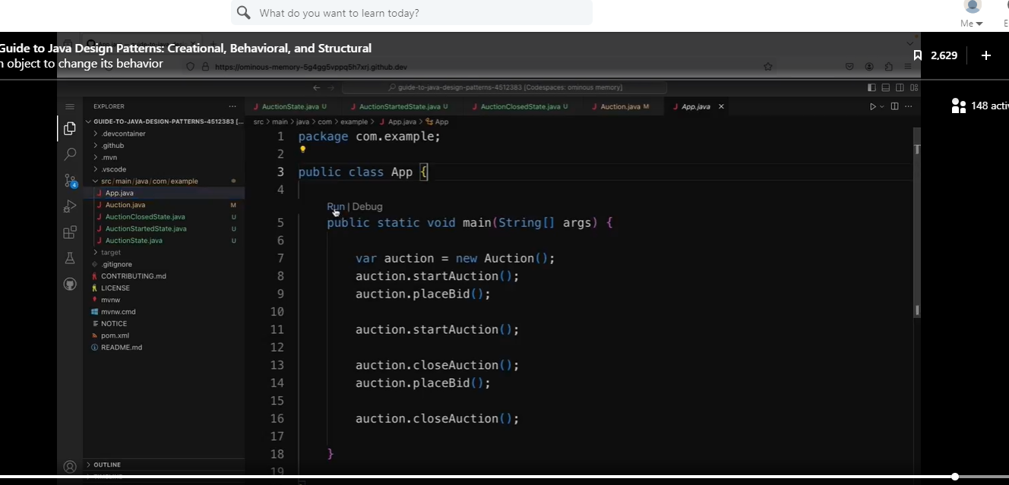

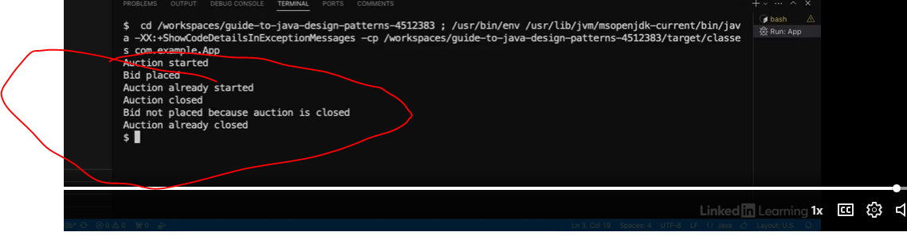

So now if I wanted to add a new state in the future, I would just need to add another implementation of the auctionState interface. So this is how the state pattern can let you change the behavior of an object when its external state changes.

The one thing I don’t like about the code above is that a lot of the code does not use the method parameters.

## The Strategy Pattern

### Understanding the Strategy Pattern

In the strategy pattern, the word strategy usually refers to an algorithm. When you use this pattern, you define a family of algorithms and make them interchangeable.

#### Use Cases

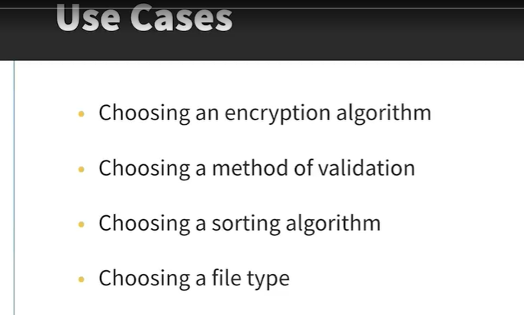

This design pattern is very common and relatively simple.

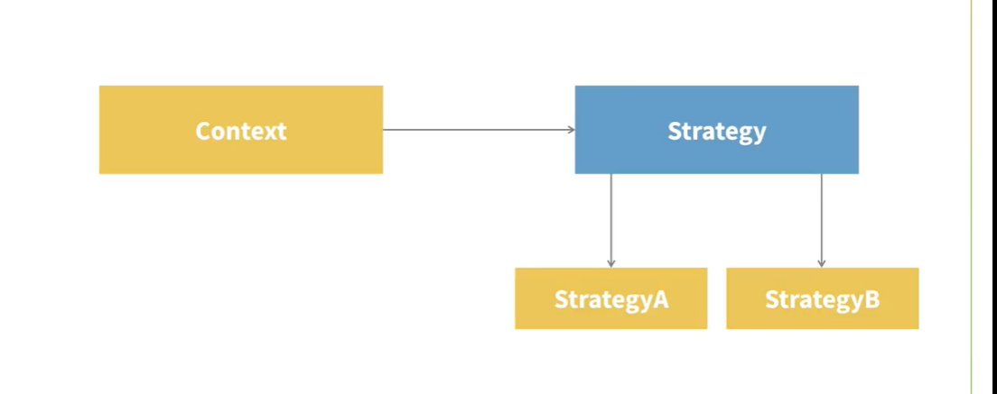

Note, the diagram above looks very similar to the state pattern.

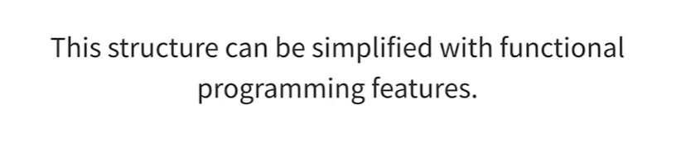

With the use of functional programming features that were introduced in Java 8, such as lambdas and static methods in functional interfaces, we can actually remove the need for the concrete implementations of the interface altogether. I'll be demonstrating how this works in my examples.

### Implement the Strategy Pattern

See code below:

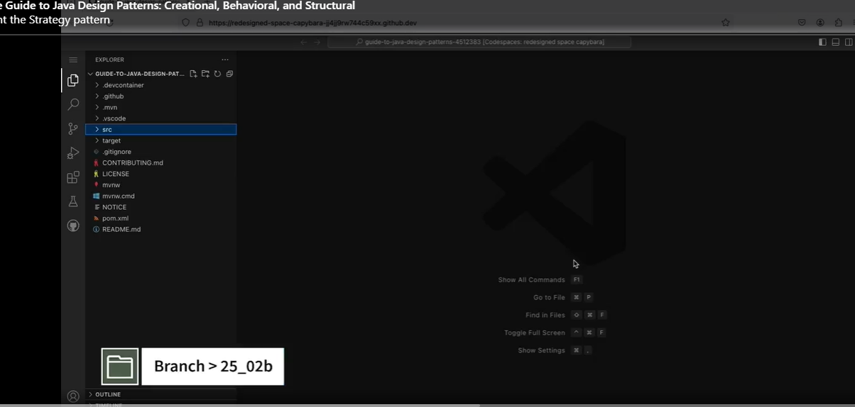

Let’s create the interface.

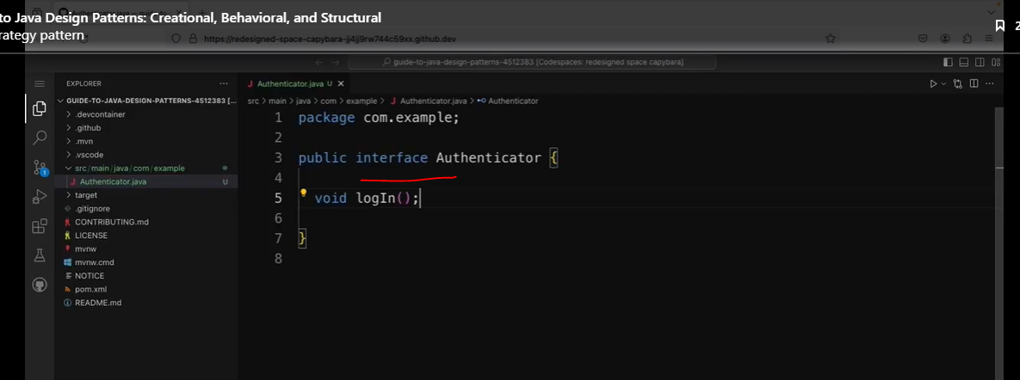

Let’s create some concrete strategies.

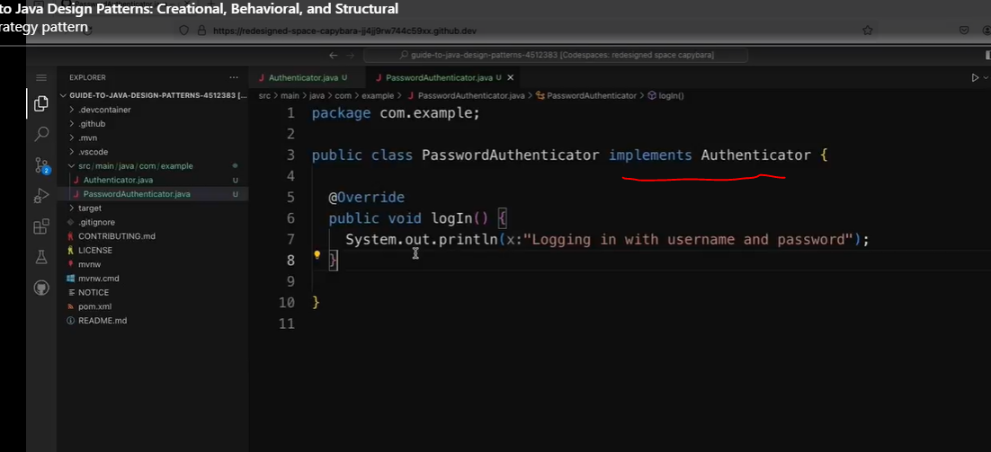

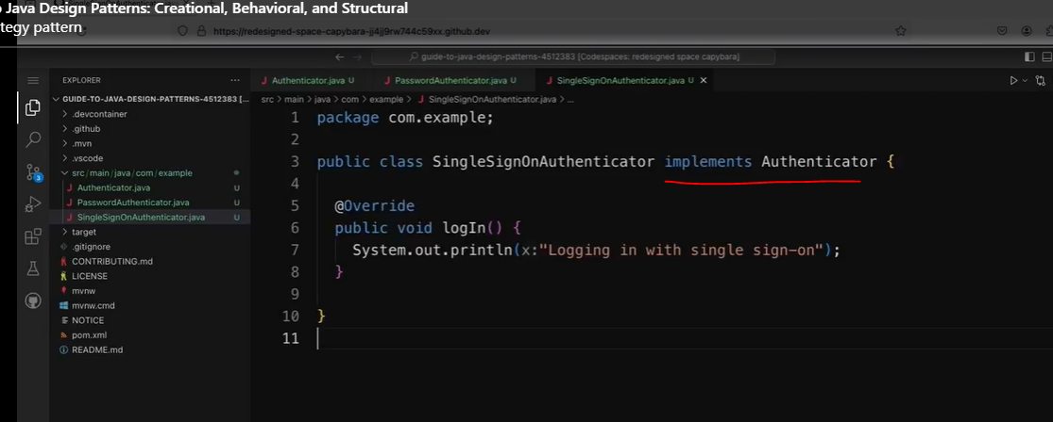

Let’s create the LoginPage class that uses the strategies.

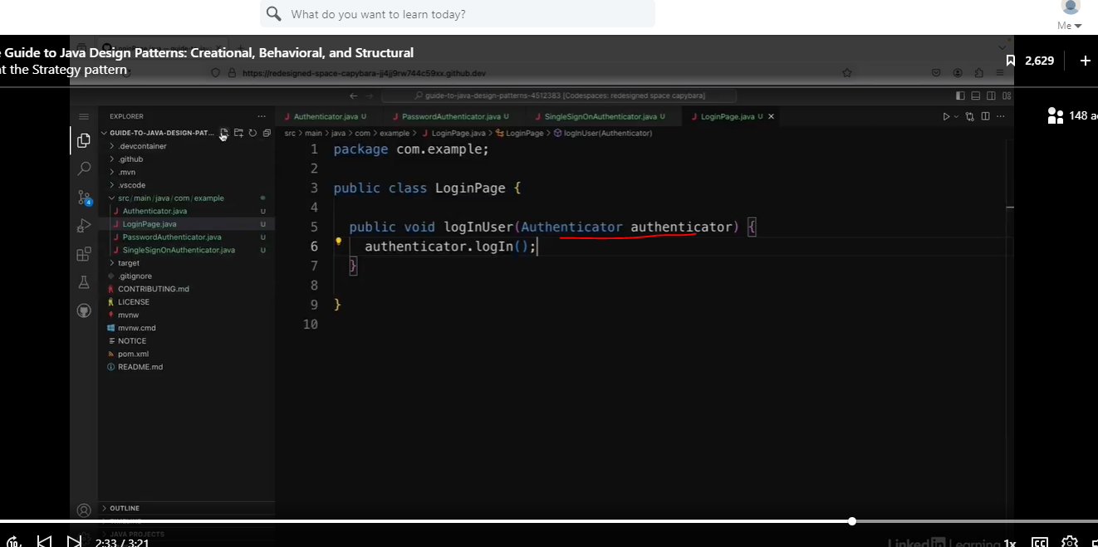

Now let’s create the client code.

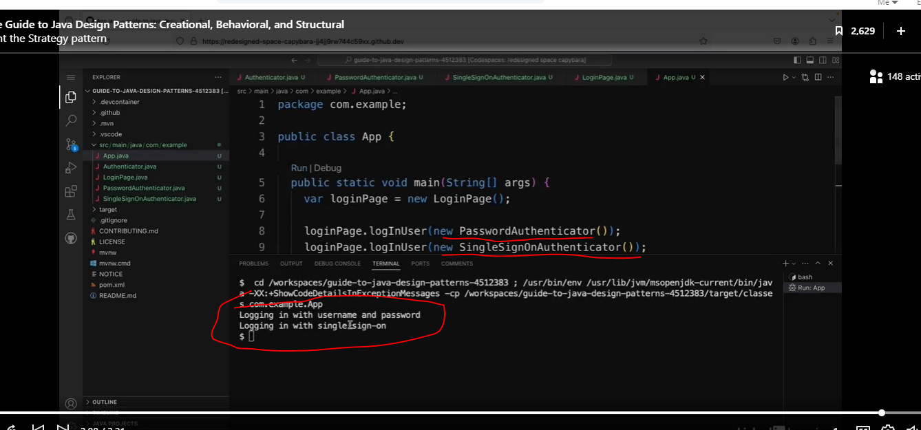

Note, I like passing in the strategies in the constructor.

So there are now different strategies that the user can use to log in, and the login page doesn't need to know about the different implementations.

### Improve the Strategy Pattern

See the code below:

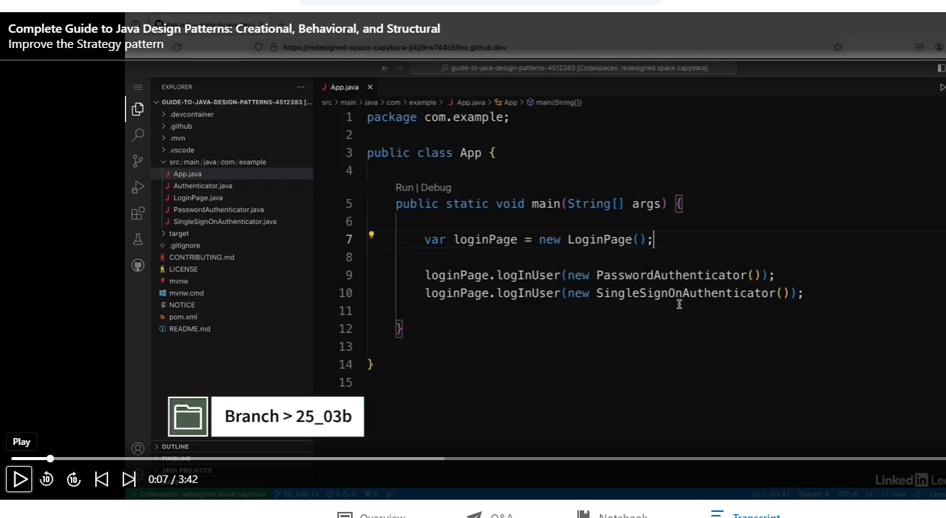

Let’s look at the Authenticator.

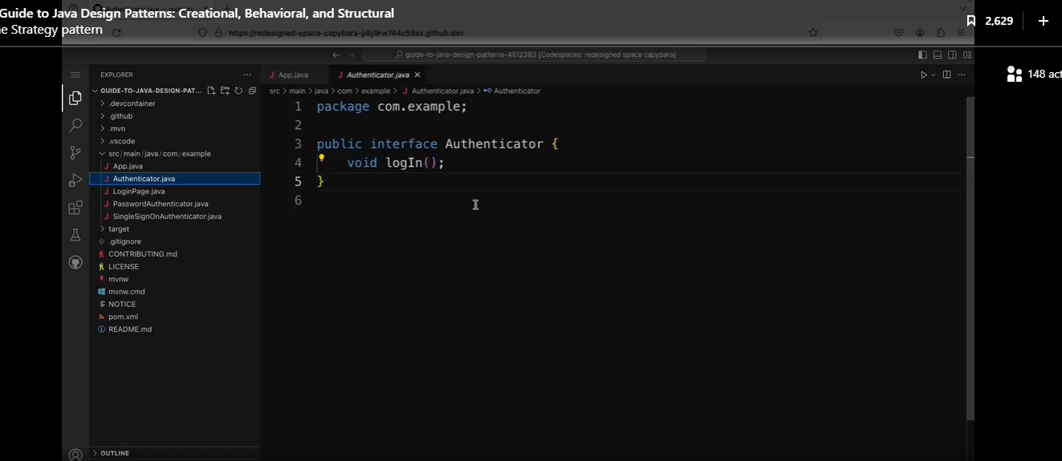

I've now implemented an app that lets users log in using two different strategies, with username and password or with single sign-on. I can actually remove a lot of the code I have by making use of functional programming features in Java. If I look at the authenticator interface, I can see that this only defines a single method, and that means that I could actually make use of lambdas instead of creating concrete implementations.

Let’s refactor the code below:

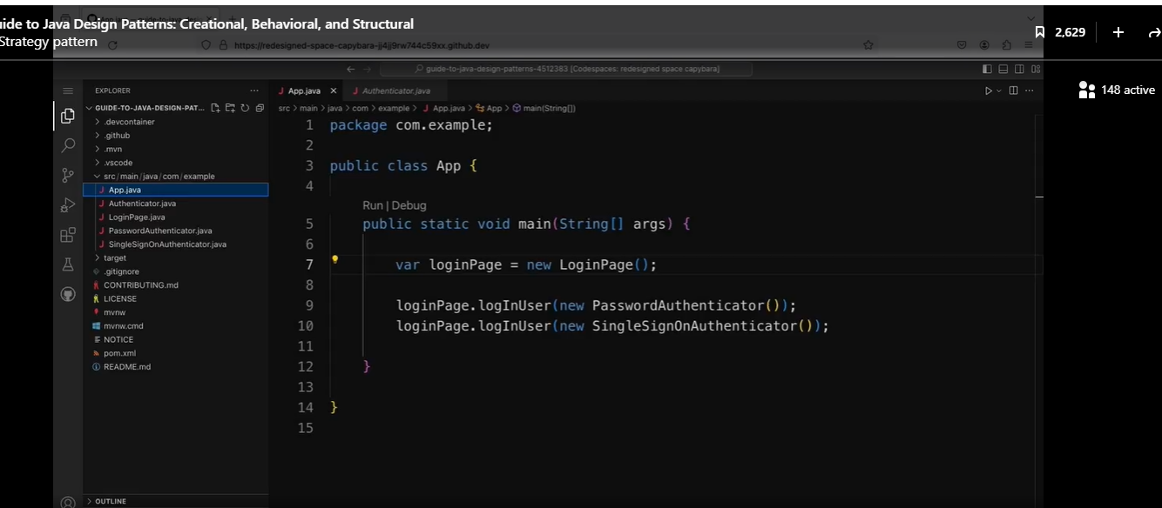

We passed in a lambda instead of the concrete implementation. Since the Authenticator interface only has one method, it is a SAM, and we can take advantage of lambdas.

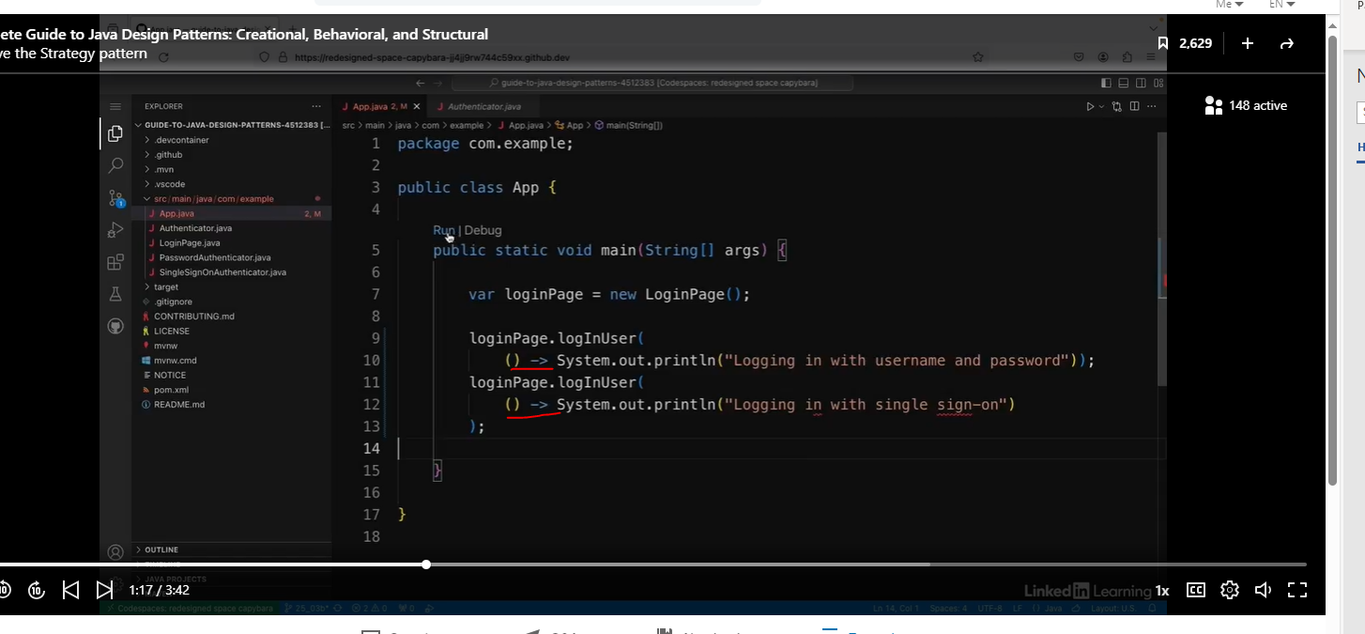

We get the same output.

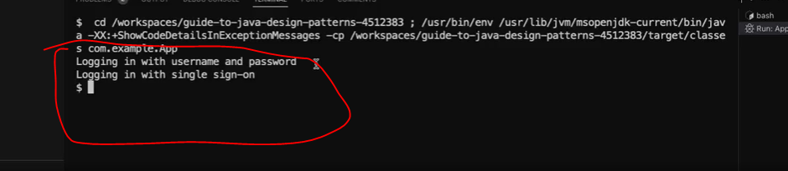

Another option I have is making use of static methods in interfaces.

Let’s go back to Authenticator interface.

Note, we just added two lambda variables. I can’t remember, but I believe variables in interfaces are static by default.

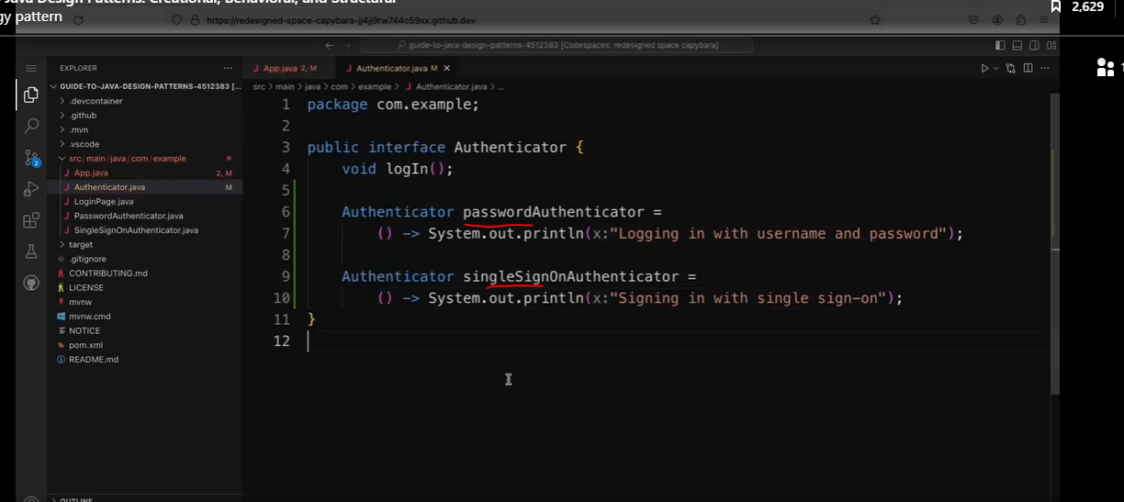

Now let’s refactor the App class.

This code is very easy to read.

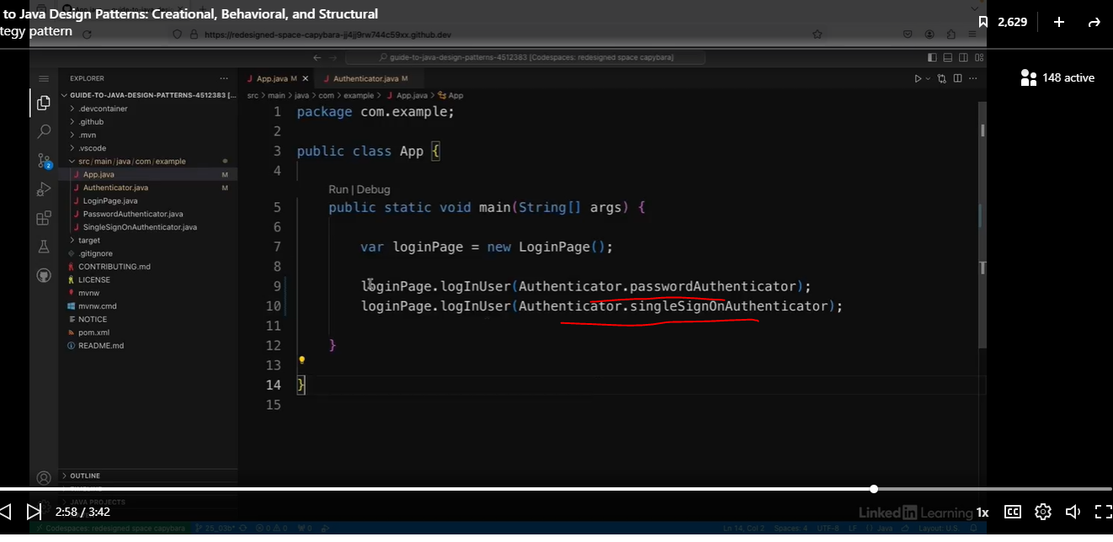

We can remove the concreate Authenticator classes.

So I'm just going to change that in the authenticator interface. So I've got the same output as before, but I've significantly reduced the amount of code I had by deleting those two classes. And if I want to add more authentication types, I can just keep defining them inside this interface.

## The Template Method Pattern

### Understand the Template Method Pattern

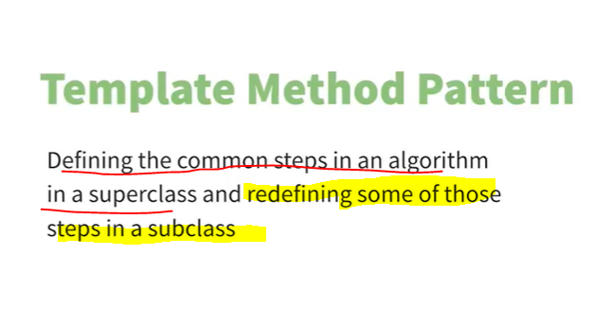

This is a very common design pattern. See diagram below. In the superclass, the addToppings is an abstract method in the Abstract class, and then the addToppins is overridden in the Hawaiian Pizza subclass.

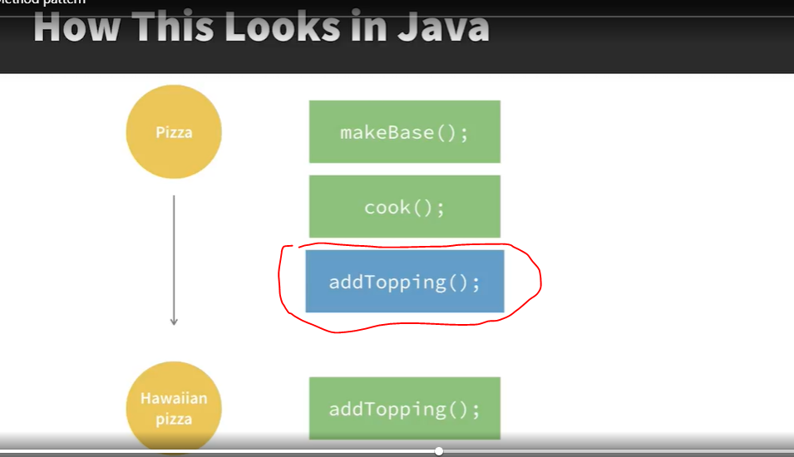

Although common, it can be overly complexed.

It can be difficult to communicate to users of the framework what the intent is. If you came across the use of this pattern, it might not be immediately obvious which parts are meant to be changed, and it can also be quite difficult to follow the flow of the program as the functionality can jump between different classes.

Use Case

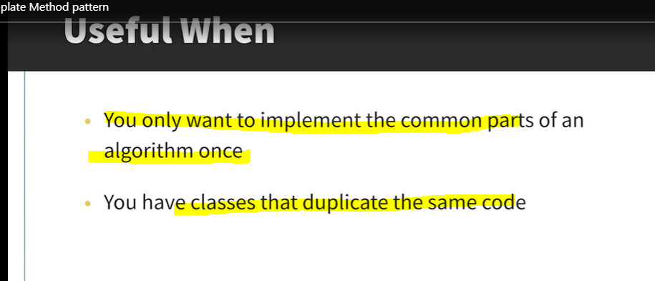

However, this is certainly not a reason not to use it if it fits your use case. And it is a useful pattern to know as it is so commonly used. It can definitely be useful when you want to implement the common parts of an algorithm once, and leave the varying parts to subclasses. In particular, if you find that you have classes which duplicate the same code, you might be able to refactor some of these steps into an abstract class.

### Implement the Template Pattern

See example below:

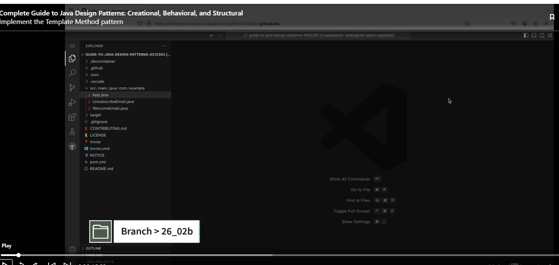

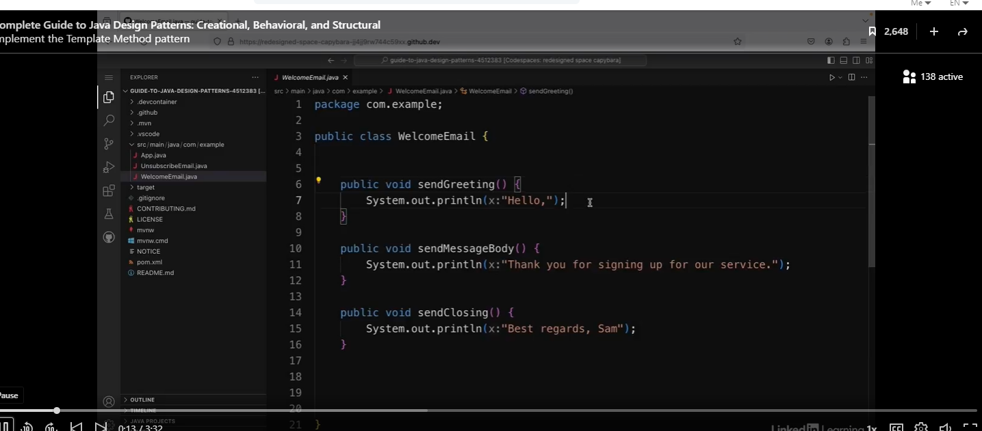

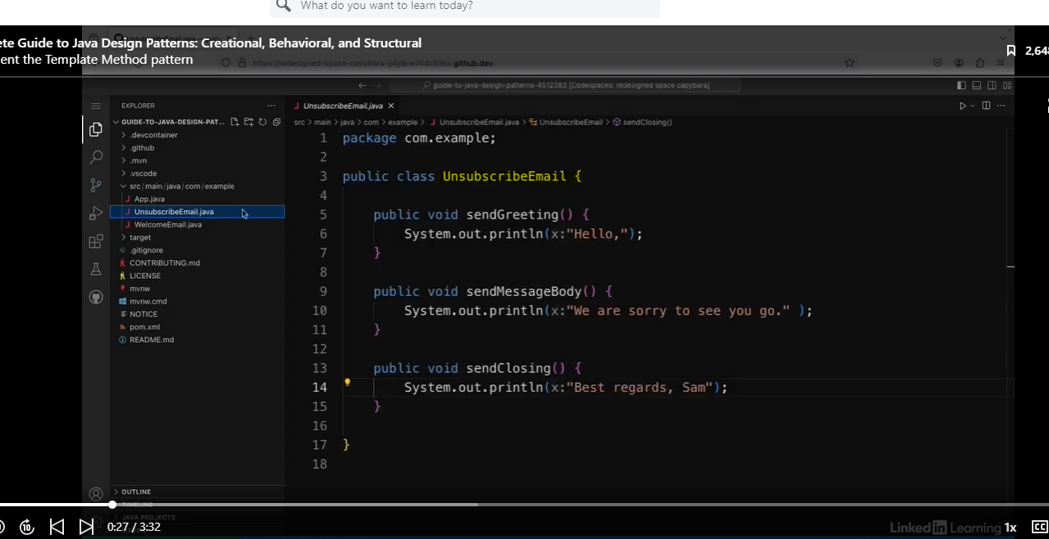

As you can see there is a lot of duplicate code, except for the sendMessageBody class.

See client code below:

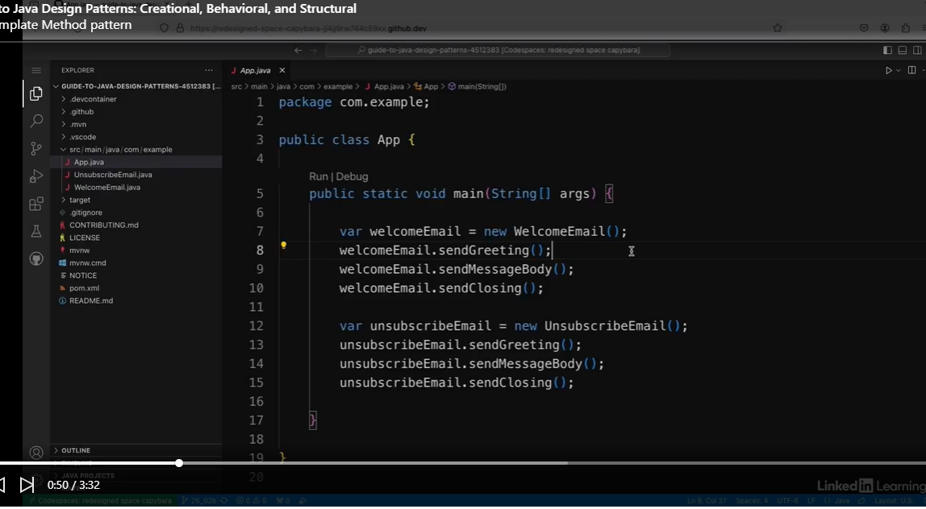

Check out the results.

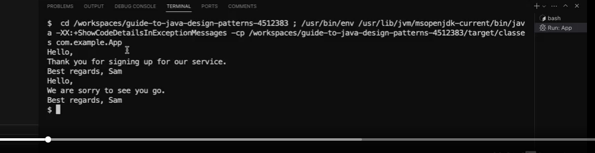

Now let’s refactor.

So there is some duplication in these emails as the welcome part and the closing parts are the same. And it would be easy to imagine that I might want to send other emails for my service with the same beginning and end, but with a different message body. So I'm going to create an abstract class to put the duplicated logic in.

Let’s create a class called Email, and put the duplicate code in it.

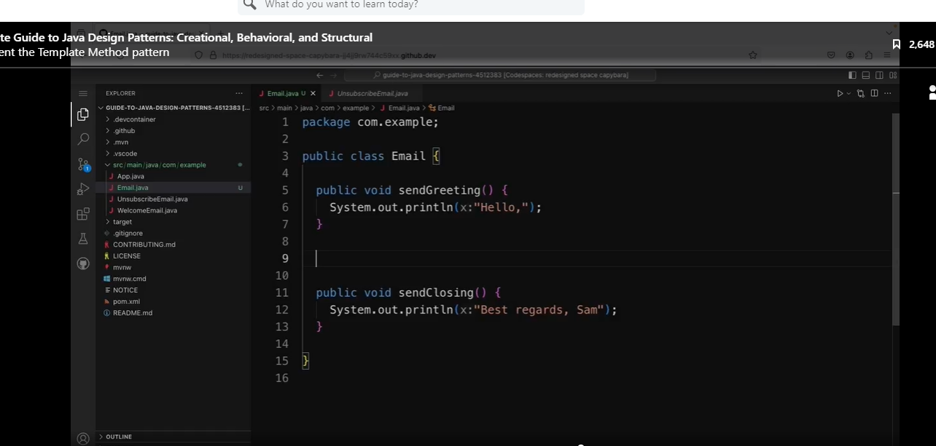

Now we have to deal with the sendMessage method.

First step, we will change this class to an abstract class and make the sendMessageBody abstract.

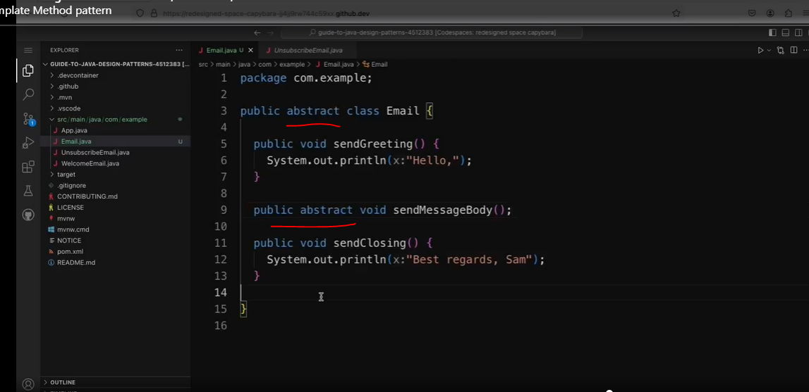

Now refactor the other classes.

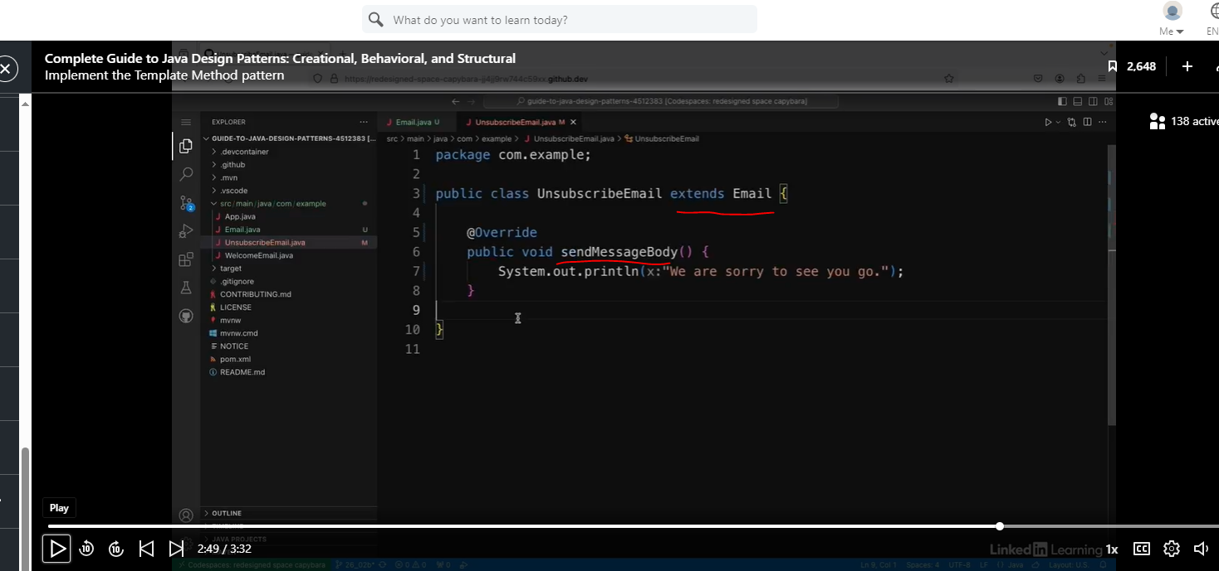

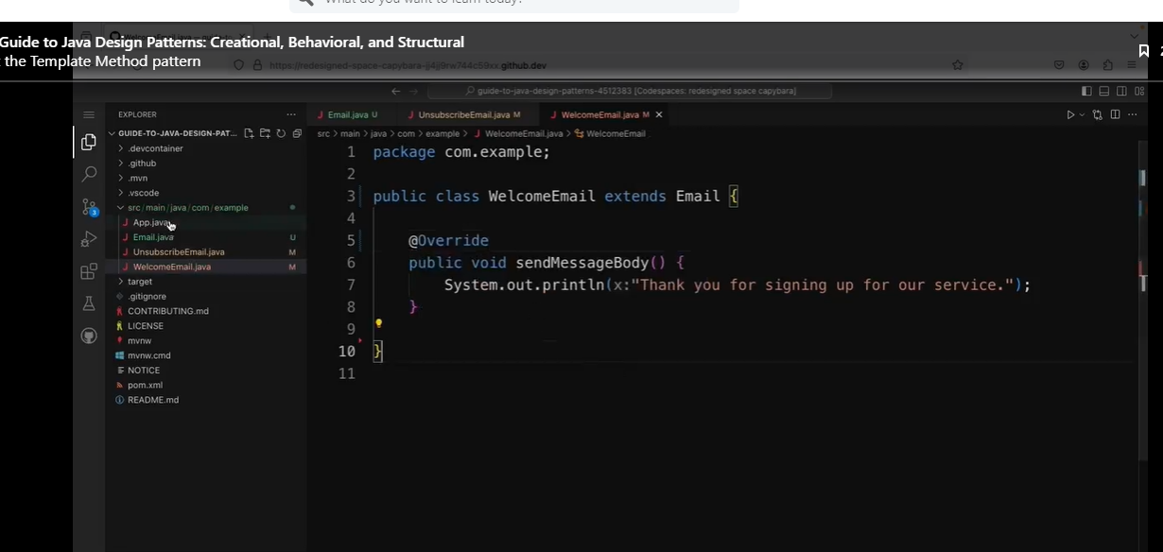

We did not have to change the client code, and the results are what we expect.

Note: The sendMessageBody did not have a return value or accepted a parameter. Making them generic be even more flexible.

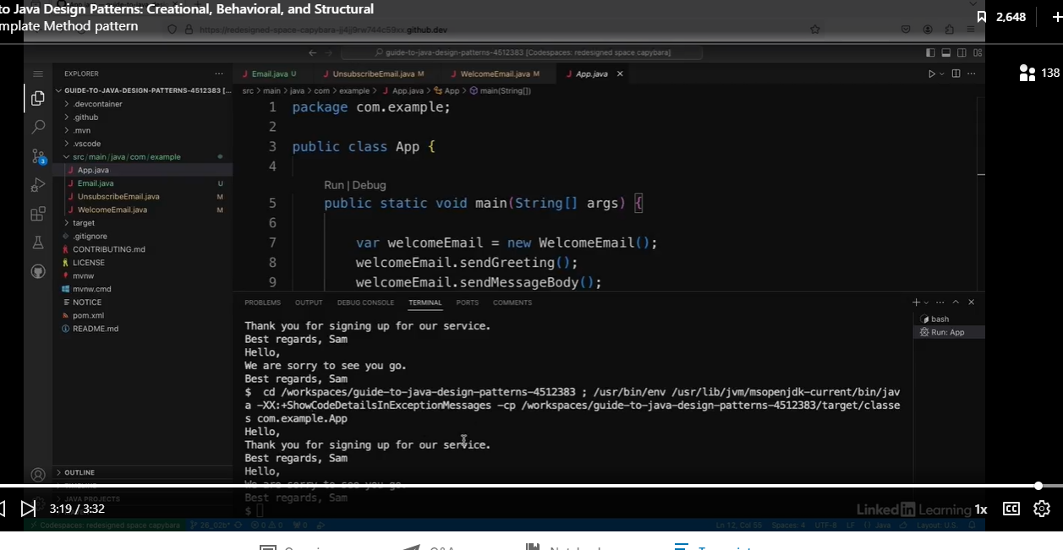

## The Visitor Pattern

### Understand the Visitor Pattern

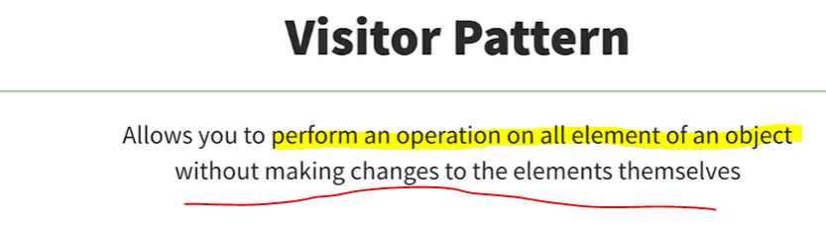

Imagine you have a tree structure of objects, and you want to perform an operation on all the elements of it. The visitor pattern allows you to do this without making changes to the elements themselves. Instead, you have a separate visitor objects, which is passed to each object to perform the operation.

#### Mechanic Analogy

Instead, you have a separate visitor objects, which is passed to each object to perform the operation. As a real-world analogy, imagine someone drives a car to a mechanic. The mechanic temporarily takes over the car to fix some things, and then the car is driven away again. The mechanics might do different kinds of fixes depending on the problem, and there also might be different kinds of vehicles, such as trucks and buses and so on. The different fixes might be similar for each different type of vehicle, but also slightly different.

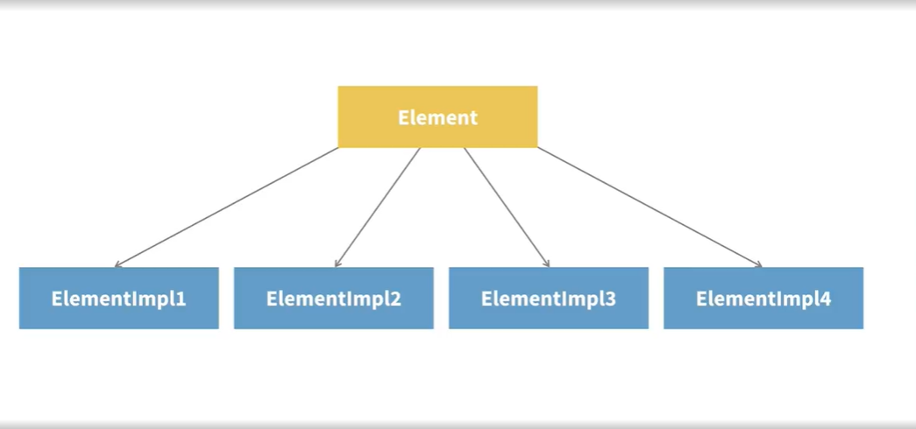

Let's see what the visitor pattern looks like in a Java program. So let's say you have an interface with some concrete implementations of it. And let's say you want to apply some operation to each of the concrete implementations. The operation will be similar but slightly different for each concrete element. One option would be to put a method for the operation inside each element, but that gives you a structure that's difficult to understand and make changes to.

#### Open-Closed Principle

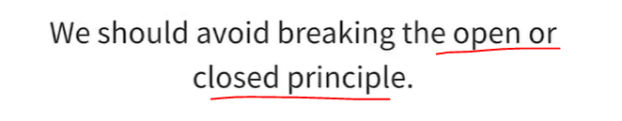

This also breaks the open or closed principle. This is a principle in object-oriented design which says that classes should be open for extension but closed for modification. One option here is to use the visitor pattern.

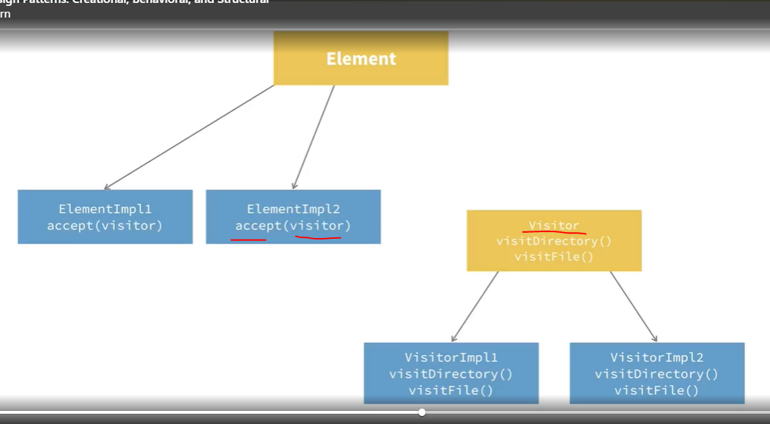

Object Structure

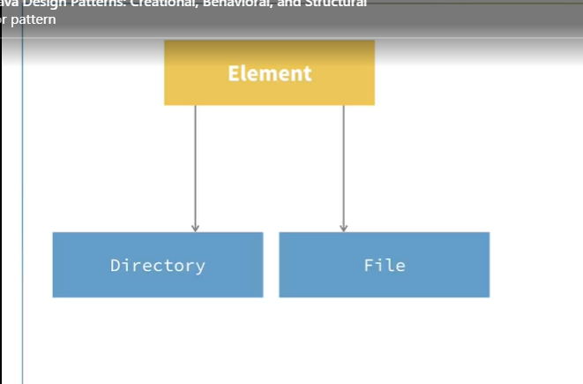

One option here is to use the visitor pattern. In this version, you create an interface that defines a visit method for each of the concrete implementations. Then you have concrete implementations of the visitor interface. The visitors have a method called visits for each of the different concrete elements, and the concrete elements have a method called accepts, which accepts a visitor. In particular, the visitor pattern is useful if you have a composite or a list of other elements. For example, say you have a file system interface. Directory and file both implements this interface, and a directory can contain a list of file objects. This is known as the object structure. The visitor pattern allows you to apply operations to each element in the list without worrying about type safety, because each will have its own separate visit method defined that performs the operation differently for each type.

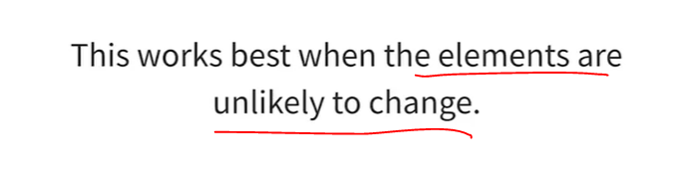

It's worth noting that the visitor pattern is best used when the elements are not likely to change. If you were to start adding more elements to the concrete implementations, you would have to go back and update the visitor interface as well as every concrete implementation of it. This inflexibility is one of the downsides of using the visitor pattern. It's also fairly rare to see this pattern used, partly because it's so complex and partly because it's for a very specific use case. But if you do have this use case and you want to define new operations without making changes to the existing object structure, the visitor pattern can offer a neat and elegant solution. It's probably best to explain this pattern with a code example. So that's what I'm going to do in the next video.

### Implement the Visitor Pattern

See the code below:

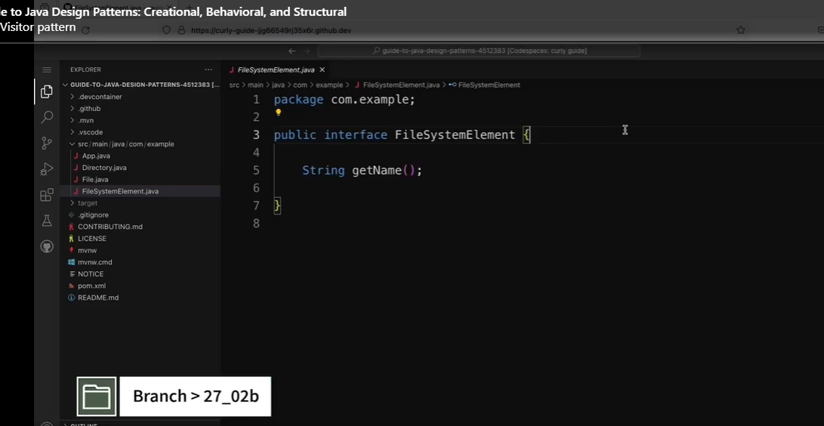

Let’s look at the File and Directory classes.

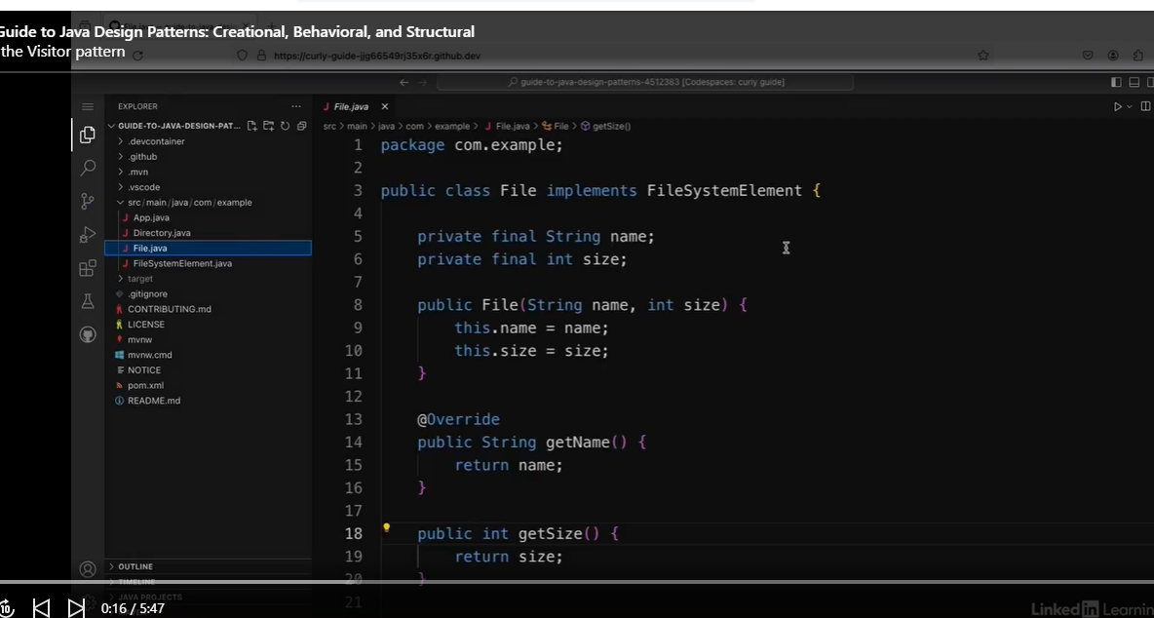

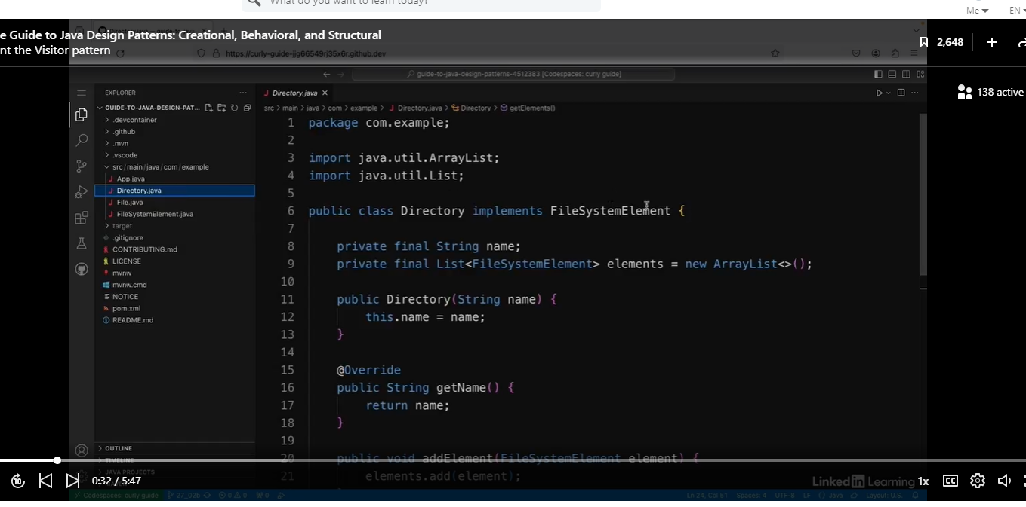

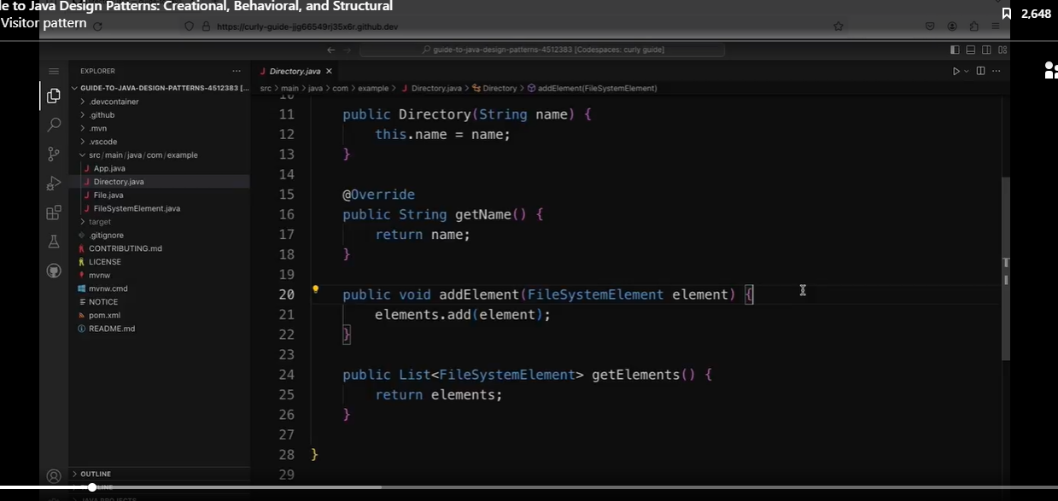

See the client code below:

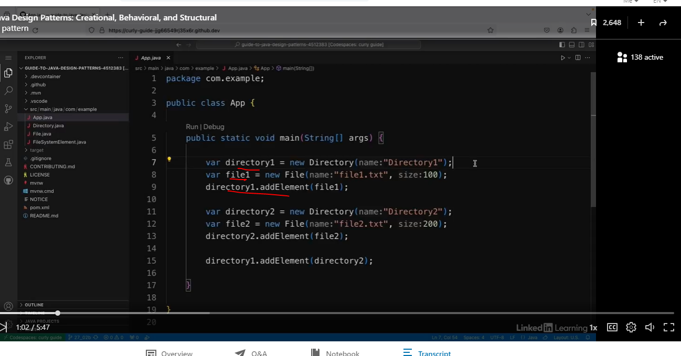

Then I have an App class with a main method. So in here, I'm creating a directory called directory1 and adding a file called file1.txt to it. Then I'm creating a second directory called directory2 and adding a second file called file2.txt to it. Then I'm adding the whole of directory2 to directory1. So directory1 contains file1.txt and directory2 which in turn contains file2.txt. Now, let's say that I want to apply an operation to all files and directories to get the total size of the file system. I'm going to use the visitor pattern to do this.

Let’s create a new interface called Visitor.

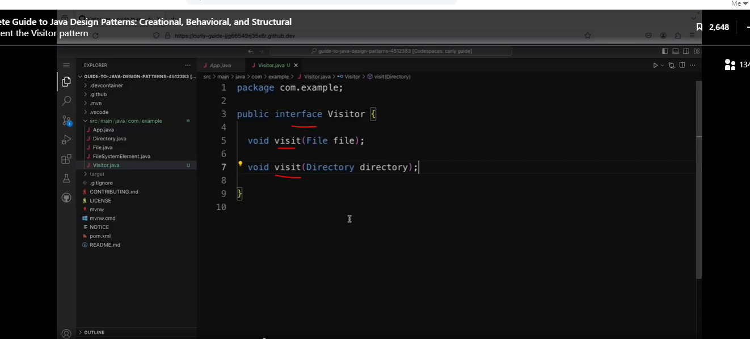

Now we will create an implementation of this interface to get the file size.

Note: I think one of the Stream’s accumulators could tally the values in the code below:

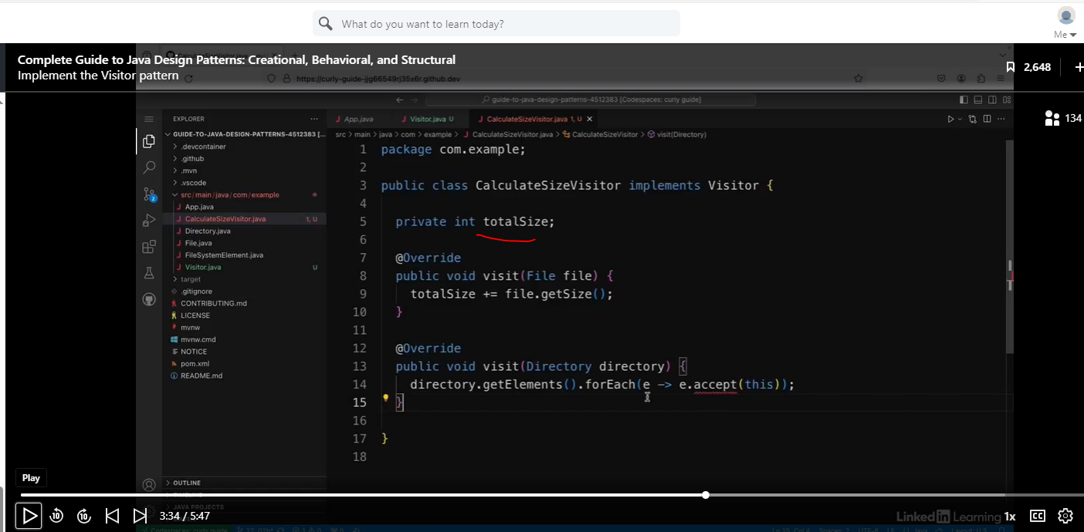

In the FileSystemElement interface, we are going to add the accept method that accepts a Visitor, so the code above compiles.

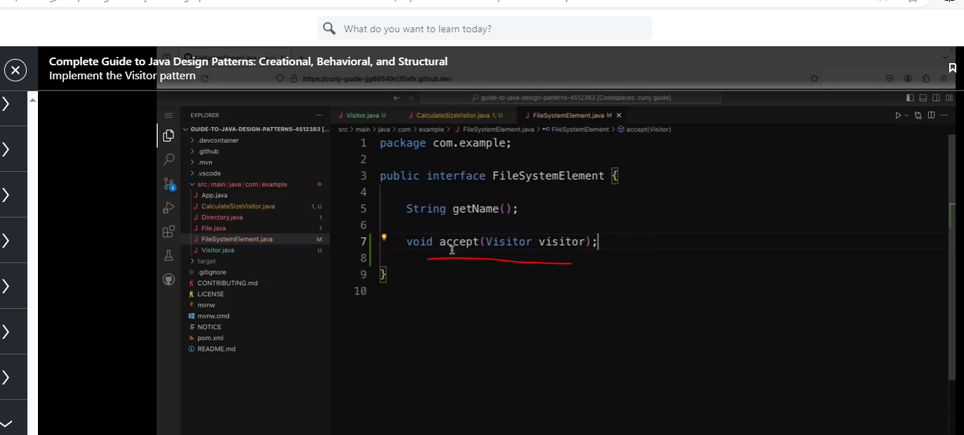

We will override the accept method in both the File and Directory class.

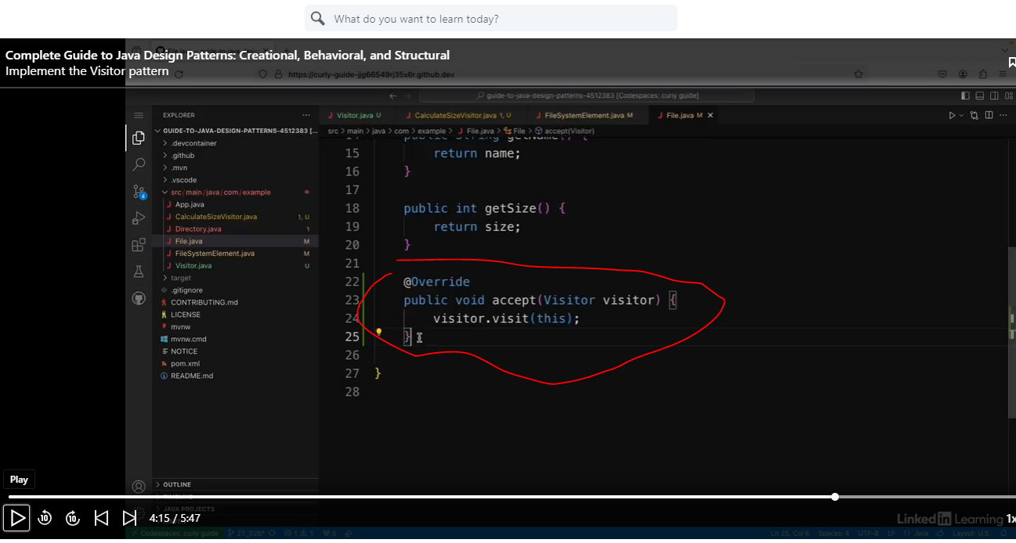

Hmmm. Look like we have duplicate code.

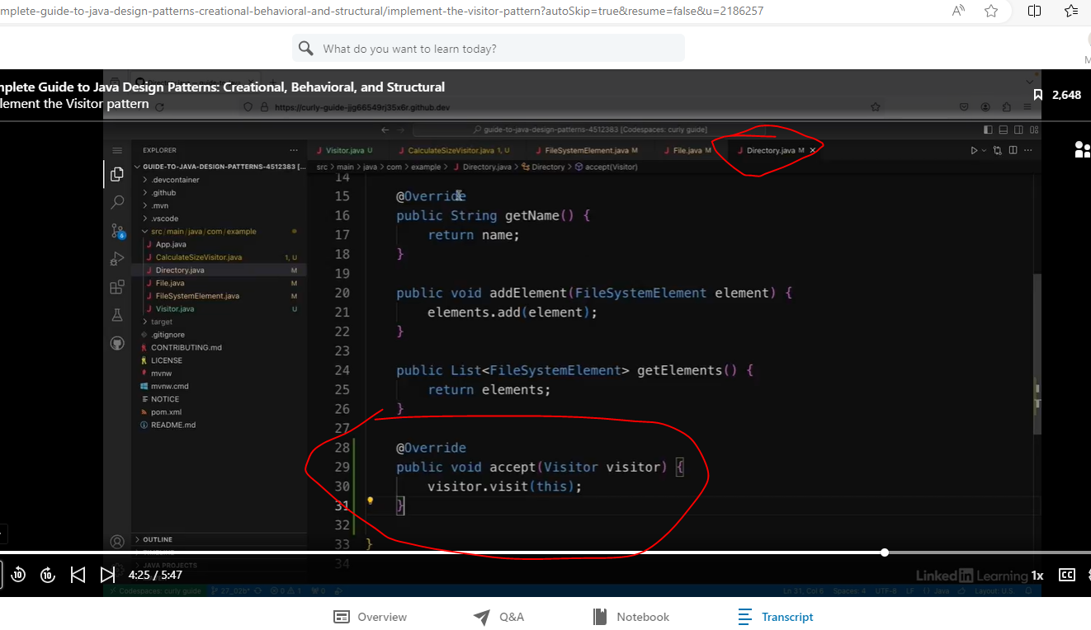

We will add the code below to the bottom of the client code.

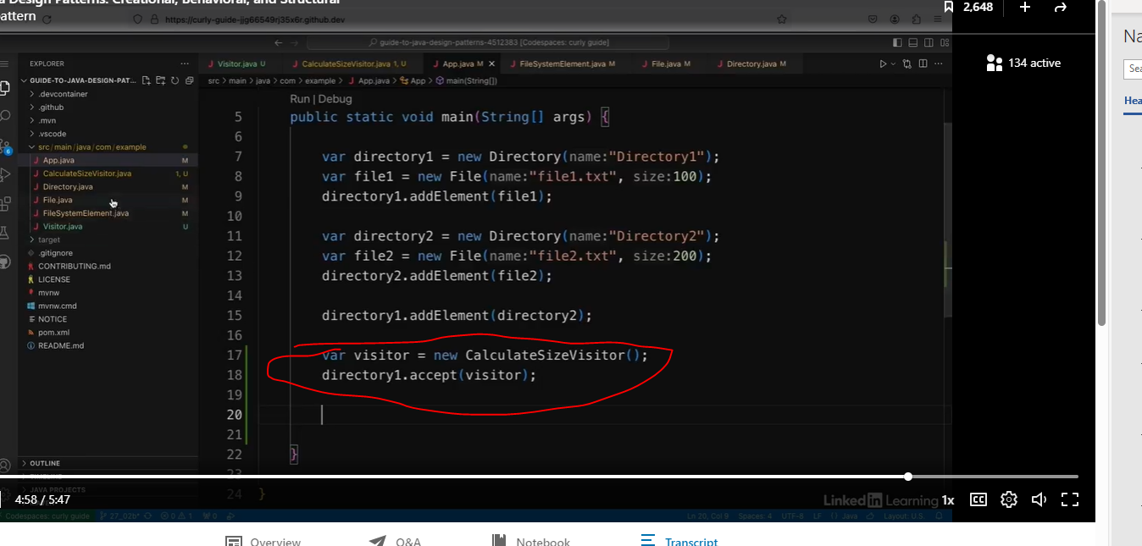

With the visitor implementation, we are going to add the code to print the size.

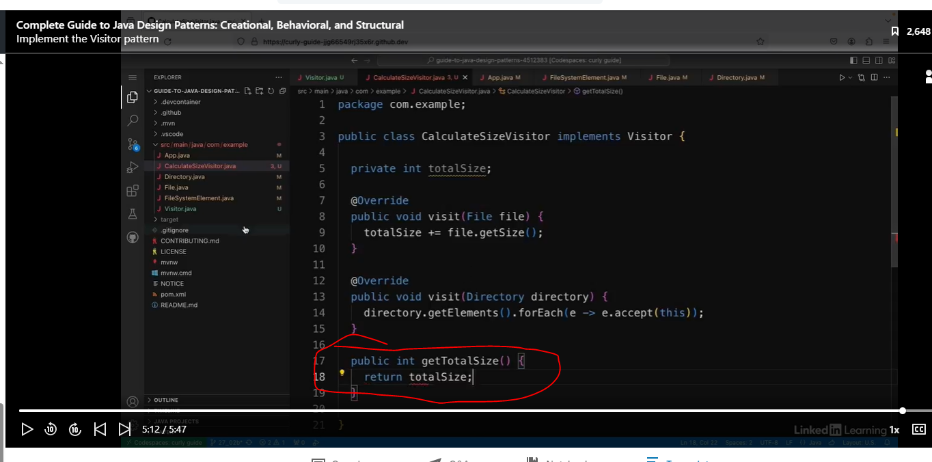

Now we will add this to our client code.

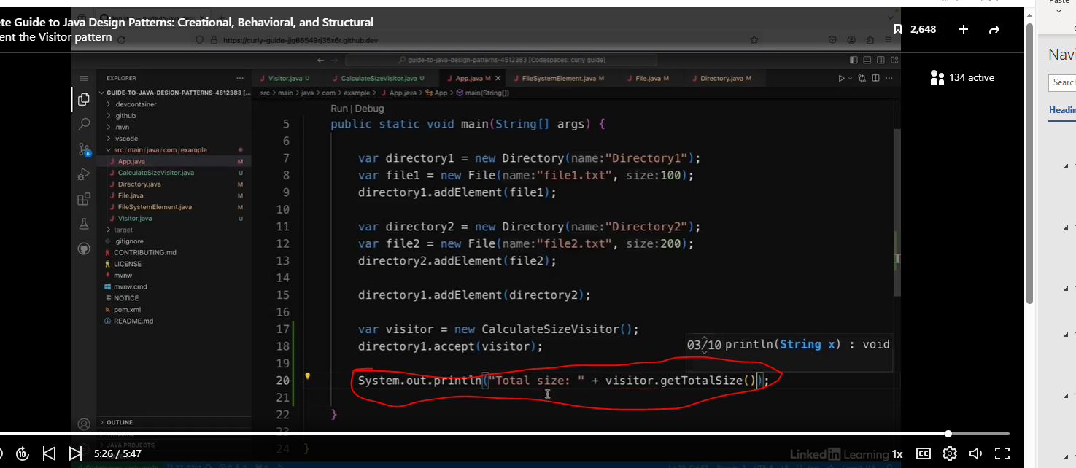

The size is 300 like we expected.

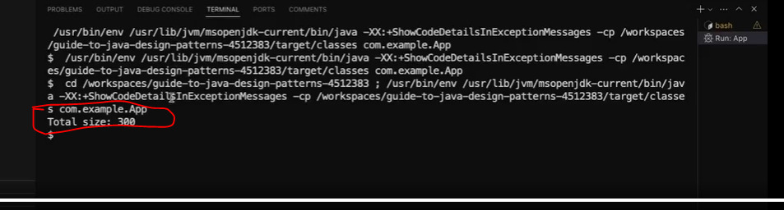

So that's how you can use the visitor pattern to apply actions to a composite object structure.